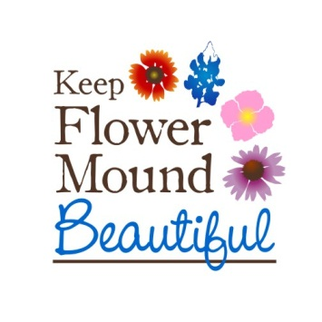

October 8, 2021

Keep Flower Mound Beautiful is a 501C3 organization that services the Flower Mound community providing 2 clean up events a year, monthly clean ups, adopt a spot, classes on composting and gardening and education on recycling.

We are a volunteer-based organization and are wanting to get our youth involved and are forming a Youth Ambassador to our board. We are seeking 10 members grades 6th thru 12th who are interested in serving and have a heart for recycling and keeping our community clean. Please fill out the bottom portion of the letter and email back for consideration. Applications must be received by November 15th. Your commitment would consist of the following:

* Serve for 1 year
* Help lead a recycle initiative on your campus
* Come up with a recycling project (this would be done as a committee)
* Help present once a year with KFMB at the Town of Flower Mound Council Meeting
* Work one of the semi annual Clean Up Event April/September
* Participate in our monthly clean up events and Lend A Hand projects as available, according to your schedule
* Attend meetings with other KFMB Youth Ambassadors and KFMB liaison as needed

Name: __________________________________ Grade:________

Address: ________________________________ School:_______________________

Email:___________________________________ Phone Number:_________________

Why you are interested in serving on the Youth Ambassador Program with KFMB:

____________________________________________________________________________________________________________________________________________________________________________________________________________________________________________________________________________________________________________________________________________________________________________

Best Regards,

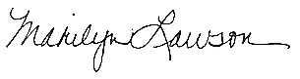

Marilyn Lawson

KFMB Board Director

469-828-9074

[kfmb@kfmb.org](mailto:kfmb@kfmb.org)

The mission of Keep Flower Mound Beautiful is “to effectively partner with Flower Mound citizens to beautify the community and preserve our unique natural environment”.

KEEP FLOWER MOUND BEAUTIFUL OPERATES AS A 501 (c) 3 ORGANIZATION.