**101st. Richmond Canadian Air Scout Group**

This step by step guide on “How to register a 1st- time youth participant’ with Scout Canada.

**There are 3 components to registration:**

**1.  Scouts Canada Registration Membership Fee - Due to changes in Scouts Canada requirements, the membership registration fee portion must be paid via** [**myscouts.ca**](http://myscouts.ca/) **online.**

**2.  Group Fee ($180.00) will collect separately. – Please write a Cheque payable to “101st Richmond Canadian Air Scout Group”**

**3.) Please bring a cheque or cash for the uniform payment at our registration desk with Ming.**

**Where do my Registration Fees go?**

Registration fees support the cost of delivering a quality Scouting program in communities across Canada, including:

* Developing dynamic Scouting programs for youth,
* Providing over 20,000 Volunteers with up-to-date training,
* Maintaining high-quality camp facilities in each province, and,

**Group Fee:**

Groups fee is an additional fee on top of the National Fee which included

* Rental Fees for the regular meeting space
* Equipment maintenance
* Program materials and etc…

**Exclude Outdoor Activity Fee like: Camping, Tour, Hiking, Aviation or flight training and etc.…**

**Uniforms are not traditionally incorporated into the fee.**

**How do I prepare to register my child as a first-time participant?**

1. Be prepared to include personal information about your youth. Specifically, 3 emergency contacts, information such as Provincial Healthcare Number, insurance details, Dr's contact information, allergies, dietary restrictions, medical conditions & special care instructions.
2. Ensure you are using a desktop or laptop computer with access to the internet. Mobile and handheld devices are not always compatible with the system and are best to avoid.

3) Method of payment. Paying fees are the final step when completing registration. Acceptable methods of payment are credit card; Visa, Mastercard and AMEX, debit and PayPal.

**Note:** The option to pay via Group Billing code will appear only if your Group has given you the option to use a Group Billing code.

**How to register my child as a first-time participant**

**Step 1: Locate Groups in your area**

**Follow this link**[**JOIN**](http://www.scouts.ca/join/)

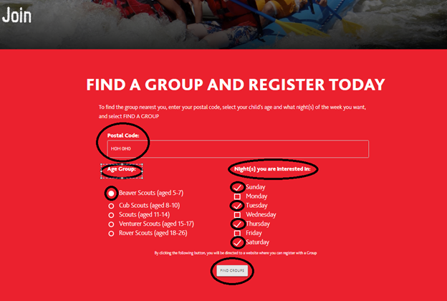

**Step 2: Select your youth's new Group**

Once you’ve included your information and selected Find Groups you will be re-directed to the page seen below - the information you've already added; postal code, child's age and nights you are interested in will be re-populated when you are re-directed.

This page lists the results of your Find a Group search.

These are the 10 nearest Groups to the postal code entered. Refer to the map for the meeting locations of the Groups listed.

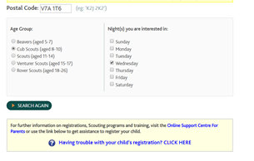

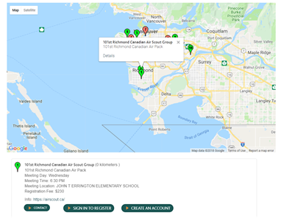

**Step 3: Create your Parent/Guardian account**

When a Group has space available you may move forward with registration by selecting Create Account.

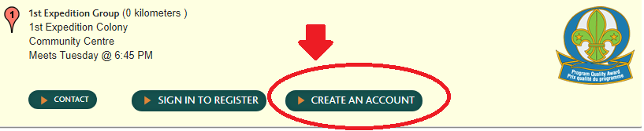

A Parent/Guardian account is required when you register youth in Scouting. When you register your youth their account will be linked with your account.

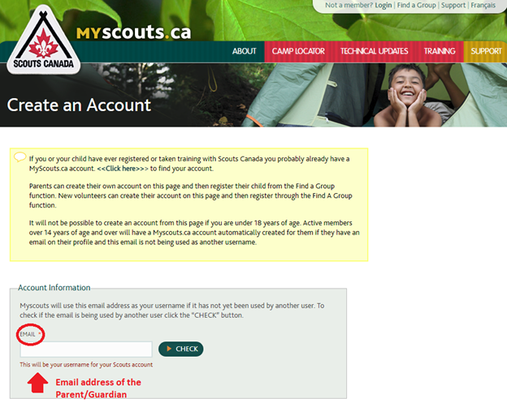

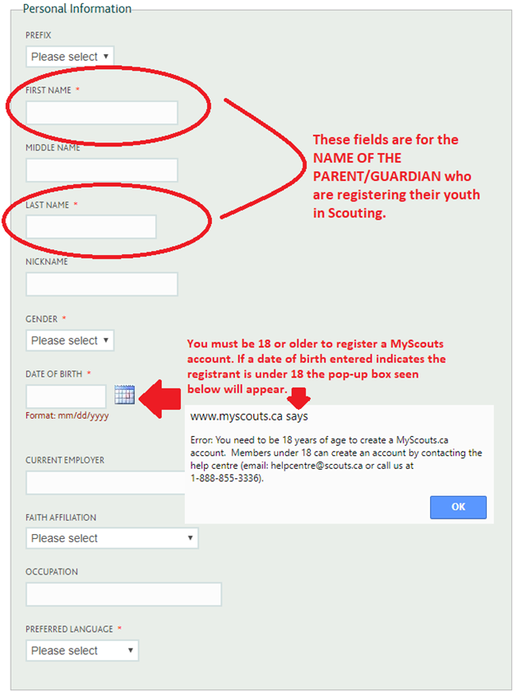

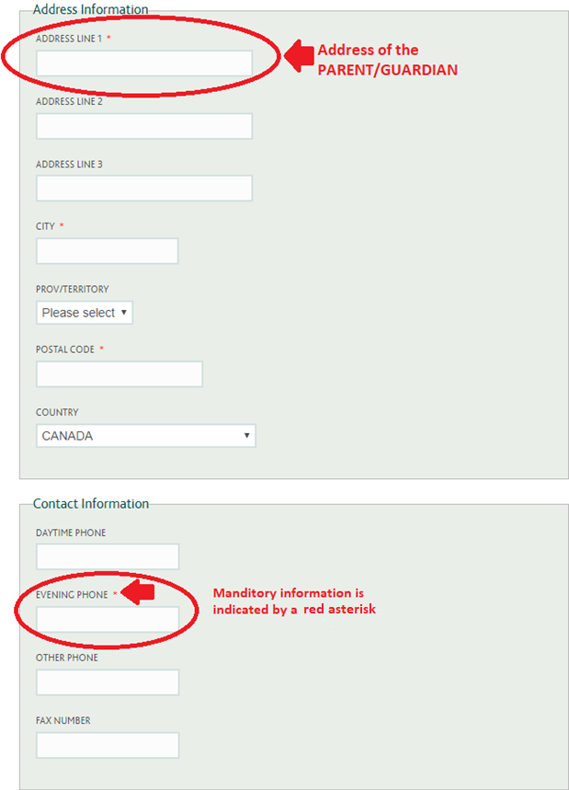

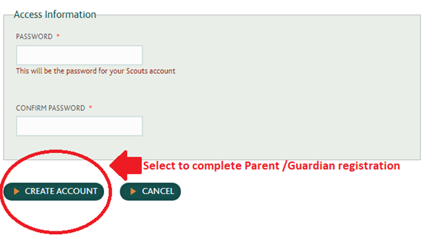

After Create Account is selected you will be re-directed to the [MyScouts](https://www.myscouts.ca/) login page where you will see the pop-up New record created / Record updated.

**Step 4: Login to your new MyScouts account**

Enter the email address and password you just used to register yourself with [MyScouts](https://www.myscouts.ca/) to gain entry to your Parent/Guardian [MyScouts](https://www.myscouts.ca/) account.

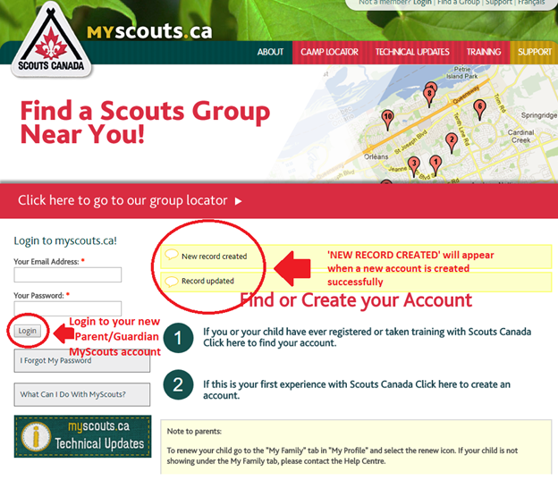

**Step 5: Register your youth**

Once logged in to your new [MyScouts](https://www.myscouts.ca/) account you may begin your youth's registration. Select Register Member from the Member Options menu.

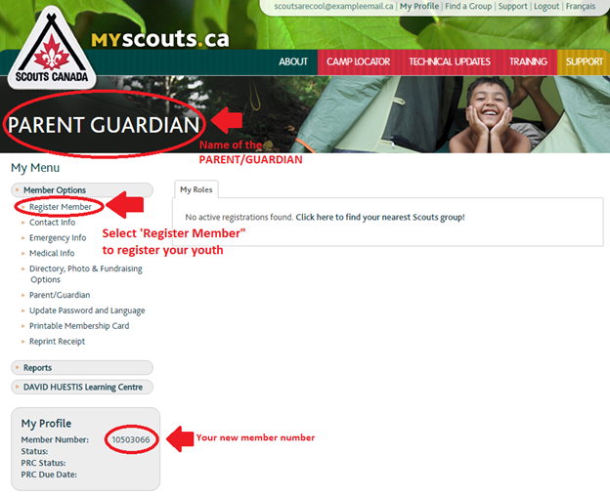

When Register Member is selected you will be re-directed back to the Find a Group page. This time as you are already logged in to your [MyScouts](https://www.myscouts.ca/) account you will see the option next to Register as a Participant.

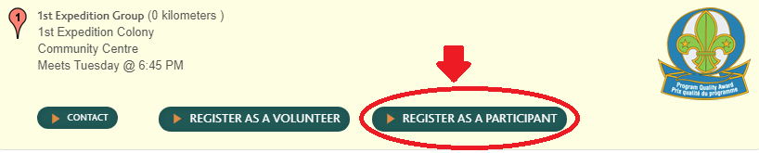

Select New Member as you are registering your youth as a 1st-time participant.

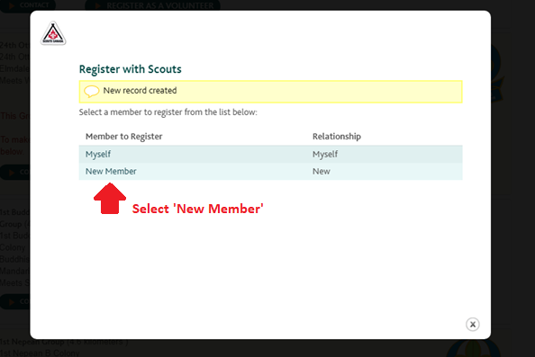

The next few screens are where you enter all of your child’s details onto the system. This information should be accurate and up to date, as these are the details which will be sent to the group you are registering with. Remember that fields marked with a red asterisk are compulsory. Select Create Account once all information has been entered.

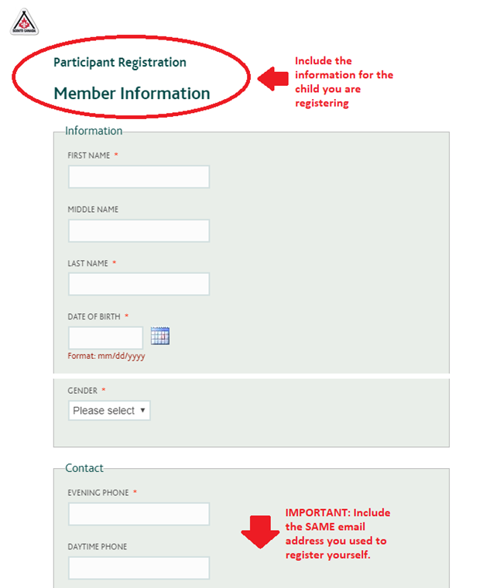

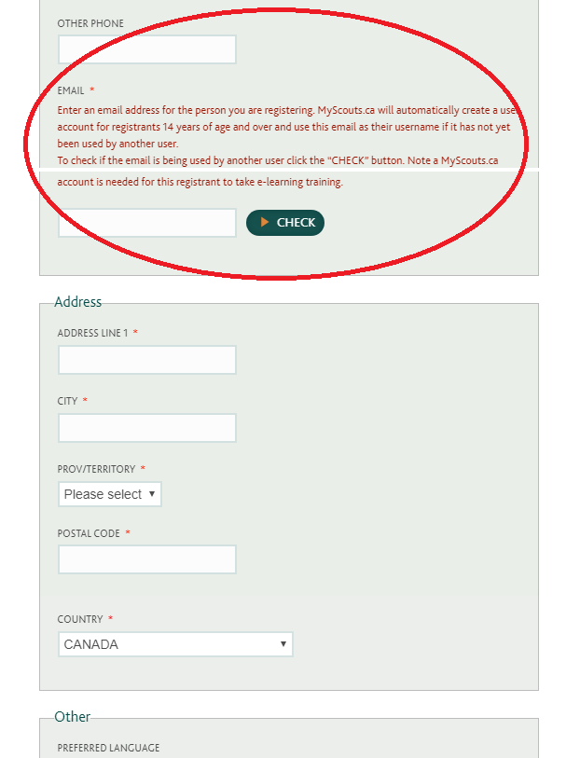

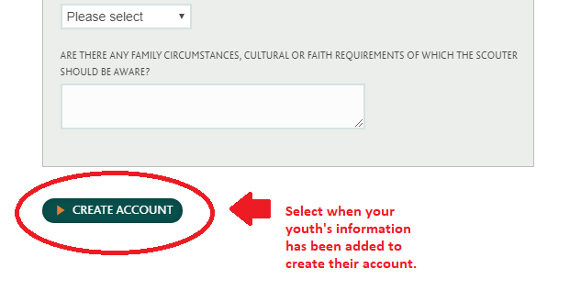

After Create Account has been selected you will be led through a series of screens requesting more information. If you do not have all of the information requested immediately available you may leave the non-compulsory fields (fields not indicated by a red asterisk) and come back to them when you have the information.

If you choose to move forward with completing the information at a later time the categories can be found within My Menu under Member Options.

* **Emergency information:** 3 emergency contacts
* **Medical Information:** Provincial healthcare number, physician information, insurance information, allergies, dietary restrictions, conditions or concerns to be aware of, date of most recent tetanus shot and swimming abilities (swimmer or non-swimmer)
* **Directory, Photo & Fundraising Options:** Photo release and communication consents
* **Parent/Guardian:** Involvement survey

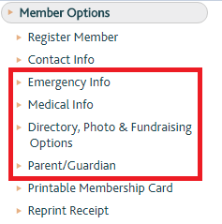

After this section has been completed you will next be asked to read and agree to the terms and conditions of Scouts Canada privacy policy, terms of registration, medical policy and participant agreement.

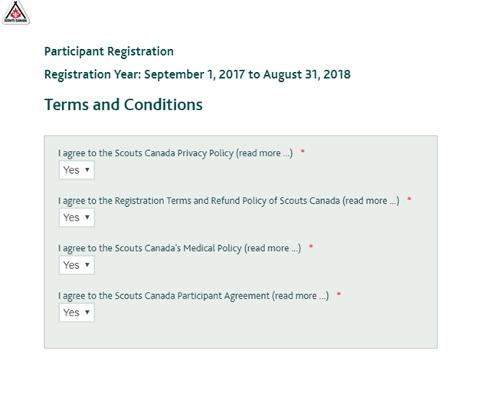

Once you have agreed to the terms you may confirm your youth's registration information before being requested to make payment.

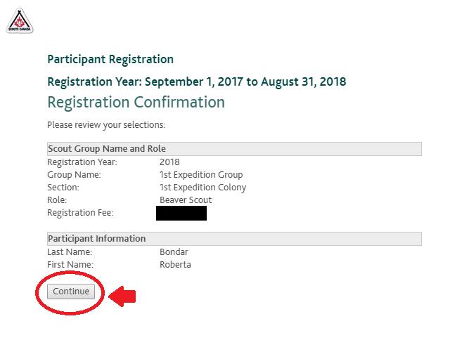

Lastly, you will complete the payment information. You have the choice of payment via credit card (Visa/Mastercard/AMEX), debit, PayPal or Group Billing code (the option to use a Group Billing Code will only appear if the Group has made the option available). If a Group Billing Code is available the option will appear as shown in screen-shot below.

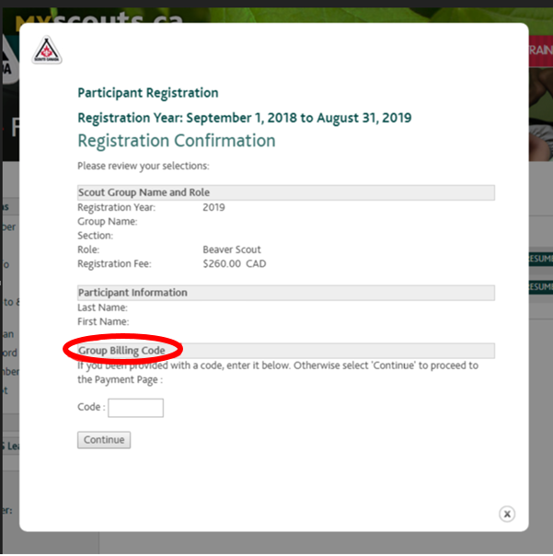

**Reminder:** Scouts Canada divides its fees into two portions, the **National Registration Fee**, and a **Group Fee**(if applicable), these are added together to give a final fee amount that is listed under Payment Amount. Fees are inclusive of taxes.

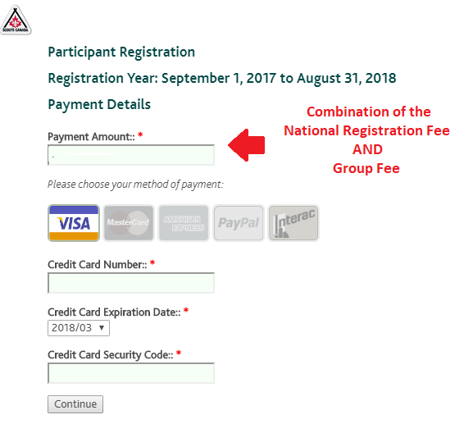

Once your payment has been processed your receipt will appear. You will be able to access your receipt at any time (if your payment is made online) by selecting Reprint Receipt from Member Options.

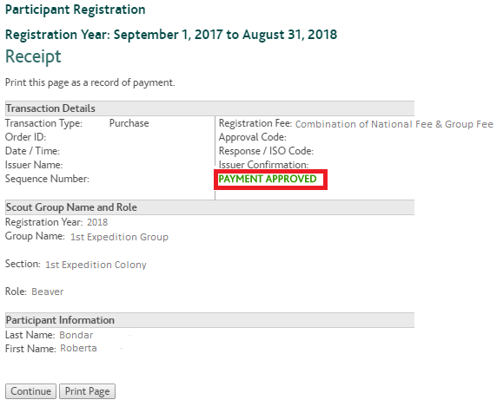

After your receipt is received select Submit Registration to complete the process.

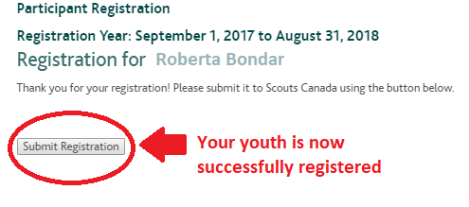

**How to resume registration**

If you abandon the registration process part way through you will be able to resume your child’s registration.

Log back into [MyScouts](https://www.myscouts.ca/) and select the tab titled Incomplete Registrations. Select Resume to pick up where you left off, or Delete to remove the registration completely.

**What happens after my child has been registered?**

After your youth has been registered you will receive an email confirmation explaining that you will be contacted by a Scouter with your youth's new Group. You should be contacted within a week of registration. If you are not contacted in a timely manner please reach out to the Scouts Canada Help Centre.

