“UNDERSTANDING COMPLEX REGIONAL PAIN SYNDROME”

by

CHRIS A. RAPOFF DC, QME

SESSION 1

Hello. I’m Dr. Chris Rapoff. Thank you for joining me in the first installment of a series examining the intriguing and often misunderstood condition of Complex Regional Pain Syndrome, also known as CRPS. Over the next several installments, I will provide you with a deep dive into this painful and very debilitating condition. I will discuss how this impacts us as QMEs in our attempts to provide an accurate rating of permanent impairment for the examinee. Finally, I will touch on some of the challenges that the AMA Guides Fifth Edition presents to us as we attempt to attain the correct permanent impairment rating. I hope you enjoy this analysis of the ongoing medical mystery of Complex Regional Pain Syndrome.

Before we get started today, I would like to give you an overview of the topics that we’re going to cover as we examine the condition of CRPS. First, we’ll define the condition and examine the different types of CRPS that you might see in your QME examination of an individual. I’ll provide you with the latest research on this topic, and we’ll touch on many of the pathophysiologic mechanisms involved in CRPS. We’ll explore the stages of this condition and possible treatment options. I’ll discuss CRPS in your QME examination. We’ll also touch on out how to provide a correct impairment rating of CRPS according to the Guides Fifth Edition, and finally, I’ll touch on some of the challenges that the AMA Guides Fifth Edition offers us when we attempt to attain the correct permanent impairment rating. But before we begin, I also wanted to mention that I will be using many clinical terms that may provide you – oh, some of us – flashbacks of your time in gross anatomy, physiology, and pathology class. Understanding that remembering this material may be a challenge for some of us that have not been in class for few years, so I’ll try to re-familiarize you with some of the scientific and clinical terminology by defining many of the less familiar terms as we go. Okay, let’s get started.


First, we need a thorough definition of what CRPS is, and it is officially defined as a rare condition, often debilitating, and is characterized by severe pain affecting one or more limbs. Another understanding is that it is defined as a pain that’s due to a stimulus that does not normally provoke pain. So, the understanding of this is very important as we move forward. It might help you to understand this if we go through more of the signs and symptoms as it relates to CRPS. First, the signs and symptoms are disproportionate, and they can include symptoms of spontaneous and/or movement-induced pain. Actually, not induced by anything but movement. Sensory impairment is another sign and symptom, and it’s defined as allodynia. You may remember allodynia is a pain in which the individual is very sensitive to touch. For example, as I put here in an image, stroking the skin with a feather.

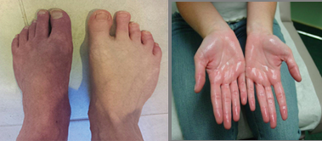
Another sign and symptom would be hyperesthesia, which is an unusual or pathological sensitivity of the skin. As you can see, this individual has a painful condition on her hand. It’s irritable and irritating to the touch. Another sign and symptom would be an on autonomic dysregulation, which are changes in skin temperature, and we’ll discuss this more in depth in future slides. But it’s vasomotor, which would be involving the constriction and vasodilation and/or color and/or hyperhidrosis. Hyperhidrosis would be a situation where the individual has excessive sweating and for no understandable reason to the individual.
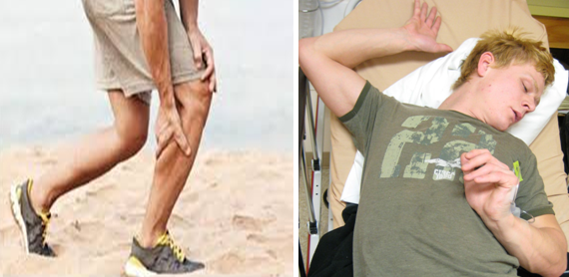
Motor abnormalities, such as joint stiffness, tremors, muscle weakness, and dystonia. Dystonia, you may recall, is an involuntary muscle contraction causing repetitive or twisting movements as illustrated by the image on the right.

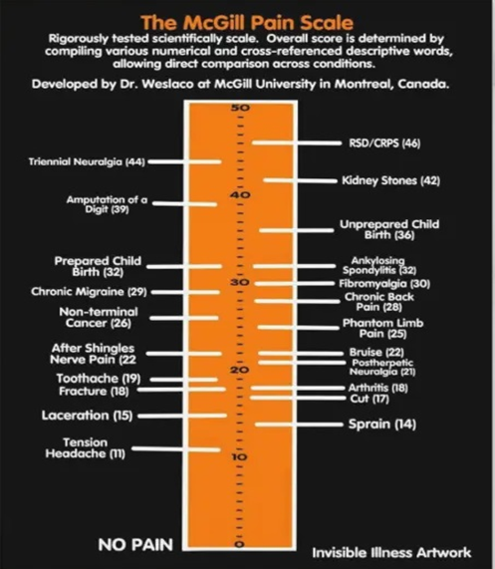
We could illustrate the symptom of pain by the scientifically tested McGill Pain Scale comparisons, where a rating of 0 is no pain and a rating of 50 is unbearable pain. Let’s take a look at some examples. We see sprain, which we might see in an examination and is provided a 14/50 possible. Postherpetic neuralgia, a 21/50. A low back condition – a chronic low back condition we will see very often in our examinations, a 28/50. Fibromyalgia, a rating of 30/50. Kidney stones, a 42/50, and my goodness, CRPS is described as a 46/50 on the pain scale. This just gives us a more in-depth understanding and a degree of pain that an individual experiences when they’re afflicted with this condition.

The cause of CRPS is very interesting in the fact that it’s an inciting event or a noxious stimulus that is usually a traumatic event, however, not as traumatic as you would think when you use the term trauma. It could be a fracture. It could be a surgery outcome. It could be a sprain or something as simple as a contusion in an extremity; however, in 10% of the cases, the precipitating cause really is still unknown.

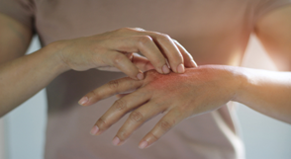
CRPS is divided into two main categories based on the absence or the presence of a nerve lesion at the periphery. First, we have Type I where there are 90% of the cases present in CRPS. This involves a condition without a nerve lesion at the periphery. The former name for this condition was called Reflex Sympathetic Dystrophy or RSD. RSD is a condition thought to be due to a malfunctioning of the sympathetic nervous system, but some researchers are questioning this. Since RSD most often follows trauma to the extremities, some conditions that can trigger RSD are sprains, fractures, surgery, damage to the blood vessels or nerves, and certain brain injuries. I also wanted to mention here that the Guides also refers to these outdated names in CRPS throughout the chapters. What I’m trying to say is they interchangeably use the term CRPS and RSD, so keep that in mind as we move forward. So first let’s talk about the noxious event, if it is an immobilization, a sprain, a stubbed toe, or fracture. You catch my drift here. The sensory presentations include allodynia. You may recall allodynia is a pain that is due to a stimulus that normally doesn’t provoke pain as illustrated in a previous slide by the image of the feather on the skin. Or hyperalgesia, extreme sensitivity to pain, which is not normal, it’s an exaggerated response. Or hyperesthesia, which is a partial or total loss of sensation. Or hypoalgesia, a decreased sensitivity. So, you could see there are variable ways that this can manifest and present itself in a clinical setting. Additionally, autonomic disorders plus inflammatory symptoms, such as edema, hyperhidrosis (which is excessive sweating), color and temperature changes; we will get into the vasoconstriction and vasodilation involved in the vasomotor aspects of this condition. We have trophic changes, which are changes in skin, fascia, muscle, such as thick, brittle, or rigid nails; increased or decreased nail growth; fibrosis; thin, glossy, clammy skin; osteoporosis in the chronic stage. We have motor dysfunction, which would be a weakness of all the muscles involved with that involved limb. Inability to move the involved extremity; stiffness and/or tremors in the involved extremity; reduced range of motion of the joints in the involved extremity or even atrophy of that extremity. When we discuss pain, obviously this is the sympathetic nervous system, they experience a burning sensation, and it is spontaneous. There is no elicited factor or noxious event that produces this pain and burning. It’s disproportionate to the intensity of the inciting event. Again, hyperalgesia, and it’s elicited by movement and pressure at the joint; therefore, they choose not to use the affected limb because of the joint pain and, therefore, it starts a cascading event of possible atrophy.

Now we’re moving on to CRPS Type II, and CRPS Type II appears in approximately 10% of the cases. The difference here is that the cases present with a nerve lesion at the periphery, whereas CRPS Type I did not present with a nerve lesion at all. The former name for CRPS II was causalgia. Now it is typically known and technically known as Complex Regional Pain Syndrome II. It’s a neurological disorder that can produce a long-lasting and intense pain, as CRPS I. CRPS II though rises after the injury or trauma to a peripheral nerve. I’ll touch on this in a second. The physical trigger for CRPS II is a direct injury to a peripheral nerve. For instance, a cut, actual surgical intervention, and I’ll explain this in a second, but that I actually had first-hand knowledge of this. Here the symptoms can spread beyond what is in the lesioned nerve, so it’s not necessarily localized to the involved limb. That’s important in your differential diagnosis. The sensory changes include the allodynia, as we discussed prior, and hyperalgesia; hypersensitivity of the skin to light, mechanical stimulation, the feather and/or even air blowing over the skin. You notice these are very similar to the types of conditions that you experience in the signs and symptoms of CRPS I. So, in addition, the autonomic disorders plus the inflammatory symptoms will leave the limb to be cold. Hyperhidrosis, which is when you get into your sudomotor activity of the sympathetics. A distal extremity edema, color and temperature changes. As I mentioned to you, I had first-hand knowledge of this. I was presented with an examinee, an applicant, approximately a year ago, a year and a half ago originally after she had suffered a very serious fall and she had sprained her left ankle while at work. She tripped over a tarp walking across a gym floor. And she – they presented to me for an impairment rating approximately six months after she had initially injured herself. I examined her and determined that she was not at maximum medical improvement. She was not permanent and stationary. So, I sent her back to her primary treating physician with recommendations of further treatment and/or a specialist involved. Well, they did refer her to a specialist, an orthopedic surgeon who found it necessary to perform surgery on this patient. So, they repaired her ankle ligaments and she responded very favorably to the surgery; however, as a result of the convalescence after her surgery, she developed CRPS due to the surgical intervention, not the severe ankle sprain. So, I reexamined her after this for an impairment rating, and although the original arthroscopic ankle surgery was successful, she had developed a condition of CRPS II of the left lower extremity. So, I had to assess for the new condition. Her impairment became as a result of this surgical intervention and not the original noxious event. So, what I’m trying to say, I guess, is that it’s not going to be beyond the realm of possibility that you might be posed with diagnosing and even possibly rating this condition in your career as a QME. This is even more likely for those examiners who specialize in rating physical orthopedic conditions.

Okay, moving on. So, as we look at CRPS II, you see trophic changes as well. These trophic changes are a little different in that there’s smoothness and mottling of the skin. If you recall, mottling is a blotchy or red-purplish marbling of the skin versus a presentation of thin, glossy, clammy skin of CRPS Type I, and possibly acute arthritis in this presentation, which is something to keep in mind when you perform, again, the differential diagnosis of this condition. There is also motor dysfunction involving their inability to initiate movement of an extremity. Is it inability, or is it lack of wanting to move it due to the pain? Stiffness and/or tremors. Again, we see dystonia and reduced ranges of motion. The pain symptoms, part of the sympathetic nervous system, also include ongoing, non-relenting pain. Neuropathic pain. This is something that we’ve not experienced in Type I. It’s a pain caused by the damage or the injury to the nerve that transfers the information between the brain and the spinal cord. So now we’re getting neural involvement. Spontaneous, unprovoked pain as well and triggered by movement. Now try to understand this. Even loud noises or strong emotions can trigger this event or the noxious stimulus. Here we enter the psychological element of this ailment, and as you can understand with looking at the McGill Pain Scale, a 46/50, which is the highest of any condition that is noted by pain in the McGill Scale, this psychological component can be very, very real for the individual. Also, they can develop deep and unpleasant, sensitive, dull or surface pain.

Now, I haven’t mentioned this prior, but there is a third type of CRPS, and it’s called, obviously, CRPS Type III. It occurs in <1% of the individuals, and they say NOS or not otherwise specified. That includes individuals that don’t fulfill the diagnostic criteria, but the signs and symptoms can’t be better explained by anything else. So, this category in the physical aspect does involve the direct, noxious, or spontaneous event, and the nerves most impacted are really none in particular. So, you can see this CRPS Type III is a catchall. And with that said, I’ll try to envision this final type by calling it a catchall category where the individual symptomatic condition doesn’t fit I or it doesn’t fit II. For those of us that have been in practice for 20 years, I’ll give you some type of comparison. Do you remember when a patient’s condition really didn’t fit into a specific category, so they created a new one? And that new category, when it was called CTS or Chronic Fatigue Syndrome. Well, I do, and in the early 2000s and late ‘90s that seemed to be a very popular condition that I would see with patients that would express their pain to me in an examination. And the chronic fatigue syndrome also then bled into a new condition when that became less popular called fibromyalgia. They really couldn’t put a handle, get a handle on the condition, so they just gave it a new name. Fortunately, <1% fall into this no-man land category. With that said, due to the rarity of this Type III CRPS, very little is known about its research, and frankly, this research is sparse, so we won’t spend any time on it. But when more is known about this Type III, I’ll provide you with the clinical information so you could feel comfortable in diagnosing this condition. As a matter of fact, the AMA Guides do not even mention CRPS Type III in the Guides Fifth Edition.

Now let’s take a look at the incidence of CRPS in the population, and we’re discussing this CRPS I and CRPS II. It occurs mostly in the age range of 40 to 70 years of age, with a median age of 46. It occurs 3X to 4X more frequently in females, and it occurs rarely in children, <10% of the children. There is not a real understanding as to why this is the case, but they are performing research, but the results aren’t in yet. So as times change and we become more knowledgeable of this, I will let you know. The upper limb is more often affected in about 60% of the cases, and what’s interesting, most cases resolve within the first year. Now, that is a good sign for the individual that suffers from this condition; however, it can devolve into a chronic condition in 15% and up to 20% of the cases. And they’re saying that it prevents about 31% of the cases to be back to work 2 years after the symptoms. So again, this explains why we as QMEs could potentially see this condition in a future examination of an applicant.

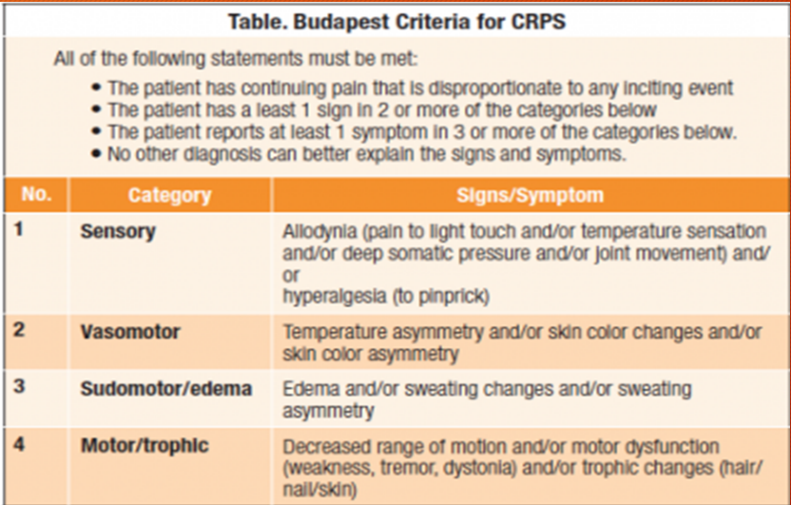
So how do we finally diagnose this condition of CRPS? Well, we wish there would be telltale signs of how to do this, but there aren’t, so it’s diagnosed solely on the clinical signs and symptoms presented by the individual. We’ll get into some further testing you could perform that might help further diagnose a condition, but initially, it’s the clinical signs and symptoms. So, in 1994, the International Association for the Study of Pain adopted a term of CRPS and defined them as diagnosis by establishing specific descriptive criteria. These diagnostic criteria were established and developed and were identified by the term Budapest Criteria in 2004. They’re still utilized in diagnosing CRPS today.

Let’s now take a look at the Budapest Criteria for CRPS. Let’s look at the categories first, and this will just be a review for you as we’ve discussed this already. But when you’re referring to sensory, you have the terms allodynia, which could be an exaggerated response to a light feather over the skin or blowing air over the skin, temperature sensations, deep somatic pressure, joint movement, and hyperalgesia to a pinprick. You’re very, very sensitive to something like that, an over exaggeration. You have vasomotor changes. That refers to the vasoconstriction and vasodilation, which is going to produce an asymmetrical look of the limb. For instance, in vasoconstriction, you’ll see more of a cyanotic or a blue. Vasodilation, you’ll see more of a hyperemic look or a very red, irritable limb. Or you could have, as I mentioned before, when you’re discussing mottling of the skin, you’ll see a purple blotching of the skin. Sudomotor changes, and sudomotor refers to sweating, the sweating of the limb. For instance, hyperhidrosis is a condition where you have excessive sweating of the skin, or the opposite would be hypohidrosis where you’re unable to sweat on the skin. You could also have edema, and it’s very, very prominent in this condition, and we’ll discuss this when we get into the pathophysiological changes that happen in this condition. And finally, the motor or trophic changes. Decreased ranges of motion and/or motor dysfunction, so you could have a lack of range of motion. Remember we discussed it could be due to the painful condition of the joint, or it could be due to an inability to move the joint as a result of the condition. You could have dystonia, and dystonia refers to the movements of the gentleman that I showed you a picture of before. And you could have trophic changes in your hair or skin. I mentioned trophic changes in the nails being brittle and the like, but you can also have blotchy hair, alopecia in parts of the limb. Or you could have hair growth, excessive hair growth, or blotching hair growth where it grows in patches.

Well, I wanted to thank you for joining me in my first installment of this presentation of Complex Regional Pain Syndrome. Although we’ve defined and described the types of CRPS, we’ve just touched the surface of our understanding of this condition. The next time, we’ll take an in-depth look into the latest research in understanding the multiple pathophysiologic mechanisms of CRPS. So, until then, thanks for joining me.

