“UNDERSTANDING COMPLEX REGIONAL PAIN SYNDROME”

by

CHRIS A. RAPOFF DC, QME

SESSION 2

Hello, and welcome back to the second of our four-part series exploring the devastating condition known as Complex Regional Pain Syndrome. I’m Dr. Chris Rapoff, and today we’re going to discuss the most researched mechanism of pathophysiology of CRPS. But first, let’s review what we’ve covered so far.

DEFINITION

C
RPS is defined as “a rare and often debilitating disorder characterized by severe pain affecting one or more limbs.”


The cause is an inciting event that is usually brought about by trauma, such as a fracture, a surgery, a surgery outcome, a sprain, or something as simple as a contusion. Also keep in mind that approximately 10% of the cases, the precipitating cause is unknown.

Signs and symptoms of this condition can include allodynia (an unusual or pathological sensitivity of the skin), hyperesthesia (a burning and pain which is disproportionate in its intensity to the inciting event), autonomic dysregulation where you have changes in skin temperature and color. These are known as the vasomotor changes. You can have hyperhidrosis, which is an excessive sweating of the involved limb, and these are known as the sudomotor changes. Edema, a very striking symptom of this affected limb. And you can also find trophic changes affecting the skin, nails, and hair. And finally, motor abnormalities, such as joint stiffness, reduced ranges of motion of the affected limb, tremors, dystonia, and muscle weakness.

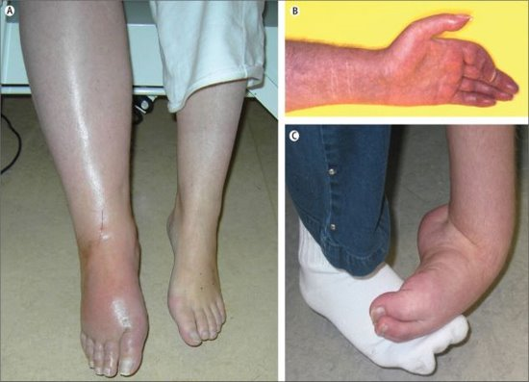
Now, if you take a look at the figures on the right, you’ll see we have A, B, and C. Can you pick out what we have? First of all, in Figure A, this is acute CRPS where you have hyperemia, swelling, and a glossy-looking skin. Figure B is CRPS in the chronic stage: Cold, blue, cyanotic discoloration of the fingers; glossy skin; increased hair and nail growth. And finally, C where we have CRPS related to dystonia of the left ankle and foot. In addition, we have plantar flexion and inversion of the ankle and flexion of the toes, edema, and increased hair growth are also visible. As we learn, CRPS is rated also overall on a scale of 46 to 50 on the McGill Pain Scale. This even rates higher than the phantom limb pain, unprepared childbirth, amputation of a digit, or even trigeminal neuralgia.

TYPES AND INCIDENCES OF CRPS IN THE POPULATION

T
here are two types of CRPS for the purposes of our discussion. There is actually a third type, but it is extremely rare, in <1% of the population, so we won’t be discussing that.

- CRPS Type I occurs generally in approximately 90% of the cases and presents with a condition that does not involve a nerve lesion at the periphery.
- CRPS II occurs in about 10% of the cases, and it does involve a nerve lesion at the periphery.
- CRPS also occurs approximately 3 to 4 times more frequently in females and mostly in the age range of 40 to 70 years of age.
- The upper limb is more affected in approximately 60% of the cases.
- CRPS can resolve within a year after onset, but it also can linger and become chronic and sometimes irreversible in a small percentage of case.

DIAGNOSIS OF CRPS

D
iagnosing CRPS is based solely on the signs and symptoms and based on the Budapest Criteria that was established and still used in the medical community today; however, later in this series, we’ll discover what the criteria in AMA Guides Fifth Edition uses for the basis of providing an impairment rating for an individual that we may seen in a future QME examination.

PATHOPHYSIOLOGY OF CRPS

C
RPS is one of the more challenging chronic pain conditions that you could treat successfully, and as a result, there is really no definitive medical treatment. Clinical trials have failed to support the efficacy of many commonly used interventions. You may ask “Why. Well, how could this be?”

Well the answer lies in the fact that although multiple attempts have been made to reduce CRPS to a single pathophysiologic mechanism, it’s been increasingly accepted that there are multiple mechanisms involved. This is where they get the term “multifactorial.” Only in the past few years has it been recognized that CRPS is not simply a sympathetically mediated peripheral pain condition, but rather, it is a disease of the central nervous system as well. Today I’ll touch on the most understood pathways of the pathophysiologic mechanism of CRPS, and later in this series, I’ll summarize the current findings regarding additional CRPS mechanisms that are the most widely accepted and documented in the literature.

MECHANISM OF CRPS

L
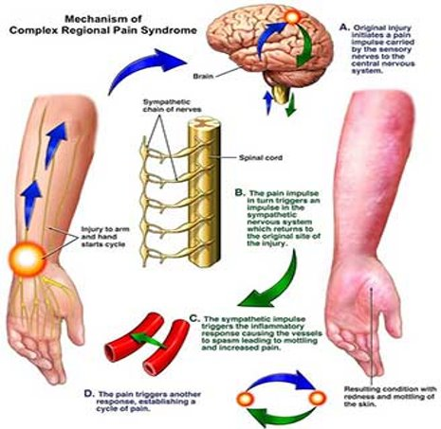
et’s begin with a simplified illustration of the mechanism of CRPS before we dive into it in a more distinct manner. First of all, you have an injury to the arm or hand that begins the cycle, say on the left side. And then the original injury initiates a pain impulse and it’s carried by the sensory nerves to the CNS. The pain impulse in turn will then trigger an impulse in the sympathetic nervous system, which returns to the original site of the injury. So this sympathetic impulse then will trigger an inflammatory response causing the vessels to spasm, leading to mottling and increasing pain - as you see in the diagram on the right. And finally, the pain triggers another response, establishing a cycle of pain, and this is the vicious cycle of CRPS.

CELLULAR MECHANISMS

L
et’s take a dive into this condition at a cellular level. So what happens at a cellular level after the initial trauma? Well, first the inciting trauma of CRPS is usually responsible for the inflammation, and this immune response triggers the keratinocytes, which are the dominant cells of the epidermis of the skin. They’re essential for skin repair. So these keratinocytes produce the inflammatory cytokines. These are going to be very important as we move forward. And these cytokines are 1) interleukins, 2) chemokines, 3) interferons, and 4) tumor necrosis factors. These cytokines then activate the osteoblasts and osteoclasts resulting in less bone density, and also, sensitization of the peripheral nociceptors. This is important when we look for diagnostic imaging to aid in our diagnosing of CRPS in an individual. This decrease in bone density. And, sensitization of the peripheral nociceptors produces a lower pain threshold for the individual as well.

IMMUNE RESPONSE IN CRPS

N
ow let’s discuss this with the aid of an in-depth view of the pathophysiologic mechanism of CRPS. So the immune response is driven by the central nervous system. We do know that. Let’s begin at the area of trauma with the letter A in the bottom left of the diagram.

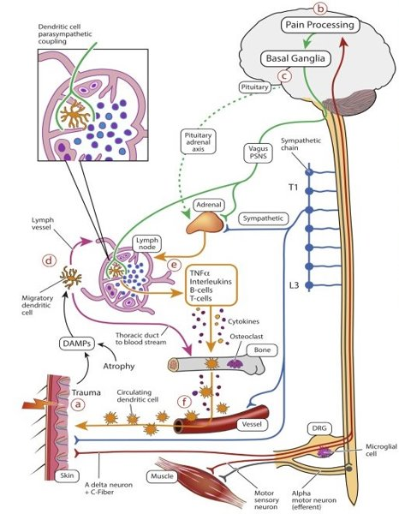
So first, the initial trauma results in nociception, and you may recall which is the detection of a painful stimulus, with activation of the mechanical receptors at the site of the trauma. This is relayed by the efferent fibers A delta and C fibers, which we will discuss in more detail shortly. These A and C fibers are relayed to the dorsal root ganglia in the brain and to the dorsal horn of the spinal cord in a very segmental manner. The pain signals are then sent to the brain for further processing, which brings us to B, top part of your screen. The pathological pain processing at the cortical and subcortical regions of the brain occurs in CRPS. Now we move into C. The reconciliation of pain processing with the basal ganglia outputs to autonomic, endocrine, and motor function, and that’s at the center of the diagram, moving us to D. We have the trauma and atrophy-releasing DAMPs, the damage-associated molecular proteins, which are captured by the dendritic cells and then migrate to the regional lymph node. We see this in the left side of the diagram. A small number of the dendritic cells will pass through the thoracic duct and into the bloodstream. So now we’re into E, which is the very center of the diagram.

Normally, the dendritic cells in the lymph nodes are held in a state of immune tolerance by innervation of the ANS, the autonomic nervous system, particularly the parasympathetic nervous system, which modulates the immune cell function via the cholinergic, anti-inflammatory pathway. This autonomic imbalance results in a transition from the immune tolerance to an adaptive immune response and immune cascade in which the T-cells and the B-cells are activated and the dendritic cells and macrophages release inflammatory cytokines we discussed before; tumor necrosis factor, interleukin. This initiates a regional immune response with the activation of osteoclasts and monocytes and colony expansion of the immune cells that results in further secondary injury. So there’s your cycle. All right. So that was a piece of cake. That’s why I mention that this research into CRPS is really in its formative stages due to the complexity of this condition. Moving on.

Let’s take a look at this now from a more macro level. We’re going to be examining the anatomy of the skin with the focus on the ANS and the innervated organs as you can see in the diagram on the right-hand side.

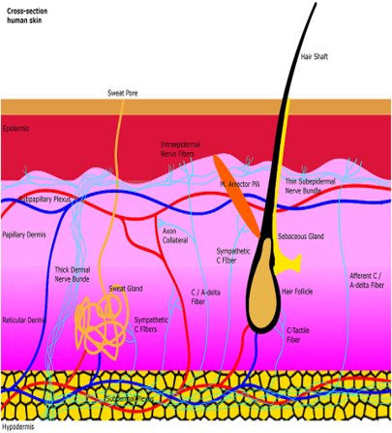
So we have the sweat glands, the blood vessels, and the arrector pili muscles are all innervated by sympathetic C fibers in the dermis. Afferent epidermal C and A delta nerve fibers are found in the epidermis as free nerve endings. We’ll discuss these again in a bit. The axon collaterals of these afferent fibers also supply blood vessels with efferent antidromic control. Now, just to review, antidromic refers to nerve flow that is the opposite direction to that of which is normal in a nerve fiber. So then small sensory fibers branch off from thicker dermal nerve bundles to create thinner subepidermal nerve bundles that innervate the epidermis. Now let’s take a looks at these A and C fibers more in depth so that we can get a better understanding of their function in this pathological, physiological process.

NOCICEPTIVE NERVE FIBERS

N
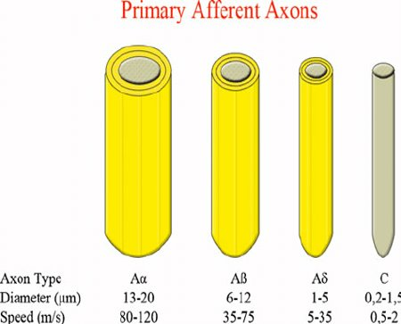
ow here we have the types of nociceptive fibers that are the body’s response to CRPS. As you recall, the nociceptors are sensory receptors that detect signals from damaged tissue or the threat of damage.

Now here you see alpha-A fibers. They’re the thickest in diameter and the fastest conduction speed. They’re followed by the A-beta and the A-delta fibers. It also should be noted that these A fibers are all myelinated, hence the faster conduction speed.

Then we have the un-myelinated C fibers whose conduction speed is the slowest. As you can see as well, the thickness of these fibers is directly related to their speed of impulse conductivity.

Let’s now discuss these nociceptor fibers in more detail.

- Alpha A: First we have the alpha-A fibers. These are myelinated fibers. They’re also the primary receptors of the muscle spindle and the Golgi tendon organs in the skin. They carry the fastest sensory conductivity, and they convey information related to proprioception or muscle sense.
- Alpha Beta: Then we have the A-beta fibers. They’re also myelinated. They’re intermediate size, and they carry fast sensory conductivity as well. They also act as secondary receptors of the muscle spindle and contribute to cutaneous mechanoreceptors, and they also mediate sensations of touch, mild pressure, vibration, and joint positioning sensations.

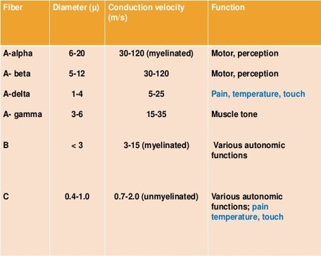
- Alpha Delta: Next we have the A-delta fibers. Again, these are myelinated and smaller, with moderate sensory conductivity speed. They’re free nerve endings that conduct painful stimuli related to cold, pressure, and acute pain signals. This is where they’re very important in CRPS. The delta-A fiber’s action is to produce a sensation of sharp, localized, fast pain. These fibers also release glutamate, which is a pain transmitter in the brain.
- C: And finally, the C fibers. They’re unmyelinated, afferent fibers, and as a result of being unmyelinated, they are the smallest in diameter and have the slowest sensory conductivity speed of these pain fibers. They convey input signals from the periphery to the CNS. The C fibers are also important as they respond to thermal, mechanical, and chemical stimuli. They also produce a sensation of a dull, diffuse, aching, burning, delayed pain, and sometimes itching as contrasted to the A-delta fibers, which was fast pain and sharp pain. Finally, these C fibers also release neuropeptides, such as P substance. Now, going back to physiology again, the P-substance promotes the inflammatory immune responses of the resident CNS cells. So this neuropeptide, P-substance, plays a major role in the mechanism of CRPS. Let’s see where this fits into the cycle.

RESEARCH IN MICE MODELS

B
efore we continue, I just wanted to mention that the research that I’m going to be providing you in this slide was initially witnessed in mice models. This is further evidence that the research into the condition in CRPS is constantly evolving and growing.

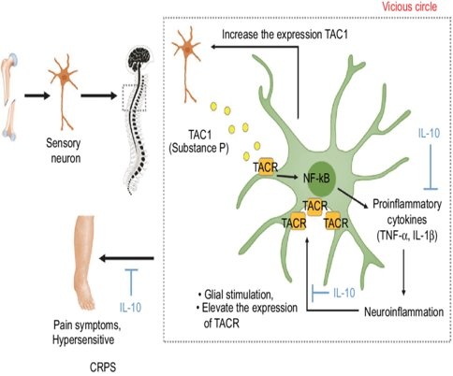
So if you start at the left area of this diagram where you see the initial trauma or the inciting event of a broken femur. Now, substance-P is important in this cascade of events as substance-P mediates or facilitates the exacerbation of neuroinflammation, causing central sensitization of the CRPS mouse model. To review, the central sensitization is a hypersensitivity to stimuli from things that are not typically painful. Now the actions of substance-P are mainly mediated by the neurokinin-1 receptor and coded by the tachykinin receptor 1 gene. Now, substance-P is then mediated or facilitated by the sensory neurons due to the peripheral nociceptive stimuli of the proinflammatory cytokines that we’ve discussed prior, such as tumor necrosis factor alpha, interleukin-1β , and interleukin 6. These are the proinflammatory cytokines that we touched on in our first installment of this series. These proinflammatory cytokines increased by substance-P also exacerbate the neuroinflammation by increasing the expression of neurokinin-1 receptor in the glial cells. And if you recall, the glial cells are the supporting cells in the central nervous system. And this can elevate the local production of substance-P, and this creates the cycle.

Before I continue on the pathophysiology, I wanted to mention that in the next installment of this series, I’ll be discussing the acute and chronic stages of this condition at a macro level.

But finishing the pathophysiologic, cellular level we want to discuss here, I wanted to mention that the P-substance in the acute stage activates the mast cells that release chemicals. So these chemicals that the mast cells release are histamine and serotonins. So as you see, we’re starting to get an inflammatory response due to the P-substance, and these are associated with the acute-phase symptoms, which makes sense. The edema, the red skin coloring, the warmth or hair growth. Now, in the chronic stage, the symptoms that could be present for months, the pro-inflammatory factors are still present, but the presence of the interleukins and the tumor necrosis factor receptors is different than in the acute stage. So they’re there, but they react differently. Now you see where this is leading? This positive feedback loop would be anticipated to sensitize the glia to this neural peptide and thereby exacerbating and exaggerating central sensitization, the beginning of this vicious cycle of a chronic, un-relenting CRPS condition. And in addition, the neurologic or neurogenic inflammation is also reported with CNS changes. And you may recall that the neurogenic inflammation is a physiological process by which the mediators or facilitators are released directly from the cutaneous nerves to initiate the inflammatory reaction. This results in the production of local inflammatory responses, such as erythema, swelling, temperature increase, tenderness, and pain. Then at the spinal level, the sustained neuropeptide signaling and inflammatory mediators induce a persistent central sensitization that could contribute to the chronicity of the pain symptom. Again, we’re getting into the chronicity because of this constant vicious cycle that this has produced with the substance-P.

CONCLUSION

W
ow, piece a cake, right? Yes, I have to admit, today’s presentation was pretty involved, but it really does just illustrate what a nasty condition this is, and frankly, the research that researchers are trying to perform on CRPS is ongoing, and really is in its infantile stage. However, in a later installment, I will briefly touch on some additional mechanisms with pathophysiology that research is uncovering as scientists try to unravel this condition as it goes.

So in the next Program, we’ll discuss “The Three Stages of CRPS.” We’ll discuss each stage distinctly and also some - although very limited - testing and treating options for the physician as they exist today.

So until next time, thank you for taking the time to join me, and I look forward to seeing you at our next installment of “Understanding Chronic Regional Pain Syndrome.” Thank you.

