“UNDERSTANDING COMPLEX REGIONAL PAIN SYNDROME”

by

CHRIS A. RAPOFF DC, QME

SESSION 3

H
ello again, and welcome back to the third of a four-part series exploring the devastating condition known as Complex Regional Pain Syndrome. I’m Dr. Chris Rapoff, and today we’re going to discuss three stages of CRPS and their characteristics. We’ll take a look at establishing a method of a differential diagnosis when you try to examine an individual that you may suspect that has CRPS. Remember, there are no real tests that are pathognomonic for CRPS, but instead, you go through a process of elimination and we will be ruling out other conditions with similar signs and symptoms. We’ll also cover the testing options available to aid you in your diagnostic decision making and then finally, limited treatment options available to the physician to help with the individual’s symptoms. But first, let’s review the mechanism and one of the most accepted pathophysiologic mechanisms of CRPS.

First we have the inciting trauma that triggers the inflammatory and immune response in the body. This in turn will then cause the cells to produce the inflammatory cytokines, such as interleukins, the tumor necrosis factor, and the chemokines that will then activate the osteoclasts and a sensitization of the peripheral nociceptors by the substance P production. This action takes place thanks to the afferent A and C nerve fibers. They relay the nociceptive impulses to the dorsal root ganglion and the spinal cord and then into the brain. Once in the brain, then the pain impulse is processed, and it sends out an autonomic endocrine and/or a motor function response, and these are the exaggerated responses we see. While this is happening, the cells at the trauma site release DAMPS, the damage-associated molecular proteins, which then migrate to the regional lymph nodes. This produces an autonomic imbalance at this point, and it results in a transition from just an immune tolerance to actually an exaggerated immune response in which the T cells and the B cells are activated. They then will release the inflammatory cytokines as well that results in further secondary injury and creates a non-relenting cycle of the pain. So today we’ll build on that knowledge to become better diagnosticians when it comes to understanding this condition.

W
e have the first stage of CRPS, and this is obviously called the acute state. The acute state can last up to three to six months and generally will form or will happen very immediately after an injury or an insult. The first symptom you would have in the skin would be hyperthermia, so you’re going to have heat production. That heat production is due to the vasodilation that was caused by the histaminic response and the serotonin that we had discussed before. The skin also appears very dry and shiny. The distribution of the pain, severe pain that can be actually more severe than it should be, the pain feeling. You’ll have burning and/or an aching of the area or the limb involved. The physical condition or emotional disturbances are possible, so this can actually cause more physical symptoms and also, emotionally, it can start to wear on the individual. It is not compatible with a single nerve injury, and that’s what we discussed in CRPS I versus II. CRPS II is a peripheral nerve and it’s non-anatomic, so there isn’t a dermatomal pattern to this type of pain.

The sympathetic response, we will get the vasomotor action, which is the altered color and temperature, and in this case, we’re going to have vasodilation as a result. And sudomotor responses, which would be the hyperhidrosis or the excessive sweating of the involved limb. Trophic changes can also occur where you would have excessive nail growth and/or blotchy, excessive hair growth. And finally, edema. Edema in this situation and in this phase is soft and localized. It has not become chronic, so you’re not going to have the hard surface that you would see in a chronic condition.

You also have motor disturbances in the acute phase, and you will have decreased ranges of motion and weakness of the involved limb. X-rays at this point, since it is an acute phase, they will be normal, and we’re going to take a look at some x-rays and some bone scans here shortly. Bone scan now, you’re going to notice an increase uptake in the bone scan. That’s the triphasic bone scans that they perform. And I had mentioned in the previous slide, we have trophic changes. You can have increased hair and nail growth.

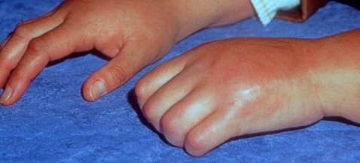
This is an example of the acute stage of a person suffering from CRPS of the left hand. As you see, the hand is swollen. It’s hyperthermic, no doubt. You can see it’s red, so it’s hyperemic as well, and that’s due to the vasodilation in this phase. You can also see that the fingers are swollen and edematous, so therefore, you’re going to have probably a lack of range of motion of these joints of the fingers and actually of the hand and the wrist.

M
oving into Stage 2 of CRPS, this is called the dystrophic phase. The first phase was called the acute phase; this is dystrophic. This is three to six months after an injury, so the first stage can last three to six months. The second stage, the dystrophic stage, can last three to six months as well. So we’re getting into a very chronic condition as we speak. You can also start to see wasting of the limb possibly due to atrophy, lack of motion, lack of muscle sensitivity and also muscle control. And this is the vasoconstricted stage. You have vasoconstriction here whereas in the acute stage we had vasodilation. So with that said, the skin is going to appear very thin, glossy, very shiny, cool due to vasoconstriction versus the acuteness being vasodilated and very warm, but you also will have a sweaty condition, the hyperhidrosis in this level. The distribution, the pain is going to worsen at this point. Now we said it was severe in the acute stage; it feels even worse in the next stage of the dystrophic stage. The pain is constant, and again, you continue to have the burning and the aching. You have hyperalgesia, so you’re experiencing a lot more of this discomfort. Allodynia, where, as we had talked, that something as simple as a feather can cause an excessive response, an exaggerated response, and hyperpathia, which things start to snowball in this case and these effects are starting to accumulate and pile up. The sympathetic responses again, the vasomotor. This time it’s variable in its intensity and it’s not as exact as the acute stage. This time you can have altered color and temperature. You can have the mottling of the skin as it looks marbly as we had discussed before and possibly purplish looking. And again, sudomotor response, the hyperhidrosis.

S
tage 2 also, when you talk about the edema, this time, instead of being soft, it’s hard, so we’re in a chronic situation. It is very vasoconstricted; however, the edema is within the joint and within the limb. This will cause a lot of joint stiffness. Then this, in turn, produces lack of mobility, increasing joint stiffness, so this is a cycle as well that starts. In the motor, you do have the decreased ranges of motion and weakness as we did in the acute stage. X-rays now, this could be up to a year at this point. You’re now going to see some possible osteoporosis, some subchondral bone erosion, osteopenia in certain bones of the involved limb, and we’ll see these in a bit. Bone scan, again, in the triphasic bone scan you’re going to have an increase in uptake, and again, the trophic changes, as we said before, increased hair and nail growth happen here as well.

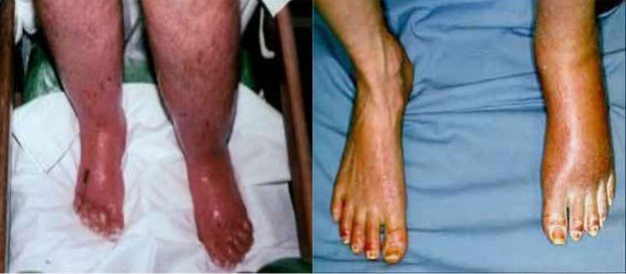
Now looking at some pictures that can help us understand more clearly. As you can see, Stage 2, you do have the purple-looking skin, the mottling of the skin a bit. You see how shiny it is on the left and the right. You see hyperhidrosis. You see excessive sweating there. Take a look at the toenails on the individual on the right. Their left foot, the toenails are a lot longer than the other foot as well. So as you can see, these symptoms don’t really go away as time goes on as you would think as a condition is resolving. And in essence, this condition is just getting revved up.

I
n the final stage, Stage 3 of CRPS, they call this the atrophy or atrophic stage. So originally we had the acute. The second stage was called dystrophic, and the third stage is atrophic. Can begin 6 to 12 months after the onset of pain. So we’re looking at a situation where this could begin a year or even longer after the original inciting injury. And this also, the bad thing about this condition is that it can last for many years, may resolve and disappear, but also it can be irreversible. So this is the bad part of this disease or this affliction. If you take a look at the skin, the skin now is still thin, very shiny, but instead of being hyperemic, it is now cyanotic, so you’re seeing a bluish discoloration due to the longstanding second stage of vasoconstriction. The skin is also dry, so we’re no longer seeing the hyperhidrosis in this case. The distribution of pain usually will spread proximally and sometimes it can actually involve the entire body. This is something that they are doing a lot of research on because they are not understanding this. It’s almost as if your body is attacking itself in autoimmune situation, but they’re continuing to do a lot more research on this. And edema, you’re getting a hardening of the skin as we discussed in the second stage as well. So the hardening, the cyanotic, sympathetic aspect of vasomotor at this point, the extremity is cold, blue, mottled versus very warm, hot, hyperhidrotic.

Again, the edema is very hard just due to the chronicity and the longstanding fluid that is in the involved limb. Again, it causes joint stiffness. This joint stiffness will then cause a person not to use that extremity as much, so then you can start developing situations of atrophy or muscle contracture, things like that. Now the motor symptoms, basically you have the decreased range of motion and weakness, and we discussed that in the acute and in the chronic stage. X-rays, you’ll see osteoporosis again. You can see osteopenia and subchondral bone erosion. So things are moving forward there. Bone scan, again, increased uptake in the triphasic bone scan. And here, the trophic phases change again. So you can have increased hair and nail growth a little bit different than in the chronic stage.

L
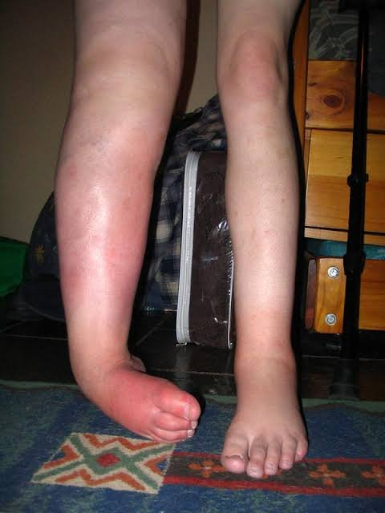
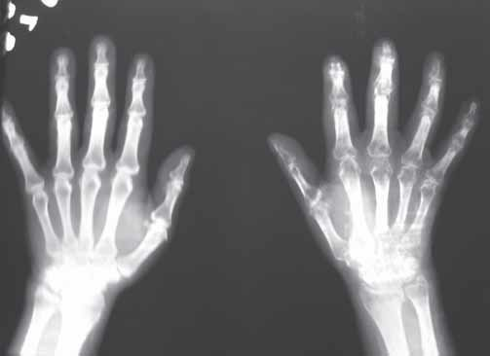
et’s take a look at a couple of examples of CRPS. First off, on the left side you have an x-ray of an individual’s hands. As you can see, the right hand is much more osteoporotic and actually osteopenic than the left hand, and you can see those in the phalanges, in the distal phalanges, the proximal phalanges, and you can actually see this in the carpal bones of the right hand we well. Moving even more proximal, you can see that in the radius and the ulna on the right as compared to the left. So the bone demineralization begins here. On the right side, you have very angry-looking right lower extremity of this individual. You see dystonia, which is the contraction and the movements of a limb. You see the plantar flexion and the flexion of the ankle and the flexion of the digits of the right foot as well. Little difficult to see, but the toe nails are actually a little bit longer, and you can see the discoloration in this body part.

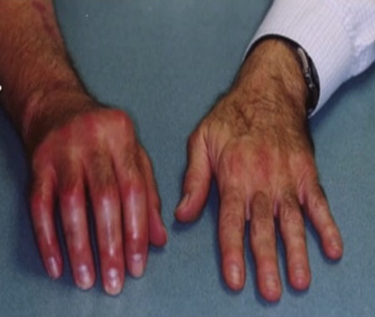
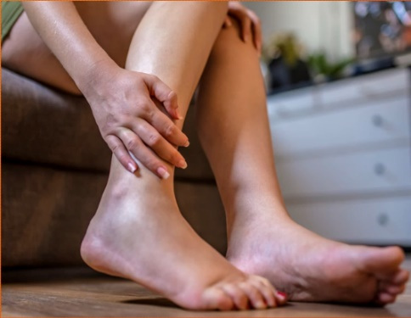
Again, a couple more examples. The lady on the left versus the man on the right, there are very distinct differences in the presentation of this symptom. As you see on the left-hand side, this individual, their condition is a lot less aggravated. You do see some edema in the top of the foot, on the dorsum of the foot, into the ankle of the right foot. You do see some changes in the color, a little hyperemic, and I’m sure it’s going to be a little hyperthermic because of the inflammation as compared to the person on the right. This gentleman, as you can see, has a very, very angry right upper extremity. You can see his hand is very hyperemic, very swollen, the blotchiness of the hair and the trophic changes in the nails, and so you’re going to have a condition that’s going to be very painful on this individual here in the hand versus the one on the right. So what I’m trying to impress upon you here is there are different presentations and every person acts differently. It’s how their body reacts this affliction.

A
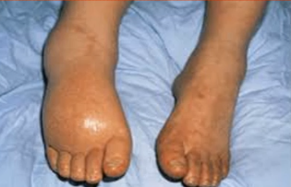
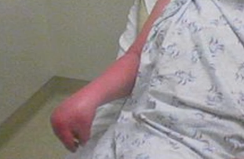
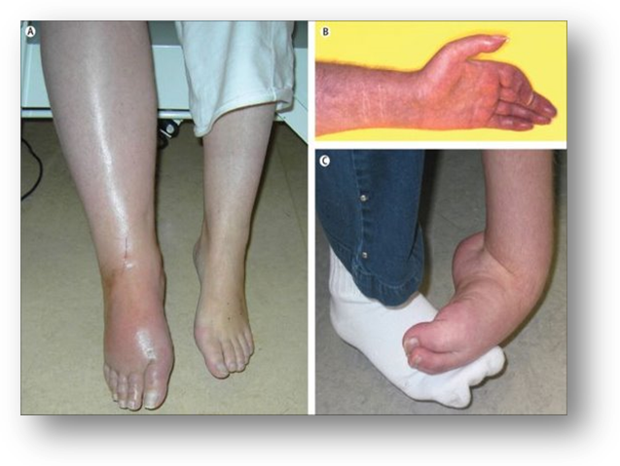
nother look. We wanted to take another look at this figure we did see in the last installment, but I wanted to bring it up again to impress upon you. On the left-hand side, you see Figure A. We have acute CRPS. You see the hyperemia. You see swelling and the glossy skin. And here in Figure B we have the chronic stage, the cold, blue, cyanotic discoloration of the fingers. We have glossy skin, increased hair and nail growth. And finally, see, CRPS-related dystonia. Left ankle and the foot, the plantar flexion, the inversion of the ankle, the flexion of the toes, edema, increased hair growth are all visible. If we take a look at the individual on the right, we have a flexion contracture of the right arm, right upper extremity, and as you see the atrophy, the pretty, pretty involved atrophy here where you have the contractures, possibly dystonia, but you see the discoloration, the red. And then finally, below you have the right foot, the dorsum of the foot is very swollen, very shiny and hyperemic.

Now let’s take a look at how we could differentiate this condition from other conditions that we know and we see more often in our practice and situation. So performing a differential diagnosis, first the risk of over diagnosing CRPS should be taken into account because many of these symptoms will look like CRPS and they are not that condition, and I’m going to give you some examples. So really, a detailed history and a physical as well as many of the specifications and tests that we’re going to talk about are necessary to differentiate CRPS from the other neuropathic and pain syndromes. So first of all, let’s talk about the neuropathies. For instance, diabetic neuropathy. This may also present with spontaneous pain. Skin color changes could happen. Motor deficits. They’re distinguished from CRPS by the patient’s history and the symmetrical distribution, whereas CRPS is not a symmetrical distribution, so there is the determining factor there. Furthermore, all kinds of inflammatory and rheumatological and infectious conditions might cause intense unilateral skin warming. Unilateral arterial or venous diseases or occlusive diseases can cause unilateral pain and vascular abnormalities as well. So again, something to consider. For instance, Lyme disease. That’s an infection, but you can get the same or very similar symptoms. You can have an entrapment syndrome. Carpal tunnel or cubital tunnel, thoracic outlet syndrome. So these can also mimic some of the unilateral extremity problems that occur in those as well. Vasculitis – inflammation of the blood vessels can be something you’re going to have to consider. Toxicity – possible food or toxic poisoning or alcohol toxicity or the autoimmune disease Guillain-Barré syndrome where the actual body will attack its own nerve cells. So these are all things to take into consideration just in neuropathy. Now let’s move on to posttraumatic neuralgia. Many patients with posttraumatic neuralgia or neuropathy have pain but not the full clinical profile of CRPS Type II for instance. In these cases, the pain is located largely in the territory of the involved nerve, but it contrasts with patients in CRPS Type II. Although patients with neuropathy often describe the pain as burning, they exhibit or they have less of a complex clinical picture than patients with CRPS Type II, and they don’t show the marked swelling or the progressive spread of symptoms. Now the principal symptoms of posttraumatic neuropathy are spontaneous burning pain, hyperalgesia, and mechanical allodynia. So here we go. These are very similar. These sensory symptoms are confined to the territory though of the affected peripheral nerve, although allodynia may extend beyond the nerve’s territory border where the pain is felt superficially. So the patients with posttraumatic neuralgia or neuropathy usually obtain relief with procedures that inhibit the transition of the nerve impulse. Those are called the sympatholytic procedures, and we’ll talk about them in a bit.

A
dditionally, we have some other considerations like the central nervous system. We need to talk about possibly something in the brain. For example, a stroke affecting one limb, neoplasms, encephalitis. The spinal cord, we can have situations that are a traumatic event to the spine, transverse myelitis, or even syringomyelia. Tabes dorsalis, another example, and that’s the complication due to untreated syphilis, is neurosyphilis. That involves muscle weakness and abnormal sensations as well. Additionally, multiple sclerosis to consider. Now it’s not as obvious, but poliomyelitis is something you would have to take into consideration performing a differential diagnosis. How about radiculopathies? This is something that we see quite often. This could be an impingement of a disc producing a symptom of that limb, an osteophyte possibly, a tumor-related situation. Maybe a cyst impinging on the spinal cord or the segments of the spinal cord. I’ve seen [that in the 23:01] cyst impinging on a spinal cord in 6 separate occasions in my chiropractic practice over the past 10 years, so it’s not absolutely something that you wouldn’t think would happen or could happen. Also the radiculopathies could be as a result of diabetes, not necessarily nerve impingement. And then, finally, neoplasms would be a consideration as well.

Additional considerations are vascular disorders, such as Raynaud’s phenomenon. If you recall, that’s a disease that’s characterized by spasm of the arteries of an extremity, especially the fingers. So that’s a situation you really need to take a close look at. Peripheral or atherosclerotic disease or PAD. That’s characterized by narrowing or a blockage of the arteries from the heart to the lower extremities. Consideration there. Or arterial insufficiency even, AKA lower limb ischemia. Chronic obstructive disease in the aorta below the outlet of the renal arteries. So you can see that a number of these could possibly mimic that look. Then we have psychological considerations, hysteria, and basically that’s just an extreme emotional excitement or upset. Somatoform disorder causes one or more bodily symptoms, including pain, as somatoform disorder does. So again, it can mimic this. And malingering. Very difficult to malinger in this situation, but complaints of allodynia, you can understand anything that would be a subjective complaint you’d need to consider that as well. So this may seem like an exhausting list when you perform the differential diagnosis, but there are many, many more conditions that take on the characteristics of CRPS, so you’re going to have to consider as much as you can.

N
ow as I continue to remind you, since there are no specific diagnostic tests to confirm CRPS, basically we’re stuck with the exclusion options. And some of the exclusion options include – first I guess we start with the blood work and the labs. You can order a CBC, an ESR (erythrocyte sedimentation rate), or a C-reactive protein. And frankly, those are all – and you would be able to see if there’s inflammation, an increase in the white blood cells and also just those markers of the ESR and CRP. They’re not going to confirm CRPS, but you rule out the possibility of infections, rheumatologic causes, and the like. Another diagnostic tool available is ultrasonography. This could identify the myofascial structure lesions and can help us identify neuropathic pain from CRPS, so there would be a differential diagnosis there. Next we have ultrasound. It’s not a typical tool to diagnose CRPS, but you can rule out PAD, which we discussed earlier. Several imaging tests can be used to diagnose PAD, like vascular ultrasound that uses the sound waves to create pictures of the arteries and locate the blockage. A Doppler ultrasound basically to help detect areas of restricted blood flow through an artery.

EMG (electromyographic studies) can be useful in patients with the Type II CRPS. So the EMG would show changes that are consistent with nerve injury. An important distinction between the Type II CRPS, if you recall, involves the peripheral nerve, but peripheral neuropathy is at the Type II CRPS, the somatosensory symptoms extend beyond the distribution of the affected peripheral nerve, not just at the nerve innervation. So this is more of non-anatomic presentation of pain whereas a mono-peripheral neuropathy affects just that, one peripheral nerve. We have an NCV or a nerve conduction velocity test. We know that tells us the health of the peripheral nerves by testing the speed of the signals through the nerve, but it’s interesting that most recent Dutch treatment guidelines state that NCV is important [for 27:53] closing in on a diagnosis between CRPS Types I and II. And according to the Rommel study, 16 of the 35 CRPS patients were found to have impaired nerve conduction. And in their research, then they concluded that nerve conduction values are about 20% above the norm than a peripheral nerve conduction of CRPS Type II must be assumed. So they’re saying if the values are 20% above the normal values for that conduction, then you’re to consider that could be a possibility of CRPS II. Now, I don’t know about you, but 16 out of 35 patients doesn’t sound like a great percentage of positives, but it just goes to show that there’s just so much more to learn and the research still doesn’t have a definitive or conclusive test that can diagnose this condition. So we’re stuck with ruling out phases of our differential diagnosis.

So we come to imaging studies as well. Now they can be instrumental in the diagnosis of CRPS because the osseous changes are very common in the affliction like we discussed earlier in the stages of CRPS as we explained. But as a result, most of the standard diagnostic test results used to support or to rule out clinical evidence for it is basically taking a look at the changes or lack of changes in the bones and the joints of the affected limb. So in CRPS, you can have diffuse osteoporosis and/or osteopenia within the skeleton of the limb involved. Taking a look at the x-rays that you see here, you have an individual on the left that has very spotty osteopenia within the phalanges of the hand and more obvious presentation of the proximal and distal metatarsals of the right foot in the x-ray on the right. An interesting note too is that you could see an individual with osteopenia or an osteoporotic condition in any of the limbs and they have a motor problem, number one, a sensory, number two, and an autonomic symptom problem. You have a condition that they note as being called the Morbus Sudeck, and that takes its name from a German surgeon, Paul Sudeck. He described this type of decalcification in x-rays way back in 1900. So you may just be thinking, “Well, why don’t they just call it the Paul Sudeck?” Well, you know how the medical community likes to name everything scientifically and steer clear of proper names. For instance, do you remember Lasègue's test? Now that is the straight leg raising test. They are trying to get rid of the proper names. But anyway, they tried to discover a more descriptive term, and they came up with the word morbus, which is defined as any impairment of normal physiological function affecting an organism. And especially, it [causes from a 31:12] specific pathological change. So they thought, “Oh, great, we’ll just go on and call this the Morbus Sudeck,” or they just say Sudeck’s atrophy for short. And today, Sudeck’s atrophy is synonymous with the term CRPS. So now that gets us back to our pathology classes years ago.
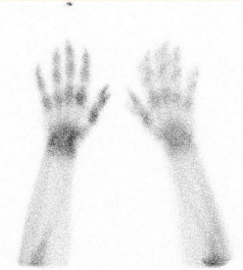
B
one scans can also help us in diagnosing our condition. So you have an individual here with CRPS of the right hand. You can see increased tracer uptake involving the entire right wrist, metacarpals and phalanges. But just as a point of reference, the dot that you see, that increased activity on the left, which is distal to the 3rd digit, that’s known as a hot marker, and that denotes the right side of the image. So this person is afflicted with a right condition.
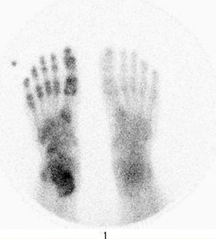
Take a look at the foot, we have CRPS of the foot, and this is a plantar view of the feet and it reveals an increased tracer uptake involving the lowermost right leg, ankle, the tarsals, metatarsals, and phalanges. And again, the dot that you see is another hot marker distal to the 5th toe, and that’s indicating the right side.

L
et’s now move on to discuss some of the limited treating options for CRPS. First we have chiropractic treatment and physical therapy modalities. This is the single most important treatment for CRPS because it just makes sense that keeping a painful limb or the body part moving improves the blood flow and lessens the circulatory symptoms and you maintain the flexibility and you try to retain strength and function that you may be otherwise losing. You’re also, with this, you’re increasing your range of motion of the limb, and that increases the function, reduces the disability through the endorphin release as well as other central peripheral analgesic mechanisms. Also rehabilitating the affected limbs helps prevent or even reverse secondary spinal cord and brain changes that can be associated with disuse and chronic pain. Occupational therapy also can help an individual. They develop alternative ways to become active and return to work and get into their daily activities or return to them. Some physical therapies include transcutaneous electrical nerve stimulator, the TENS unit. Very popular. Ultrasound, laser, pain education just to name a few. Even whirlpool baths or contrast baths.

W
e have some pharmaceutical options available to us, but due to our limited understanding of the pathophysiology of this affliction and the lack of consistent objective criteria for diagnosing, the clinical trials that demonstrate effective therapies are really difficult to perform. These studies that have been performed and reviewed provided very little consistent information that treating CRPS with medication is very effective. But with that said, I will touch on some of the most accepted pharmaceutical treatments with the best clinical outcomes so far. First we have corticosteroids. The clinical evidence has shown that their use in the early, acute stage of CRPS patients does give them a better outcome than in the later stages, so if you administer that in the early stages. Next we have calcitonin, which are calcium-regulating drugs. They have been demonstrated to significantly reduce pain in CRPS patients as well. We have opioids, have been effective for treatments of postoperative inflammation, cancer treatment-related pain, but there’s no real solid scientific evidence that it helps as a standalone drug approach here. They do feel that the opioids would be used as a comprehensive treatment program with other medications and other management options. We have NSAIDs. NSAIDs can be used to treat the mild to moderate pain. Moving into tricyclic antidepressants and serotonin reuptake inhibitors. If you remember when we were discussing the pathophysiological mechanisms in our last installment, the P substance (neuropeptides), activated the mast cells that release histamine and serotonin. And that’s associated with the acute-phase symptom. The thought here is to provide serotonin uptake inhibitor to reduce the production of serotonin. So they administer amitriptyline, a serotonin inhibitor. The problem is that the research indicates that it’s effectiveness in significantly treating this condition hasn’t really been realized, so here we just have another roadblock for effective treatment options. Although giving individuals gabapentin has been shown to be effective for other neuropathic pain conditions like diabetic neuropathy, postherpetic neuralgia, they find it to be only mildly beneficial for pain associated with CRPS. We have bisphosphonates. They’re a class of medication that is used routinely in the bone-related problems as it inhibits [osteoclastic 37:22] activity, so that would be very important. But if you recall the imaging we saw earlier in the slides that those individuals may have benefited from this type of medication. And finally, low doses of ketamine infusion have been shown to decrease pain in the patients with CRPS. Ketamine is known to block central sensitization by affecting an aspartate receptor which has been recently shown to be effective in CRPS. So as you can see by this slide, the list we have, basically there is not a whole lot that they found that can be effective treatment to date. This list by no means is the entire list of pharmaceutical treatments as well, but these are the most popular options so far. And you may have another pharmaceutical in mind to treat CRPS, but as we know, there is a drug to treat every condition known to man but if you [have even 38:27] considered one, chances are they’ve researched it and its role in treating CRPS going forward.

So moving into behavioral therapy, the research, they discovered that elevated levels of the catecholamines that are associated with depression can worsen in individuals with CRPS by inducing the central sensitization through adrenergic mechanisms. So the reversal of this effect is one of the proposed mechanisms of psychotherapy in CRPS. Again, just one cog in a wheel of many when we address this condition and try and define a comprehensive treatment that works for the individuals.

N
ow, finally we come to pain management as another treatment option for CRPS individuals. Aside from the pharmaceuticals that we’ve talked about, there are some additional interventions available for the treating physician. Now, just to review, since the sympathetic hyperactivity is believed to be the underlying pathophysiological mechanism, you would think, well, lumbar spinal sympathetic nerve blocks could be used in the treatment of the lower extremity symptoms and then the stellate ganglion sympathetic blocks would be used for management of upper extremity symptoms of this syndrome. So that’s a possibility. And spinal cord stimulation is another. This involves providing an electrical stimulation to the dorsal column of the spinal cord by placing the electrodes in the epidural space. There have been a number of mechanisms of action proposed by these spinal cord stimulations as well, but to name a few, the type of stimulation inhibiting the nociceptive receptor conduction in the cord are also inhibiting the adrenergic response of vasodilation. So that’s an approach you can take. And one more stimulation option is the DRG stimulation or the dorsal root ganglion. Here the electrodes will actually target the dorsal root ganglions instead of the spinal cord. It’s a much more focused approach than the spinal cord stimulation I just mentioned, but as you recall when we discussed the mechanism of CRPS, we know that the afferent A and C fibers relay their nociceptive pain impulses to the DRG and then to the dorsal horn of the spinal cord. Then the pain signals ascend to the brain for processing. Well this type of treatment attempts to forgo the action to the brain but instead addresses the pain fiber impulses at the DRG and not get to the brain. It’s been found to be more effective than spinal cord stimulation as well in reducing the pain and improving the quality of life for the individual.

On the last few slides, just to sum that up, we were discussing the management or how to manage an individual with CRPS, and as you can see, there’s no magic bullet that is available to us as a training physician. So it’s going to have to be part of a more comprehensive treatment program, including possibly pharmaceuticals, modalities, therapies, behavioral understanding as well.

S
o in the next program, we’re going to uncover how the AMA Guides Fifth Edition addresses this condition. We’ll discuss how to make a correct diagnosis according to the Guides and how to arrive at a correct impairment rating for an examinee and finally, some of the incongruities that the AMA Guides Fifth Edition reveals as we attempt to rate the examinee. Until next time, I’d like to thank you for taking the time to join me, and I look forward to seeing you in our next installment of Understanding Complex Regional Pain Syndrome.

/kj

