“UNDERSTANDING COMPLEX REGIONAL PAIN SYNDROME”

by

CHRIS A. RAPOFF DC, QME

SESSION 4

H
ello again, and welcome back to the last of our four-part series exploring the condition known as Complex Regional Pain Syndrome. I’m Dr. Chris Rapoff, and today we’re going to discuss CRPS and a QME examination as we discuss, step by step, the process of providing an impairment rating for an individual that may present to us in a QME exam. But first we need to examine the methods and the criteria that the Guides Fifth Edition asks us to consider when establishing the diagnosis of CRPS in an examinee. I’ll give you a hint: The Budapest Criteria that we discussed at length in prior installments is not even mentioned in the Guides Fifth Edition. We’ll also take a look at the not-so-easy method of providing a correct impairment rating as we’re asked to sometimes refer to three different chapters of the Guides when we consider the impairment. And finally, we’ll take a look at the curveballs that the Guides seem to throw at us when we go through this process. It may appear cut and dry to them, but it may not be that clear to you. So hopefully I can help you understand some of the rationale that the authors used as I try to provide you with some insight from one of the authors.

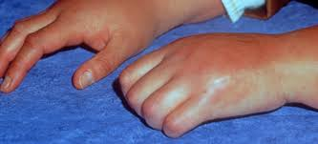But first, let’s briefly review what we learned in our last session. First we have the three stages of CRPS, and they are the acute stage, which occurs very shortly after an inciting incident and can last three to six months. It’s known also as the vasodilation stage, and it involves the presence of edema, hyperthermia, a type of pain that’s more severe than one would expect for the injury. In CRPS I, we have a non-peripheral nerve pattern. As you recall, CRPS I does not involve a specific peripheral nerve, whereas Type II does. We have vasomotor, sudomotor, and trophic changes as well. There are no changes in x-rays, but you’ll have a positive bone scan because of the periarticular accentuation due to the juxta-articular and soft tissue swelling. You’ll have osteoporosis possibly and erosions of the subchondral bone. Second, we have the dystrophic stage. Now this can occur three to six months after the acute stage, and it’s known as the vasoconstricted stage known for very hard edema, hypothermia or cool skin, wasting of the tissue, even more severe pain, and also vasomotor, sudomotor, and trophic changes. Additionally, you have increasing stiffness in the joints, less range of motion of the affected limb. So we begin to see osteoporosis and the subchondral bone erosion on x-ray and, again, a positive bone scan of the injured area. Now we move on to the final, third stage, which is the atrophic stage. This could occur 6 to 12 months after the injury and take even years to resolve, or in some cases, it can be irreversible. This stage presents with dry, thin, cyanotic skin. You can see mottling here as well. Even more severe pain can spread either proximally or distally to the injury in Type I and can become systemic and spread to the other limb as well. There are more sudomotor and possibly trophic changes. We can see atrophy of the affected limb, decreased range of motion, weakness, and even possibly dystonia of the limb. We can have bone demineralization, spotty osteoporosis, again, subchondral bone erosion, and Sudeck's atrophy. As you recall, the name defines the condition of a radiological evidence we just mentioned and additionally the trifecta: Motor, sensory, and autonomic changes.

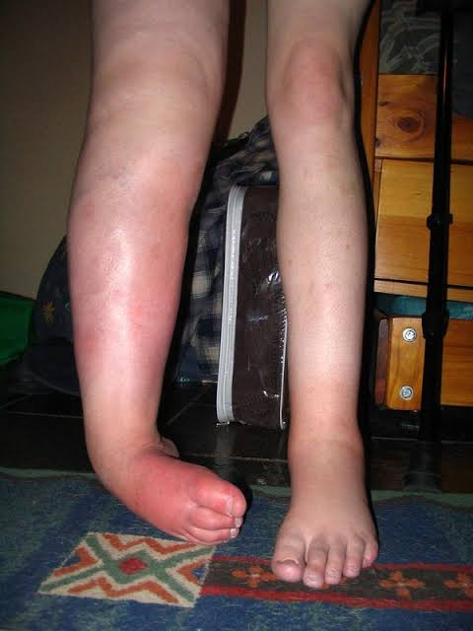

W
We also discussed the difficulties that this condition presents us as clinicians. Providing a correct diagnosis actually can be quiet challenging when we consider that other possible diagnoses of a slew of conditions that present with many of the same or similar symptoms that CRPS does. That’s why our differential diagnosis is one of exclusion and not inclusion. Since there are no real tests to include CRPS as a diagnosis, we find ourselves excluding everything else, and we arrive at a diagnosis of CRPS pretty much through the back door. And with that, we come to testing options. And as I just stated, since there are no tests to diagnose CRPS directly, we rule out other conditions first. They can start that process by performing lab work. You can also do ultrasonography for the muscle, ultrasound. You can do EMG and nerve conduction velocities to rule out other obvious conditions, and you can start with imaging studies, and that would include x-rays and bone scans. Finally, we touched on the limited treatment and pain management options that we can provide the individual, such as chiropractic and physical therapy modalities, pharmaceuticals, behavioral therapies, pain management in the way of spinal blocks or nerve stimulators at the spinal level. But we have to keep in mind that there is not one magic bullet for treatment of an individual with CRPS, so that’s why we provide a comprehensive management system, which would include one, two, three, or all four of those management options that I just gave you. So with that behind us, let’s get to today’s topics. 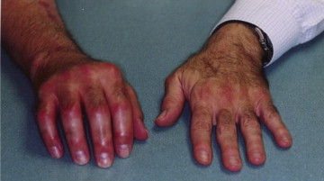

So before we can make a permanent impairment determination for this condition, we first have to understand what the Guides has really determined regarding a rating of the condition of CRPS. This appears on page 496, and they state, and I’m quoting, “Since a subjective complaint of pain is the hallmark of these conditions,” so it’s right off the bat you see the subjectivity comes in to mind here, “many of the associated physiological signs and radiologic findings can be the result of disuse, the differential diagnosis is extensive; it includes somatoform pain disorder, somatoform conversion disorder, factitious disorder, and malingering. Consequently, the approach to the diagnosis of these syndromes should be conservative and based on objective findings.” Now, as you recall, when we discussed how to diagnose this condition, most of the findings were very subjective. The objective findings of testing and lab testing are really not there, so this is a conundrum that we are faced with in this situation. But when you rate an examinee with CRPS, it’s not very easy and let me tell you why.

F
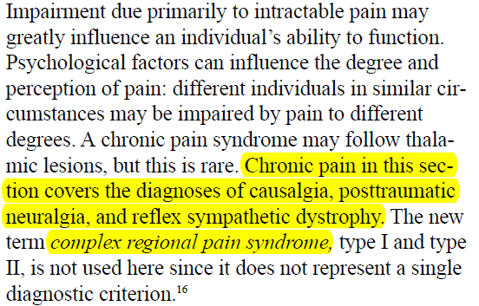irst, I failed to mention that we’re going to be referring to the AMA Guides Fifth Edition quite often, and if you would feel more comfortable, it might help if you did have that next to you as we go through these slides and discuss this during this installment of the presentation. But we’ll refer to these, and I have the page numbers here listed as well. But first of all, the situation with CRPS in the AMA Guides is a difficult task to perform an impairment rating because CRPS appears in three separate chapters of the Guides. Not to say that that’s an easy situation to consider, but we’ll take an example of the three. First we take a look at Chapter 13.8, and there are criteria for rating impairments related to chronic pain. So now we’re talking about chronic pain here. They talk about the terminology here is hard for us to understand because, as we discussed before, we use the terms RSD, a reflex sympathetic dystrophy and causalgia, to mean parts Type I and II in the past, or that’s what they have moved forward to. But if you see the Guides, and we’ll read this here, “the impairment due primarily to intractable pain may be greatly influencing an individual’s ability to function.” Okay, moving forward in the middle of the paragraph. Chronic pain syndrome may follow thalamic lesions, but this case is rare. Here we are. Chronic pain in this section covers the diagnoses of causalgia, posttraumatic neuralgia, and reflex sympathetic dystrophy. The new term complex regional pain syndrome, type I and type II, is not used here since it does not represent a single diagnostic criterion.” Now they use this and say that they’re not going to use the symptom and the terminology of CRPS; however, in Chapter 17, that’s all they use. So here’s where you get a little bit of confusion here, but we’ll move forward.

T
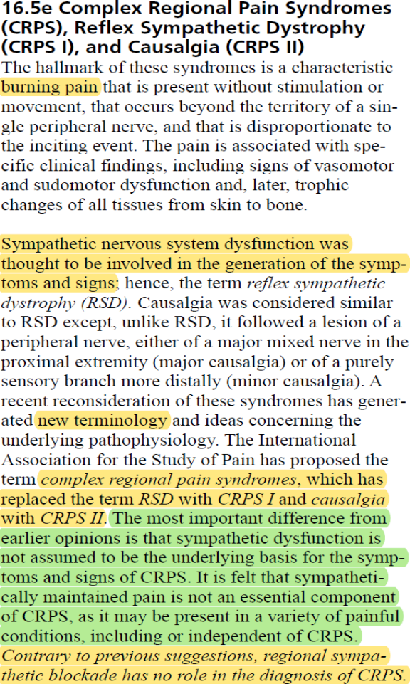hen, in Chapter 16.5e, Complex Regional Pain Syndromes (CRPS) and CRPS I and II. Here we go. So they are using these terms not interchangeably, but they’re using them together. Here they get into a more depth discussion differentiating between type I and II, and they provide us with the Guides criteria or their diagnostic criteria, but they go on to say that the
sympathetic nervous system dysfunction was thought to be involved in the generation of the symptoms and signs that give us the term RSD. Causalgia was considered to be similar to RSD except, unlike RSD, it followed a lesion of the peripheral nerve. And if you remember, causalgia was considered CRPS II. So then they go on to tell us about a recent reconsideration. Now, when they say recent reconsideration, keep in mind the AMA Guides was published in 2001, so we’re going back to 2001 and they said well, we have some new terminology. RSD is replaced with CRPS I and causalgia with II. We know that. The most important difference of the earlier opinions is that now they’re saying the sympathetic dysfunction is not assumed to be the underlying basis for the symptoms and signs of CRPS. They conclude to tell us that sympathetically maintained pain is not an essential component of CRPS, and their reasoning is that CRPS may be present in a variety of other painful conditions, including or independent of CRPS. So see what they’re trying to do? They’re differentiating between the two but they’re drawing a line and saying that it’s not a sympathetic dysfunction. Finally, they indicate that contrary to previous suggestions, regional sympathetic blockade has no role in the diagnosis of CRPS. You’ll find this to be a discrepancy that we’ll talk about later.

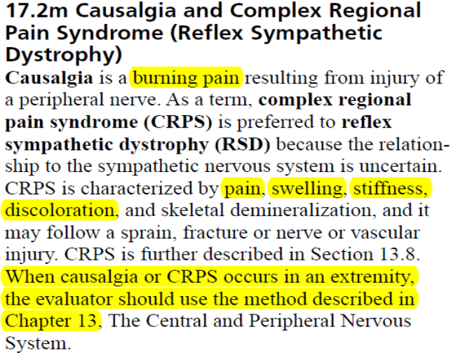And the third reference to CRPS in the Guides appears in Chapter 17.2m, Causalgia and Complex Regional Pain Syndrome. So here we go with causalgia and RSD. They will indicate that the Guides describes causalgia and reflex sympathetic dystrophy again, but they tell us that causalgia or CRPS occurs in an extremity, the evaluator should use a method in Chapter 13, the central and peripheral nervous system. So there you have it. We’re talking about an extremity, upper extremity problem or lower extremity, and you’re looking at Chapter 16 and 17; however, when you’re discussing how to rate an impairment for CRPS in an individual, they refer you to Chapter 13. Again, a little bit of a discrepancy here that’s sometimes a little difficult to understand.

So let’s muddy the waters just a little bit more. So we’re going to say let’s take a look at how we diagnose CRPS according to the Guides. Now you remember the Budapest Criteria was how the medical community and the researchers and the scientists are discussing the relevance and if, indeed, an individual has CRPS by the criteria that were listed there. Now we have the diagnostic criteria used by the AMA Guides. Now, I mentioned to you they refer you to Chapter 13 in order to make an impairment rating; however, you find the diagnostic criteria in Chapter 16. So let’s review this.

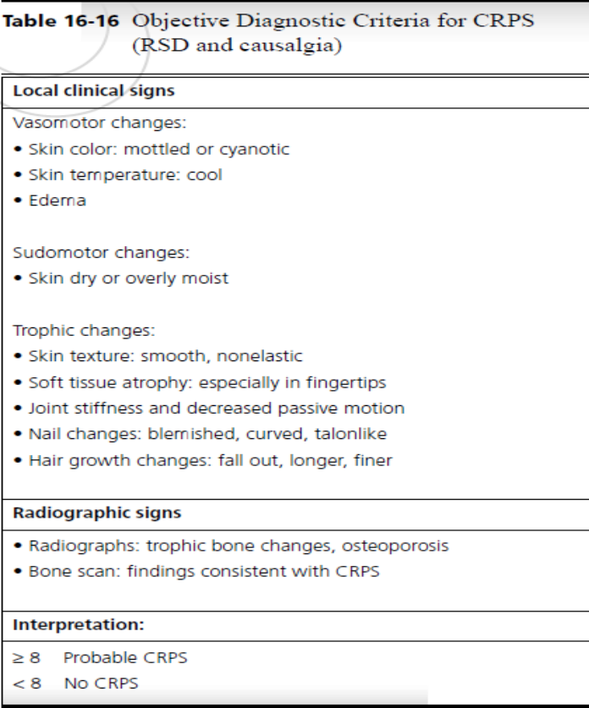On page 496, they indicate that the criteria listed in this table, as you see here, Table 16-16, predicate a diagnosis of CRPS upon a preponderance of objective findings that can be identified during a standard physical examination and demonstrated by radiographic techniques. Let’s question that. Radiographic techniques, many times they don’t appear in an early diagnosis of CRPS, and when you’re talking about objective criteria, you’re taking subjectivity out, and how do we diagnose generally? Signs and symptoms. Again, some discrepancies. But the Guides list that at least eight of these criteria findings must be present concurrently for a diagnosis of CRPS. So you have seven, you’re almost there, but if you have eight, you’ve got the diagnosis. Now these signs must be objective evidence – this is important – as opposed to subjective sensations explained by the examinee. We’ll talk more about this too. So there are some subjectivity questions that the AMA Guides wants to address, but if you take a look at this, it’s nothing new that we haven’t already discussed with the other criteria. The local signs and symptoms and clinical signs of vasomotor changes we’ve discussed. It could be mottled, cyanotic, which would be of the later stages. Cool temperature, edema, that could be any of the three stages. Sudomotor changes, skin dry or overly moist. Well, that covers the three stages of CRPS. Trophic changes, skin texture, soft tissue atrophy, possibly or especially in the fingertips they mention here, which is very interesting. We did see a couple of those in our references and the pictures I had shown you in the previous installment. You can have joint stiffness and decreased passive motion. Well, if you have decreased passive motion, obviously you’re going to have decreased active motion as well. The nail changes and hair growth changes. The radiographic signs, you can have trophic bone changes, osteoporosis, spotty osteopenia also. Bone scans consistent with CRPS as well. So the interpretation according to the Guides is that we’re looking at eight or more of these conditions or symptoms could be a diagnosis of CRPS. Less then eight, we find that there would not be.

S
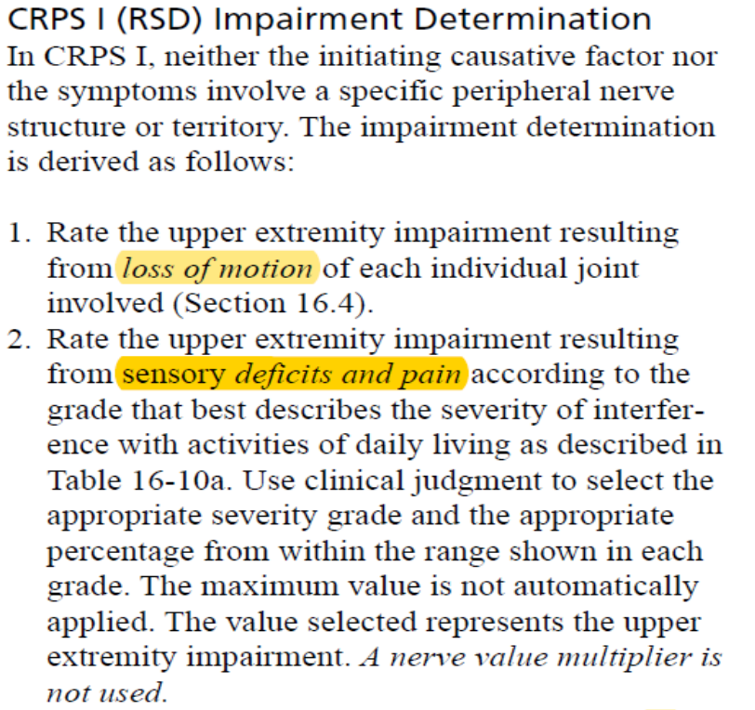o you recall, as I said earlier, the Guides in their infinite wisdom indicated that we are to go to Chapter 13 for the determination of impairment for CRPS; however, right after that, we find out the diagnostic criteria appear in Chapter 16. And immediately after that criteria table that I showed you, we have the impairment determination for CRPS I, and they mention RSD here. And they indicate it in Chapter 16, so let’s follow through with that. They say in CRPS I, neither the initiating causative factor nor the symptoms involve a specific peripheral nerve structure or territory. We know that. That’s the definition. It does not involve a peripheral nerve. So they say here’s how you make the determination. First you rate the upper extremity impairment resulting from loss of motion. So that is a very traditional impairment rating that we would use for loss of motion when you are considering an upper extremity or lower extremity impairment. That’s nothing new to us. But then they also say you rate the upper extremity impairment resulting from sensory deficits and pain.

So for those of you who have your book and you have your book out, page 42 refers to Table 16-10, determining the impairment of the upper extremity due to sensory deficits or pain resulting from peripheral nerve disorders. So a little bit of a discrepancy because it’s not a peripheral nerve disorder. So if you take a look at that, you will see that the sensory deficits are graded 0 to 5 and the deficits go from a 5 of 0 sensory deficit to a 0 of 100% deficit, and there are grades in between. So for instance, a person with a grade 2, and I’ll give you an example, has a decreased superficial cutaneous pain and tactile sensibility, abnormal sensations or moderate pain that may prevent some activities, and they give you a deficit number between 61 and 80. Now this happens a number of times in the book especially when we’re using impairment ratings in the DRE categories, you’ll have a deficit percentage that you need to determine for that individual. For instance, in this grade 2, you have 61 to 80%. It’s not either 61 or 80, it can be somewhere in between. It can be 80, but in order for your opinion to qualify as substantial medical evidence, you’re going to have to explain how and why you arrived at that number. So if you say 75%, if you say 62%, you have to say, “This is why I have given this number and the reasons for my opinion include,” and you must list it. Otherwise, your conclusion is nothing more than conclusory and not substantial, and chances are, you’ll be hit with a supplemental report request and/or possibly a deposition to explain yourself in that case.

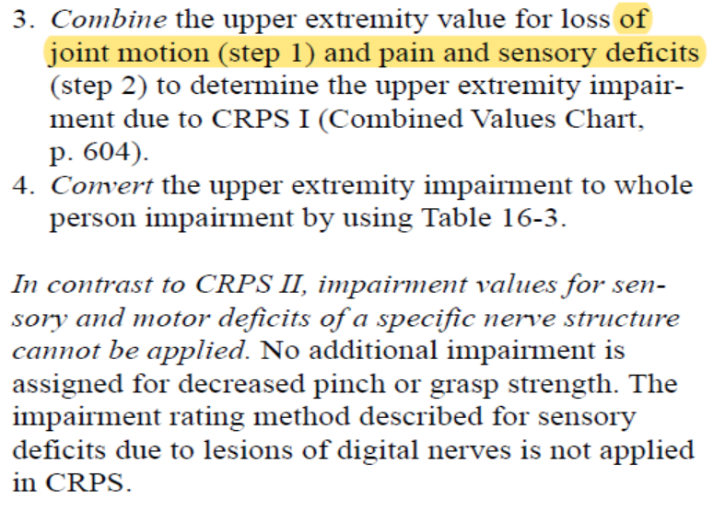So we have provided impairment due to loss of motion and then sensory deficit. So what we’re going to do, we combine those upper extremity values and we do pain and sensory deficits in addition to loss of motion.

Now I put in here, do you see the discrepancy here? When you’re talking about pain and sensory deficits, aren’t those very subjective? Those are subjective findings a lot of times. Very difficult to have objective findings when you’re using the Semmes-Weinstein and/or the 2-point discriminator so you have to be careful here. There’s a little discrepancy with the Guides. So once you get those two values, you convert them to upper extremity to the whole person impairment, and that’s found on page 439, Table 16-3. Interesting also that they indicate in italics in contrast to CRPS II, the impairment values for sensory and motor deficits of a specific nerve structure cannot be applied, so no additional impairment is assigned for a decreased pinch or grasp strength. The impairment rating method described for sensory deficits due to lesions of the digital nerves is not applied in CRPS. Again, confusion.

W
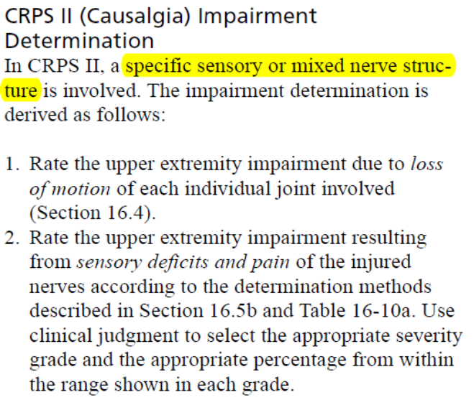hen we are discussing CRPS II and we’re trying to rate an upper extremity impairment due to CRPS II, we first go to Section 16.4, and again, we rate for loss of range of motion or loss of motion.

It’s no different than the last section. We also, in step 2, we rate the upper extremity permanent impairment resulting from sensory deficits and pain according to determined methods that we discussed before, and they also tell you use clinical judgment to select the appropriate severity grade. Again, show your work. You have to tell them why you came up with a certain percentage, and if it is between 61 and 80, why you determined that. Generally, you go to the activities of daily living and you see how impacted the individual would be or has been as a result of this condition, and that generally will increase the rate of severity of the condition and, therefore, increase the percentage of the impairment.

N
ow, something a little different here when you’re rating CRPS II and the upper extremity is you’re going to rate the upper extremity values for motor deficits and loss of power, whereas CRPS I was just sensory.

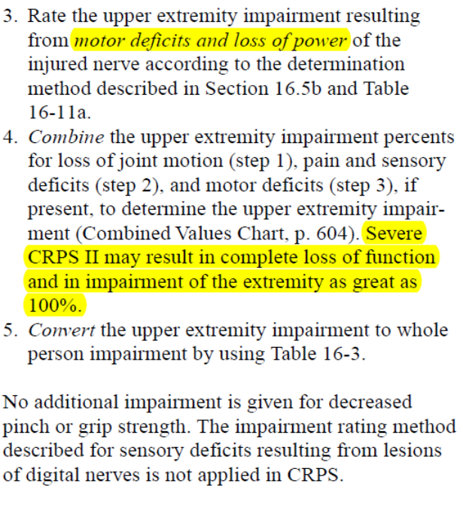
So the third step here is you rate the upper extremity impairment resulting from motor deficits and loss of power of the injured nerve according to the determination method described in 16.5b and 16.11a. What we’re discussing here is motor deficits due to a specific nerve as we know CRPS II involves a specific peripheral nerve [inaudible 23:36]. Number 4, they combine the upper extremity impairment, so you have the loss of joint motion plus the pain and sensory deficits, and then the motor deficits if they’re present. And number 5, you convert the upper extremity to whole person, and you’re finished. Now, one thing to consider here. This is a rarity in the Guides. There can be an impairment rating for severe CRPS of 100% of the extremity, so in this case, there can be 100% loss of use of an extremity as a result of a CRPS II condition.

So we’ve done CRPS I and II, and we’ve used Chapter 16. Now we finally are referred to Chapter 13, and we discussed that back in the beginning of this presentation today. It appears that they’re giving us an alternative way to rate the examinee for CRPS II in an upper extremity as well.

So the Guides in page 343, if you’re following along, they say to rate an impairment for causalgia, posttraumatic neuralgia, and reflex sympathetic dystrophy in an upper extremity, you can use Table 13-22. So when an examinee would present with the required diagnostic criteria, not the Budapest but the AMA Guides Fifth Edition, for the permanent impairment, you calculate the upper extremity impairment according to Table 13-22 and use the instructions on page 496.

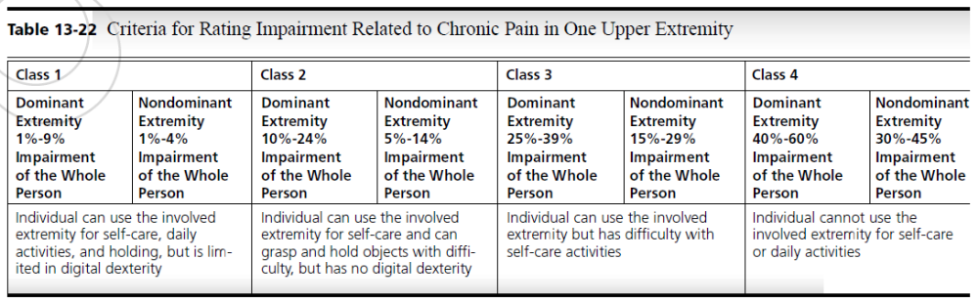

Now, let’s remember, Chapter 13 doesn’t deal with either upper extremity or lower extremity but it deals with problems arising from the central and peripheral nervous system. If we take a look at these, we have a situation where we can go from a 1 to 9 in the dominant extremity all the way up to 40% to 60% in a dominant extremity. They class these 1 through 4 whereas in the CRPS II Chapter 16, they were classing it in 5 classes. So you’ll have the individual fall into one of these classes and you make that determination. Again, look at these ranges for the percentages. You’re going to have to determine in your best calculation as to what that determination would be and then show your work. Explain why you came up with that.

So we have two different ways to provide an impairment rating here now using Chapter 16 and Chapter 13. So how do we handle it? Well let’s review what’s covered way back in Chapter 2 of the Guides. And in the Guides, they state, “Generally, the organ system where the problems originate or where the dysfunction is greatest is the chapter to be used for evaluating the impairment.” So this authorizes you as an examiner to use the higher of the two ratings when an impairment rating is rated in multiple chapters. We just mentioned that, Chapter 16 and Chapter 13. This not only applies to this situation but at all times you can provide two separate ratings for the same condition. We understand that. Now, don’t forget, show your calculations for both impairments. So you’ll provide both impairments and then you’re allowed to use the higher of the two, but you have to show your receipts or show the work that you provided so they know that you established the correct impairment rating as a result. If not, again, it will not qualify as substantial medical evidence and we just may see you in a deposition request coming soon.

So let’s move on to the lower extremity. So we’ve covered the upper extremity for the conditions, and we have an alternative method for conditions using Chapter 16 and Chapter 13. Here we recognize CRPS as one of the 13 methods used by the examiner to assess lower the extremity.

So if you go to Table 17-1, you’ll find number 9, causalgia/reflex sympathetic dystrophy, and they indicate CRPS.

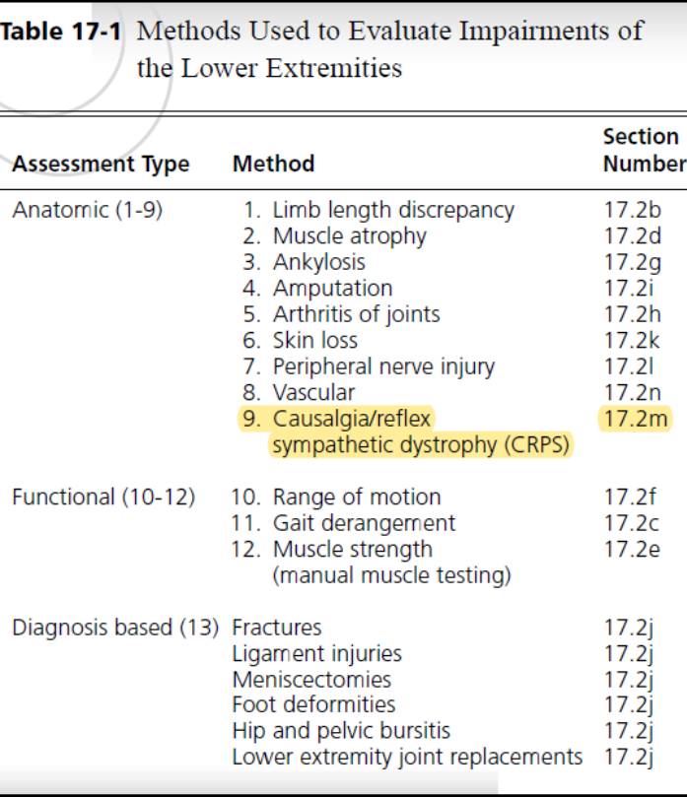
So they are recognizing that the names, they’re not synonymous, but they’re at least recognizing the old terms versus the new terms. So this is an anatomic assessment type as well. It’s not functional and it’s not a diagnosis base. Why? Because we had talked, there’s not very many diagnosed or diagnostic findings that will provide that. You’re looking at signs and symptoms, so you’re going more on what a condition would be anatomically. You would also, in this case, provide a combination of range of motion and the peripheral neurologic evaluation techniques to move forward.

S
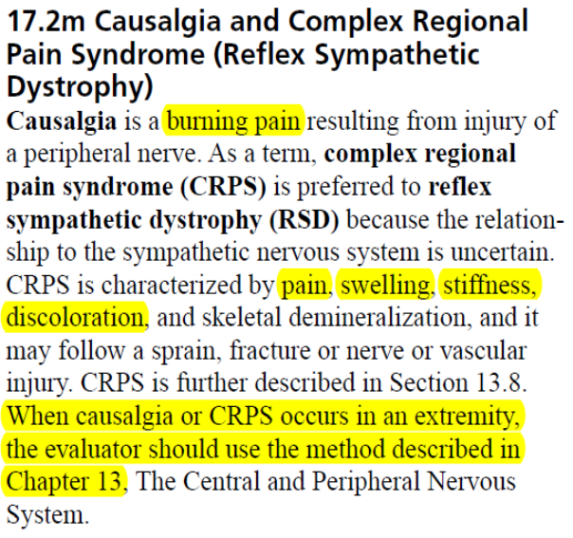o how do we rate CRPS in the lower extremity? Well, they refer us to Chapter 13. So we’re in Chapter 17, the lower extremity here, and 2m specifically. When you talk about CRPS, they start to make some determinations and they repeat the definitions. Causalgia is a burning pain, injury of a peripheral nerve. That would be type II. It’s called complex regional pain syndrome, and it’s preferred to reflex sympathetic dystrophy because a relationship to the sympathetic nervous system is uncertain. So here to we go back into this lack of determination of whether or not it’s a central nervous system issue or if it’s a sympathetic nervous system issue, either or, or both.

They do characterize the symptoms as pain, swelling, stiffness, discoloration, possible skeletal demineralization. We know that. Then they say well let’s go back to Chapter 13 because they further describe in Chapter 13.8 when causalgia or CRPS occurs in an extremity, the evaluator should use the method described in Chapter 13. The Central and Peripheral Nervous System. What a minute. How are we supposed to do that when we have specific instructions on how to use Chapter 16? So here we go. We’re getting some confusion involved in how we’re to move forward. Let’s see if we can make some sense of this.

Now we get to rating CRPS in the lower extremity, and before we move forward, I wanted to make it clear, I maybe wasn’t very clear on the last slide. When we’re discussing the lower extremity, we go, obviously, to Chapter 17. That’s the lower extremities chapter of the AMA Guides. When we go to the upper extremity impairment ratings, we go to Chapter 16, and in 16, we had references to the upper extremity; however, let’s go to Chapter 17 and find out what they have to say about CRPS here. The Guides on page 343, they indicate if a lower extremity needs to be rated for causalgia, posttraumatic neuralgia, or RSD, use the station and gait criteria given in Chapter 13. If you recall, Chapter 13 is a chapter on the central and the peripheral nervous system. So they’re already taking the lower extremity chapter out of our CRPS determination and throwing it back into a central peripheral nervous system disorder.

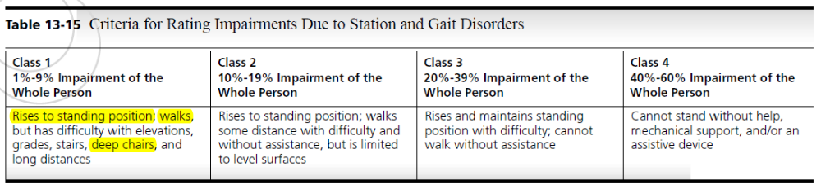

With that said, going to Chapter 13 and Table 13.15, the criteria for rating this condition are basically you establish a class, 1 through 4. Where does the individual fall? And let’s just talk about Class 1 because I want to mention something to you. As you see, 1 to 9%, now you are going to determine what actual number that is. You cannot give 1 or 9 or anything in between – well, you will be asked to make a determination and clarification if you do give a range, but if you give a number of 9, then you have to explain why you arrived at that number because there is a possibility of having less. Again, if you provide the receipts, you won’t be called for a deposition or you [will not be necessitate a 32:35] supplemental report to explain where you arrived at that. But when you indicate Class 1, you see rises to a standing position, walks but has difficulty with elevation. Individual can walk grades or has difficulty walking grades or stairs or sitting in or getting out of deep chairs or walking long distances. I’ve highlighted these in yellow because these are observations that you could actually make during your examination appointment. You can see how the individual presents themselves when they walk into your office, they walk into the examination room. How they carry themselves when they perform the multiple positions of testing that you put them through. Not just understanding when you talk about the activities of daily living and they tell you they have difficulty walking 10 feet but yet you don’t see any change in the gait or any problems when they walk into your examination room. So this allows a little more objectivity in the case when you provide these. So you go then to a class of 1 through 4. You can go from 1% all the way up to 60%. Again, just provide your reasoning, what you came up with and how you came up with the number. So that brings us to the end of the rating process for determining impairment for the upper and lower extremity in CRPS. As you can see, it’s not as cut and dried when it comes to rating someone as you’d expect it. Some other conditions we were able to rate a little more easily. The authors of the Guides made the decision not to say that the affliction was involving the sympathetic nervous system entirely, so the rating methods are not as exact as we see in other chapters of the Guides, so we keep that in mind.

With that said, I want to point out some of the incongruities or maybe call it inconsistencies that exist when you possibly could encounter as you prepare to provide an impairment rating for somebody with CRPS. Some of these are my observations and others come from authors of the AMA Guides Fifth Edition as well.

N
ow, you may be thinking, okay, we have Chapter 13, the central and peripheral nervous system. That’s going to be for the lower extremities. Chapter 16 for the upper extremities, CRPS I and II. What – if this is such a painful condition, as we discussed earlier, the CRPS has a rating of 46 out of 50 in the McGill pain scale. It’s determined to be more painful than childbirth or kidney stones or trigeminal neuralgia, so why don’t they assess this or make a determination in Chapter 18 that is determined to be pain? That’s the title of the chapter. Well, let’s take a look. The pain chapter, 18, Section 3 is something to take a look at and note that there is no direct mention of CRPS, it’s just a discussion of pain overall, and that’s what I’m trying to get at here. So as we see this, Section 18.3 states the symptom to rate pain described in this chapter relies largely on self-reports by individuals. Here we go. Signs and symptoms. Thus, it differs significantly from the conventional rating system, which relies primarily on objective indices of organ dysfunction or failure. So they go on and say an individual’s pain-related impairment evaluation should be aborted if his or her behavior during the evaluation raises significant issues of credibility. In this case, the Guides do not want us to allow subjectivity to affect our decision-making process as examiners. We must rely on objective criteria to guide our decisions, and this can reduce the likelihood of an examiner rating for examinee who may be malingering. So there we are. They are discussing the subjectivity of the symptoms and signs that we have with CRPS and the lack of diagnostic criteria to get us to a correct diagnosis or a more defended diagnosis than we have. So let’s move forward.

So they don’t want us to have subjectivity enter in our decision-making process as far as rating an individual for an impairment, but how do they directly relate to the pain? How are we talking about pain when we talk about, again, McGill 46 out of 50? Well, they address it indirectly in Chapter 18 and they rate pain as an unanticipated or excess pain-related impairment. So that’s what they determine pain to be in Chapter 18, and they say it’s a chronic type that interferes more than anticipated with the individuals performance of ADLs. And if you recall, we have that objectivity, but we also have some subjectivity involved that we can add a 3% pain-related impairment. And those are generally due to how they’re affected by their activities of daily living. This also impresses upon you the importance of a very thorough activities of daily living discussion to have with these individuals during the examination interview. You don’t want to just provide them with the sheet and have them tell you what their problems are, you want to [ask them 38:48] individually each of those activities, how they’re affected and how bad they’re affected or how much they’re affected by that. And then finally, Chapter 18 generally doesn’t overlap with CRPS tables because the tables in Chapter 13, which is the central and peripheral nervous system chapter, incorporated anticipated pain that’s severe enough to cause a total loss of use of the extremity. So they already take that into consideration so you don’t have to.

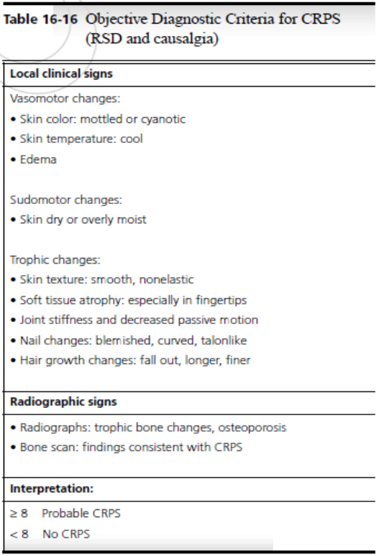Let’s move into some conflicts that I was able to ascertain when you have this CRPS diagnosis process.

In review of Chapter 16, Table 16-16, which we discussed, there’s a list of 11 criteria that are used for the diagnosis of CRPS, and we discussed that early on in this program. Eight much be present or more to make the diagnosis, and they have to be present concurrently. It can’t be a situation where they had this present prior and it no longer exists. Well, 8 of the 11 have to be present concurrently or at that time of the examination. Now, what is odd is that’s Chapter 16, yet when you go into Chapter 13 when we’re discussing lower extremity impairments because we were referred to them from Chapter 17 for lower extremity, the central and peripheral nervous system is silent on the use of the table. There is no mention that there are criteria for that. So again, if you’re providing criteria and separate impairment ratings, be sure to provide both and then also to explain the how and they why you arrived at your conclusion. And also in Chapter 16, they state, “Contrary to previous suggestions, regional sympathetic blockade has no role in the diagnosis of CRPS,” yet in Chapter 13, “sympathetic block frequently relieves the pain.” And additionally, “the acute distal dwelling usually responds to a sympathetic block.” So there you go. Chapter 16 says no go; Chapter 13 says bring it on. Again, just wanted to bring this to your attention.

S
o other observations I’ve made, the methodology for rating CRPS in the Guides, you take a look at Table 16-16, is it outdated? Is this something that needs to be addressed? Well, let’s go back. The authors published this book in 2001, so the AMA Guides Fifth Edition was produced and published in 2001. So we’re looking at 21 years ago, and I have told you in the previous installments that the understanding of CRPS is changing daily. There has been very little research done prior to, gosh, for the last 10 years. So as you see, they were making decisions in 2001 that are probably typically outdated at this point. And how do we know? Well, if you look at Table 15-15 in the Guides Sixth Edition, they’re similar to the fifth edition except the sixth edition you only need to identify 4 of the 11 criteria to make it a ratable diagnosis for CRPS. So in the fifth edition, you need eight concurrent criteria. In the sixth edition, we only have four. But albeit it would be nice to be able to refer to the sixth edition in our reporting and your methods [and make 42:56] explanation, we still, regardless, must follow the fifth edition. So you have to keep that in mind.

So are you confused yet? Let’s give you another one. Chapter 13. Well, they tell us on page 343 that a three-phase bone has low sensitivity and cannot be used as a required criterion for the diagnosis of CRPS. That’s Chapter 13, and I just showed you in the previous slide the criteria for determining a diagnosis in Chapter 16, positive bone scan is listed as one of the criteria that determine an individual has CRPS. So as you see, another discrepancy. Confusion. Not meant to be confusing, it’s just the way this turned out. It’s just a very difficult condition that is covering more than one chapter, and as we discussed, it’s three chapters.

Let’s move on to rating neurologic impairments.

We’re just talking about the neurology aspect here. Table 13-15, which is Chapter 13 of the central and peripheral nervous system, rates non-neurologic impairments in the section on station and gait disorders. So non-neurologic impairments in station and gait disorders, yet it’s also used to rate CRPS and station and gait disorders from either a central or peripheral nervous system impairment. So they refer us from Chapter 17 and lower extremity to Chapter 13 and discuss non-neurologic impairment, yet it appears in Chapter 13, the central and peripheral nervous system. And those impairment ratings are made from that as well. So as we discussed, if a lower extremity needs to be rated for causalgia, posttraumatic neuralgia, or reflex sympathetic dystrophy, you have to use the station and gait impairment given in the criteria in 13-15, which I included again. So you’re using this for two different conditions, non-neurologic and neurologic.

We have one more, I promise. Let’s take a look at this one. I’m not stating it’s a problem, it’s just I’m making an observation. It appears that the Guides doesn’t differentiate between rating for an impairment of one upper extremity and rating for chronic pain secondary to a central nervous system disorder in one extremity. In reference to the last slide where we were discussing how they were using non-neurologic impairment and central nervous system impairment using Table 13-15, now Table 13-22 and Table 13-16, if you take a look, it’s the exact table but has a different title.

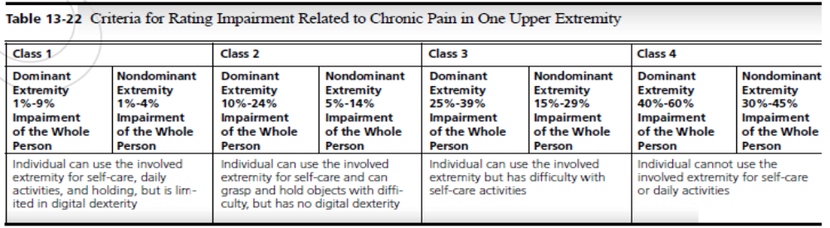

Table 13-22, or the criteria for rating impairment related to chronic pain in one extremity, and the exact same table is Table 13-16, criteria for rating impairment of one upper extremity.

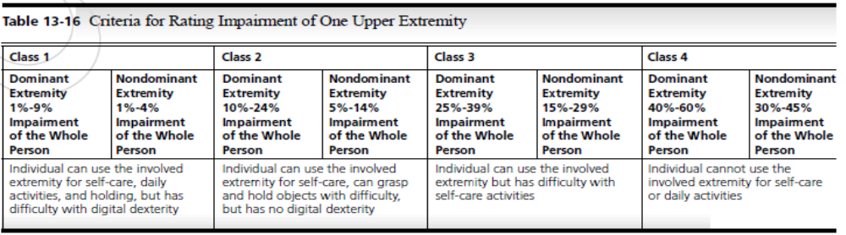

So we have chronic pain in one and just a regular upper extremity impairment in the other. Interesting observation.

F
inally, just to close this part of the discussion here, observations and incongruities. I want to make it perfectly clear that I’m just pointing out these incongruities but not pointing out the shortcomings or admonish the authors or trying to be critical. What it just is illustrating to us though is this condition is still not thoroughly understood as the other conditions that are addressed in the Guides Fifth Edition. And let’s keep in mind, this was published in 2001, this fifth edition. We’ve already seen, as I discussed earlier, the 6th Edition has reduced the number of criteria from 8 to 4 out of 11, so that has changed substantially. And also, there’s an increasing amount of research that they’re currently doing and is taking place on the subject, so our understanding of this condition is ever evolving and will continue to evolve moving forward. But we as examiners will have a better understanding on how to diagnose CRPS the more we learn of how to recognize the condition in these individuals. So stay tuned on that as we will try to provide you with updates as well as things change and move forward and the Guides possibly becomes a little more understanding as to how we move forward with this.

Well, we’ve come to the end of the program. I hope you’ve enjoyed this extensive look into CRPS and how it affects us and how it affects your examinee’s potentially and examination procedure. Since we’ve come to the end of this, I do want to thank you for taking the time to join us as we learn more about this condition. The research into CRPS is pretty much ongoing, and we’re learning more and more about it every day. And also, I want you to feel confident that we at the California Chiropractic Evaluators will continue to update you and keep you advised as to the ongoing research that gives us more information to become better examiners as part of the California QME profession. I’m Dr. Chris Rapoff, and once again, thank you for joining us and take care.

/kj

