E-Z QME CONTINUING EDUCATION
FOR DOCTORS

In this Program:

6.0 hours of Home Study CEU’s approved by DWC. Topics include:
- Lower Extremity Impairments due to Peripheral Nerve Lesions:
- Neurology 101 – Development of Dermatomes and Myotomes
- Conus Medullaris, Cauda Equina, Lumbar Plexus, Sacral Plexus, and the named peripheral nerves of the Lower Extremities
- Injury to the Obturator, Femoral, and Sciatic Nerves
- QME Neurologic Examination Procedures of the Lower Extremities
- Determining Permanent Impairment due to Peripheral Nerve Injury

Presented by:
Perry J. Carpenter DC QME

EZQMECEU.COM

This program is approved for 6.0 hours of Continuing Education credit through the Division of Worker’s Compensation – Medical Unit

Instructions: Listen to the audio program or watch the PowerPoint presentation in its entirety. Supplement your learning with the written materials provided with the course – including Notes and References included here. Then, complete the 20 Question Examination. Upon successful completion, your Certificate of Completion will be faxed or emailed back to you.

LOWER EXTREMITY IMPAIRMENTS – PERIPHERAL NERVE LESIONS

Perry J. Carpenter D.C., Q.M.E.

DWC Continuing Education Provider #1280

QME REPORT TEMPLATES

Below is a Sample Template used to guide your Physical Examination and to report your findings within the body of your QME Report. You may or may not require the use of all elements depending on the needs of your particular examinee.

LUMBAR SPINE & LOWER EXTREMITY NEUROLOGIC EXAM

GENERAL FUNCTION
- BALANCE: In order to assess a general overall level of function Mr. Jones was asked to first stand with all of his weight on his left foot and then to repeat with the right foot. He was able to stand on his left leg and maintain his balance without sway or fall. He was able to stand on his right leg and maintain his balance without sway or fall.
- STRENGTH: He was then asked to squat as low as he could and rise using the strength in his lower back and legs. He was able to squat to below parallel and repeat 5 times without complaints of pain or restriction in the lower back. These general maneuvers give an indication of overall good strength and function of the lower back and lower extremities. This indicates preserved and intact function of the L4 nerve root, and of the femoral nerve.
- NEUROLOGIC FUNCTION: He was able to heel walk and toe walk without difficulty or sign of lower extremity weakness. This is a sign of preserved function of lumbar spine nerve roots (L5 and S1 nerve roots) and lower extremity peripheral nerves (Sciatic Nerve - Tibial and Common Peroneal Nerve branches).

SCIATIC NERVE STRETCH TESTS
- Neri’s bowstring sign was negative for radiculopathy on the left and right legs.
- The straight leg-raising maneuver was positive/negative on the left leg to degrees before hamstring tightness limited further movement.
- The straight leg-raising maneuver was positive/negative on the right leg to degrees before hamstring tightness limited further movement.
- Braggard's sciatic nerve stretch test was positive/negative bilaterally for reports of lower back or lower extremity pain.

GIRTH MEASUREMENTS
Girth Measurements Lower Extremities
Extremity | Measurement | Difference | Percent difference
Right thigh
Left thigh
Right calf
Left calf

On visualization, there was no significant evidence of atrophy of either lower extremity as visualized in the quadriceps or calf muscles. To measurement 1) at 10 cm. above the knee, and 2) 10 cm. below the knee , the lower extremity measurements were symmetric bilaterally with no evidence of atrophy or wasting noted to either nerve root impingement or disuse.

REFLEX EXAMINATION

REFLEX | LEFT | RIGHT
Adductor (L3/obturator nerve) | +2 (normal) | +2 (normal)
Patellar (L4/femoral nerve): | +2 (normal) | +2 (normal)
Medial Hamstrings (S1/tibial nerve | +2 (normal) | +2 (normal)
Lateral Hamstrings (S1/common peroneal nerve) | +2 (normal) | +2 (normal)
Achilles (S1/tibial nerve): | +2 (normal) | +2 (normal)
Plantar (S1/tibial nerve): | toe flexion (normal) | toe flexion (normal)

SENSORY EXAM

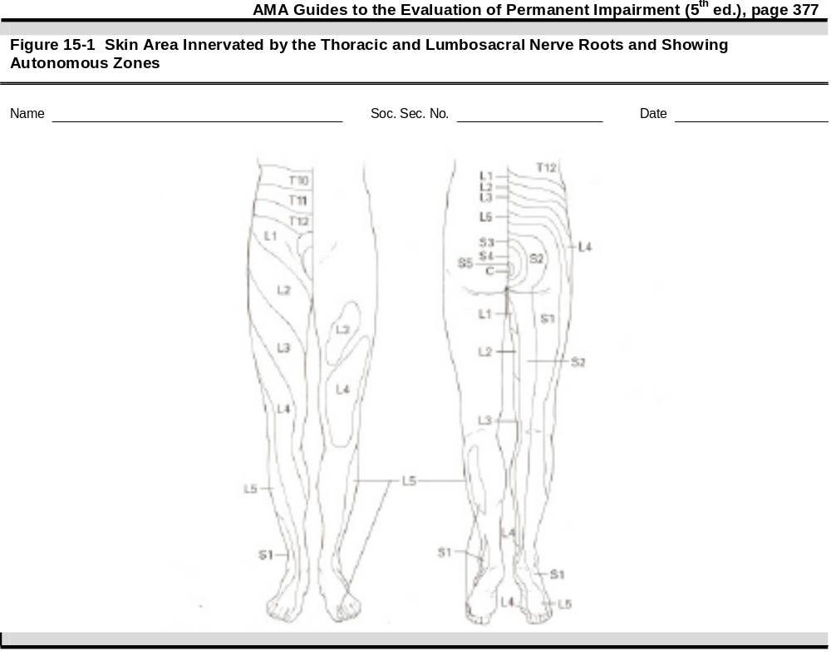

The Sensory Examination consisted of procedures to test the sensory modalities of light touch/pressure, pain, and joint position sense.

- Superficial Tactile Sensibility (Light Touch) – This Sensory Exam was performed using a Semmes Weinstein monofilament (2.83 gauge). A 2.83 gauge monofilament is similar to a human hair.

- L1 sensory dermatome: Normal sensation to light touch testing on the upper anterior aspect of the left thigh between the anterior superior iliac spine and the groin.
- L1 sensory dermatome: Normal sensation to light touch testing on the upper anterior aspect of the right thigh between the anterior superior iliac spine and the groin.
- L2 sensory dermatome: Normal sensation to light touch testing on the middle anterior thigh testing from lateral left thigh to medial thigh.
- L2 sensory dermatome: Normal sensation to light touch testing on the middle anterior thigh testing from lateral right thigh to medial thigh.
- L3 sensory dermatome: Normal sensation to light touch testing on the lower anterior thigh testing from lateral left thigh to medial thigh.
- L3 sensory dermatome: Normal sensation to light touch testing on the lower anterior thigh testing from lateral right thigh to medial thigh.
- L4 sensory dermatome: Normal sensation to light touch testing on the medial aspect of the calf to the left foot.
- L4 sensory dermatome: Normal sensation to light touch testing on the medial aspect of the calf to the right foot.
- L5 sensory dermatome: Normal sensation to light touch testing on the lateral shin to dorsal medial aspect of the left foot.
- L5 sensory dermatome: Normal sensation to light touch testing on the lateral shin to dorsal medial aspect of the right foot.
- S1 sensory dermatome: Normal sensation to light touch testing on the lateral aspect of the left foot.
- S1 sensory dermatome: Normal sensation to light touch testing on the lateral aspect of the right foot.

The Superficial Tactile Sensibility examination was normal with no loss of sensibility in any of the lower extremity dermatomes tested. He was able to quickly and accurately localize the test stimulus. This indicates preserved and intact sensory function of the lumbar spine nerve roots and lower extremity peripheral nerves.

- Pain - This Sensory Exam was performed using the Whartenburg pinwheel with sharp and dull sides.

- L1 sensory dermatome: Normal sensation to pinwheel and dull testing on the upper anterior aspect of the left thigh between the anterior superior iliac spine and the groin.
- L1 sensory dermatome: Normal sensation to pinwheel and dull testing on the upper anterior aspect of the right thigh between the anterior superior iliac spine and the groin.
- L2 sensory dermatome: Normal sensation to pinwheel and dull testing on the middle anterior thigh testing from lateral left thigh to medial thigh.
- L2 sensory dermatome: Normal sensation to pinwheel and dull testing on the middle anterior thigh testing from lateral right thigh to medial thigh.
- L3 sensory dermatome: Normal sensation to pinwheel and dull testing on the lower anterior thigh testing from lateral left thigh to medial thigh.
- L3 sensory dermatome: Normal sensation to pinwheel and dull testing on the lower anterior thigh testing from lateral right thigh to medial thigh.
- L4 sensory dermatome: Normal sensation to pinwheel and dull testing on the medial aspect of the calf to the left foot.
- L4 sensory dermatome: Normal sensation to pinwheel and dull testing on the medial aspect of the calf to the right foot.
- L5 sensory dermatome: Normal sensation to pinwheel and dull testing on the lateral shin to dorsal medial aspect of the left foot.
- L5 sensory dermatome: Normal sensation to pinwheel and dull testing on the lateral shin to dorsal medial aspect of the right foot.
- S1 sensory dermatome: Normal sensation to pinwheel and dull testing on the lateral aspect of the left foot.
- S1 sensory dermatome: Normal sensation to pinwheel and dull testing on the lateral aspect of the right foot.

The Pain examination was normal with no loss of deep or superficial cutaneous pain in any of the lower extremity dermatomes tested.

A proprioception test was performed where with the great toe was pushed up or down with the examinee supine and he/she was asked to report the position of the toe as “up” or “down.” He reported the position of the toe correctly 100% of the time.

Mr. Jones had normal sensation and did not report any reduced or absent sensation on any of the lower extremity dermatomes including the plantar or dorsal surfaces of the feet. He was able to quickly and accurately localized the test stimulus. had normal sensation and did not report any reduced or absent sensation on any of the lower extremity dermatomes including the plantar or dorsal surfaces of the feet. This indicates preserved and intact sensory function of the lumbar spine nerve roots and lower extremity peripheral nerves.

MOTOR EXAMINATION

- L1/L2/L3 Nerve Roots: resisted hip flexion using the iliopsoas muscle was strong and symmetric bilaterally with no evidence of weakness or giveway. This tests the L1, L2, and L3 nerve roots - and indicates normal function.

- L2/L3/L4 Nerve Roots: resisted knee extension using the quadriceps muscles was strong and symmetric bilaterally with no evidence of weakness or giveway. This tests the L2/L3 and L4 portions of the femoral nerve - and indicates normal function.

- L4 Nerve Root: resisted foot inversion with dorsiflexion using the tibialis anterior muscle was strong and symmetric bilaterally with no evidence of weakness or give way. This tests the L4 portion of the deep peroneal nerve, a branch of the common peroneal nerve, a branch of the sciatic nerve - and indicates normal function.

- L5 Nerve Root: resisted great toe extension and resisted toe extension using the extensor hallucis longus and extensor digitorum longus muscles respectively were strong and symmetric bilaterally with no evidence of weakness or give way. This tests the L5 portion of the deep peroneal nerve, a branch of the common peroneal nerve, a branch of the sciatic nerve - and indicates normal function.

- S1 Nerve Root: resisted foot eversion using the peroneus longus and peroneus brevis muscles was strong and symmetric bilaterally with no evidence of weakness or give way. This tests the S1 portion of the superficial peroneal nerve, a branch of the common peroneal nerve, a branch of the sciatic nerve - and indicates normal function.

The Motor Examination was normal and Mr. Jones was able to generate normal and full strength in all areas tested. This indicates preserved and intact motor function of the lumbar spine nerve roots and lower extremity peripheral nerves.

LOWER EXTREMITY PERIPHERAL NERVE EXAMINATION

MOTOR EXAM

The Motor Nerve Examination was completed with the use of resisted manual muscle testing of lower extremity muscles.

Sciatic – Tibial Nerve: Motor
- Resisted foot plantar flexion using the gastrocnemius muscles was strong and symmetric bilaterally with no evidence of weakness or give way. This tests the motor portion of the peripheral tibial nerve.
- Resisted toe flexion using the flexor digitorum longus muscles was strong and symmetric bilaterally with no evidence of weakness or give way. This tests the motor portion of the peripheral tibial nerve.

Sciatic – Common Peroneal Nerve:
- Resisted great toe extension using the extensor hallucis longus muscles was strong and symmetric bilaterally with no evidence of weakness or give way. This tests the motor portion of the deep peroneal nerve, a branch of the peripheral common peroneal nerve.
- Resisted toe extension using the extensor digitorum longus muscles was strong and symmetric bilaterally with no evidence of weakness or give way. This tests the motor portion of the deep peroneal nerve, a branch of the peripheral common peroneal nerve.

SENSORY EXAMINATION

The Sensory Examination consisted of procedures to test the sensory modality of light touch/pressure:

- Superficial Tactile Sensibility (Light Touch) – This Sensory Exam was performed using a 2.83 Semmes Weinstein monofilament. A 2.83 monofilament is similar to a human hair.
- Pain - This Sensory Exam was performed using the Whartenburg pinwheel with sharp and dull sides.

- Saphenous Nerve: Sensory
  - Normal sensation to light touch at the medial aspect of the leg extending from the knee to the medial malleolus bilaterally.
  - Normal sensation to pinwheel and dull testing at the medial aspect of the leg extending from the knee to the medial malleolus bilaterally.

- Lateral Sural Cutaneous Nerve: Sensory
  - Normal sensation to light touch at the lateral aspect of the leg extending from the knee to the lateral malleolus bilaterally.
  - Normal sensation to pinwheel and dull testing at the lateral aspect of the leg extending from the knee to the lateral malleolus bilaterally.

- Superficial Peroneal Nerve: Sensory
  - Normal sensation to light touch at the dorsum of the foot and over the anterior ankle bilaterally.
  - Normal sensation to pinwheel and dull testing at the dorsum of the foot and over the anterior ankle.

- Deep Peroneal Nerve: Sensory
  - Normal sensation to light touch at the dorsal web space between the great toe and second toe bilaterally.
  - Normal sensation to pinwheel and dull testing at the dorsal web space between the great toe and second toe bilaterally.

- Sural Nerve: Sensory
  - Normal sensation to light touch at the lateral aspect of the foot and along the fifth metatarsal bone bilaterally.
  - Normal sensation to pinwheel and dull testing at the foot and along the fifth metatarsal bone bilaterally.

LOWER EXTREMITY VASCULAR EXAM

- The posterior tibial and dorsal pedis pulses were equal and bounding bilaterally.
- There were no Physical signs (such as localized blanching of one or more of the toes, cyanosis, and/or erythema) of Raynaud’s disease of the feet or lower extremities.
- There was no edema in the knees, calves, ankles, feet, or toes.
- There were no signs (such as loss of subcutaneous tissue of the toes, dilation of veins or arteries, or ulcerations) of vascular damage of either lower extremity.

