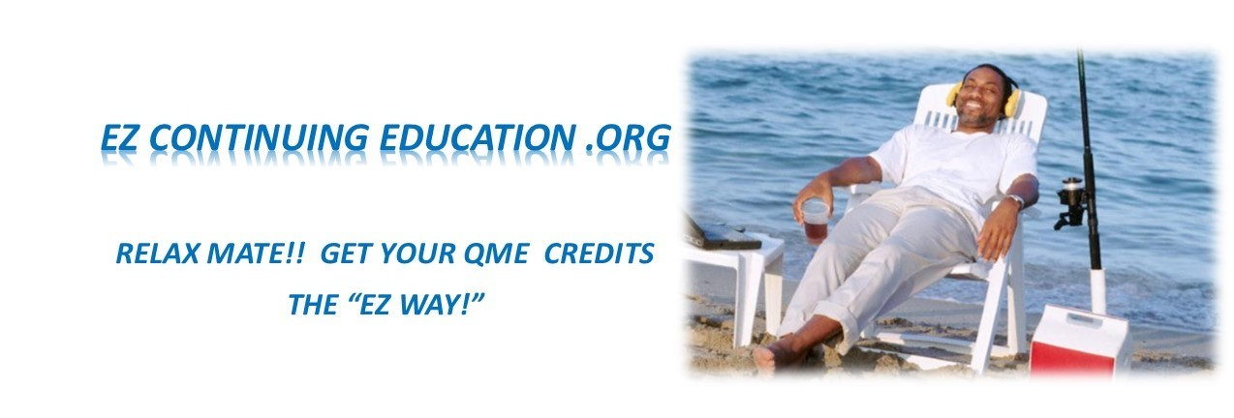
THE QME REPORT COMPLIANCE, CREDIBILITY, AND PERSUASIVENESS CHECKSHEET

TABLE OF CONTENTS

1. IDENTIFYING INFORMATION 2
2. INTRODUCTION SECTION 2
3. COMPLEXITY FACTORS 2
4. HEADERS/FOOTERS 2
5. FORMATTING 3
6. REQUIRED HEADINGS 3
7. SUMMARY STATEMENTS 3
8. REVIEW OF RECORDS 3
9. SYMPTOMS QUESTIONNAIRES & ADL ASSESSMENTS 4
10. PHYSICAL EXAMINATION 4
11. DIAGNOSITIC STUDIES 5
12. DIAGNOSIS 5
13. CAUSATION 5
14. PERMANENT & STATIONARY/MMI 5
15. PERMANENT IMPAIRMENT 5
16. APPORTIONMENT OF THE PERMANENT IMPAIRMENT 6
17. STATEMENT OF SUBSTANTIAL MEDICAL EVIDENCE 6
18. FUTURE/FURTHER MEDICAL CARE 6
19. WORK RESTRICTIONS 6
20. OVERALL REPORT 6

IDENTIFYING INFORMATION
  - Demographics (including photo and driver’s license number). Much information can be obtained through photo and driver’s license.

INTRODUCTION SECTION
  - CCR 34b and CCR 35.5b – location of appointment
  - CCR 40 – disclosure requirements
  - CCR 9795 - Clear, concise statement in separate section at the beginning of the report describing complexity factors
  - Evidence Your Compliance with Regulations

BILLING CODES AND MODIFIERS
  - Clearly substantiated in the INTRODUCTION section of the Report.
  - Interpreter (-93) modifier contains accompanying language described in CCR 9795 (“Also present during the evaluation was Isabella Cruz (interpreter) of ProCare Interpreting (Certification # 80000, phone number 800-500-6000). The circumstance that necessitated the Interpreter was due to impaired communication between Mr. Smith and me. Mr. Smith speaks Spanish and no English while I speak English but no Spanish. Thus, language translation through the Interpreter was necessary. I estimate that the examination time was increased by approximately 30 minutes due to this language barrier, and the added complexity of communicating through the use of the third-party Interpreter.
  - Billing level consistent throughout the Report (same billing code described in the INTRODUCTION section, as described in the DISCLOSURE section).

HEADERS/FOOTERS
  - Brief demographic data – i.e. Name/Date of Injury
  - Footer – page number

FORMATTING
  - Use of bullets, and numbered lists to visually break up large sections of text and data

CONTAINS ALL REQUIRED HEADINGS – CCR 10682
  - History
    - As described in the Medical Records
      - Emphasis on mechanism of injury
    - As described by Ms. Jones
      - Emphasis on mechanism of injury
  - Relevant Medical History – same format as History
  - Social History – Provides insight into examinee’s ability to perform ADL’s
  - Review of Records
  - Occupational History
  - Review of Systems
  - Current Symptoms
  - Activities of Daily Living Assessments/Symptoms Questionnaires
  - Physical Examination
  - Diagnostic Studies
  - Diagnosis
  - Causation
  - Permanent & Stationary
  - Permanent Impairment
  - Apportionment of the Permanent Impairment
  - Further/Future Medical Care
  - Work Restrictions
  - Disclosures
- SUMMARY STATEMENTS – contains summary/analysis statement at the end of each major topic heading
  - History
  - Relevant Medical History
  - Activities of Daily Living Assessment
  - Physical Exam – provide Summary Statement at the end of each body region examined
  - Diagnostic Studies
  - Permanent Impairment
- REVIEW OF RECORDS – many checks here
  - Complies with Labor Codes and Codes of Regulations (LC4062.3(d), LC4628(a)(2), CCR10606, and CCR 41 (b)(2)
  - Includes description of the number of pages of medical records reviewed.
  - Declaration and attestation received from the parties for all of the pages of medical records reviewed.
  - Review of Records presented in MSWord Table format
  - Records Formatted Consistently
    - Chronologic order
    - Author/Name of Document/Summary of Relevant Data relied upon in the formulation of the QME’s opinions and conclusions
  - Includes All Intake Documents/Symptoms Questionnaires/and any other forms generated as part of the evaluation and directs the reader to the page of the Report wherein these documents are referenced
  - Contains Medical Research References and directs the reader to the page of the Report wherein these documents are referenced
  - Does not recapitulate entire documents but rather presents the information that the examiner received, and that he/she relies upon for the formulation of opinions and conclusions.
  - Contains evidence that the QME did the summary of the records him/herself

ACTIVITIES OF DAILY LIVING ASSESSMENTS
  - Activities of Daily Living - Follows AMA Guides exactly – page 4
  - Done in face to face interview and done for EACH of the body parts in question
  - Accurately translates examinee statements into the true and accurate limitations to ADL’s
  - Provides a Summary Statement at the end

PHYSICAL EXAMINATION
  - Complies with all requirements of AMA Guides?
  - Contains verisimilitude in descriptions of ROM measurement, angles, circumferences, and other objective examination findings.
  - Evidences use of instruments (i.e. dual inclinometers/Semmes-Weinstein monofilaments) described in the AMA Guides
  - Examines for the Impairments – rather than for Diagnosis
  - Describes “true” objective Findings? And not simply “positives.”
  - Uses charts/tables to depict technical data
  - Contains complete neurologic exam of each of the body regions
  - Contains evidence of EVERY SINGLE objective test
  - Includes non-physiologic exam maneuvers to assess for Symptom Magnification
  - Exam follows HIPPIRONEL format
  - Exam positives are cross referenced with other similar exam maneuvers to assess for consistency – i.e. heel/toe walk in combination with testing resisted ankle dorsiflexion/great toe dorsiflexion, inability to squat compared with Minor’s sign
  - Physical Exam provides support for later opinions and conclusions and constitutes adequate exam as described by Escobedo.

DIAGNOSTIC STUDIES
  - Demonstrates that the proper studies were obtained
  - Demonstrates that the proper measurements were obtained
  - Demonstrates responsibility in ensuring that the procedure was done properly
  - Provides OWN summary of all Studies (exception would be electrodiagnostic studies)
  - Provides a description as to whether or not the findings of Dx Studies correlate clinically with the findings of Physical Exam
  - Summarizes findings into a clinical statement

DIAGNOSIS
  - Is accurate for the Physical Exam Findings
  - Supports the finding and description of Permanent Impairment

CAUSATION
  - Addresses all questions in the Cover Letters
  - Focuses on causation of “injury” rather than causation of “disability”
  - Provides “how” and “why” reasoning based on relevant facts from the history, medical records, diagnostic studies, etc.

PERMANENT & STATIONARY/MMI
  - Provides opinion on P&S, or non P&S
  - Provides date of P&S
  - Provides “how” and “why” reasoning in support of 1) P&S status, and 2) P&S date.
  - Reasoning is based on language of CCR 10152, CCR 9785, and AMA Guides pages 373, and 601).

PERMANENT IMPAIRMENT
  - Addresses questions requested in the Cover Letter
  - Offers opinion under strict interpretation of AMA Guides.
  - When offering an alternative Impairment opinion:
    - Follows 4 Step Formula:
      - Provides strict rating
      - Explains why strict rating not accurate
      - Provides alternative impairment rating from within the 4 corners of the AMA Guides
      - Explains why alternative impairment rating “most accurate”
  - Specifically addresses whether or not “pain” qualifies for additional Impairment
  - Specifically addresses whether Impairments for multiple body parts or multiple body regions should be combined by way of Combined Values Chart (CVC), or added. When opining that Impairments should be added:
    - Follows same 4 Step Formula as Almaraz/Guzman plus:
    - Additional 3 Step Formula:
      - Describes “synergistic effect”
      - Confirms “lack of overlap”
      - Provides statement as to “most accurate rating”
  - Opinions supported by “how” and “why” and supported by adequate exam

APPORTIONMENT OF THE PERMANENT IMPAIRMENT
  - Addresses questions requested in the Cover Letters
  - Apportionment “approximate percentage” supported by “how” and “why” reasoning, and supported by adequate history, and adequate exam
  - Demonstrates understanding of LC4463 and LC4464
  - Demonstrates importance of understanding the mechanism of injury
  - Opinion on Apportionment qualifies as “substantial medical evidence:”
    - Based on relevant facts
    - Based on adequate History
    - Based on adequate Exam
    - Explains basis for opinions
    - No evidence of 1) speculation, 2) conjecture, 3) surmise, or 4) guess.
  - Give Apportionment opinion for each body part separately (versus global opinion)

- STATEMENT OF SUBSTANTIAL MEDICAL EVIDENCE - and evidence that the opinions and conclusions are supported by “how” and “why”

FUTURE/FURTHER MEDICAL CARE

WORK RESTRICTIONS

DISCLOSURES – Includes time spent reviewing records and preparing Report. Includes final description of billing level. Signature on the Report is accompanied by the date of the signing of the Report.

OVERALL REPORT
  - Writing style is free from evidence of bias
  - Layout, organization, formatting looks IMPRESSIVE
  - Contains 3 disclosures at conclusion of Report
  - Does not contain “puff up” language (“it is the opinion of this evaluator”/”my opinion is based on my 40 years of evaluations of same/similar conditions”/”it is the opinion of the undersigned”
  - Is properly proofread and spell checked through MS Editor
  - Contains “certainty” language
  - Contains medical photography when applicable

