CGFHA GREEN REPORT

**NEIGHBORS HELPING NEIGHBORS**

**Community Events:**

🌍 **African American Cultural Experience Trolley Tour**  
🗓 March 22 & 29 | ⏰ 10:00 AM – 1:15 PM  
📍 Location: Downing Gross Cultural Arts Center

🐣 **Spring Eggstravaganza**  
🗓 March 29 | ⏰ 12:00 PM – 5:00 PM  
📍 Location: Lincoln Park

🎉 **Juneteenth Freedom Festival**  
🗓 June 21 | ⏰ 12:00 PM – 5:00 PM  
📍 Location: Victory Landing Park

🌟 **Stars in the Sky**  
🗓 July 4 | ⏰ 6:00 PM – 9:15 PM  
📍 Location: Victory Landing Park

🎶 **Made in Newport News**  
🗓 August 16 | ⏰ 4:00 PM – 8:00 PM  
📍 Location: City Center Oyster Point

Mark your calendars and enjoy these wonderful community events!

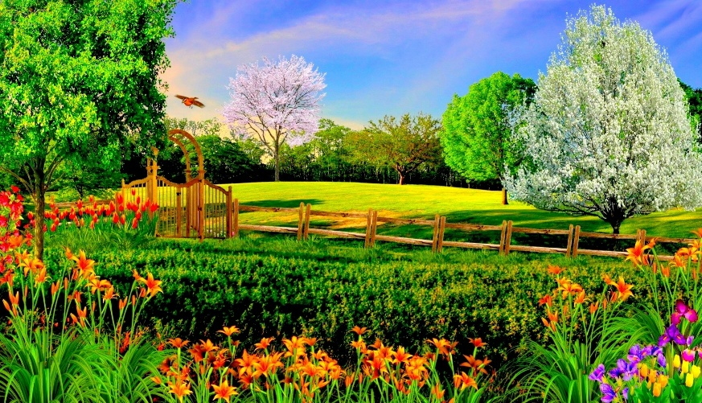

🌸 Spring is Here & Summer is on the Way! ☀️

Now is the perfect time for spring cleaning, yard maintenance, and home repairs!

✅ Tidy up your yard – Trim overgrown bushes, mow the lawn, and refresh flower beds.  
✅ Declutter & donate – Get rid of items you no longer use.  
✅ Complete home repairs – Address any needed fixes to keep your home in great shape.

*Let’s all do our part to keep our neighborhood looking beautiful!*

🏡 Community Yard Sale – May 17! 🏡

🗓 Date: Saturday, May 17  
⏰ Time: 8:00 AM – 12:00 PM  
📍 Location: Side of the office

✨ Sell your treasures & find great deals! ✨  
Bring your own table and set up your space.

📞 Sign up at the office to reserve your spot!

Don’t miss this chance to declutter, shop, and connect with neighbors!

**Office Information:**

Office #: 757-898-7794

Email: [cgfha@cgfha.com](mailto:cgfha@cgfha.com)

Website: cgfha.com

🗑️ Bulk Waste & Trash Collection Guidelines 🗑️

📅 Bulk Waste Pickup: Thursdays – Items may be placed on the curb no earlier than Wednesday afternoon.  
🚛 Dumpster Pickup: Tuesdays & Friday

🏡Single-Family Home Trash Pickup: Tuesdays, set out Monday PM

⚠ Important Reminders:  
✅ Schedule may change due to weather or holidays.  
✅ Do NOT dump trash outside of bins.  
✅ Break down boxes and close dumpster doors to keep pests out.  
🚨 Fines will be imposed for early bulk waste placement or improper disposal around dumpsters.

Let’s keep our community clean! Thank you for your cooperation

🏗️ Construction Approval Required 🏗️

Planning exterior work on your home? Before starting any construction, you MUST get approval from the office.

📌 Approval is required for:  
✔️ Roofs ✔️ Windows ✔️ Gutters

✔️ Fences ✔️ All outdoor installations

✅ Signed approval is required BEFORE work begins

✅ Share this information with your contractor to protect yourself.  
✅ All work must follow CGFHA rules, regulations, and guidelines.

📞 Have questions? Contact the office for more details. Let’s keep our community safe and well-maintained!

🚧 Contractor Waste & Disposal Policy 🚧

All contractors must dispose of construction debris properly by taking it to the Landfill on Atkinson Blvd. Illegal dumping is strictly prohibited.

🚨 See Illegal Dumping? *Take Action!* 🚨  
📸 Snap a photo of the vehicle’s license plate.  
📞 Report it to the office immediately.  
🏛 We will notify the city to impose fines.

Let’s work together to keep our community clean and free of construction waste! Thank you for your cooperation.

🚗 Visitor Parking & Towing 🚗

To ensure fair and accessible parking for all, please follow these guidelines:

✅ Visitor Parking is by Decal Only – Vehicles without a visible decal will be towed.  
✅ Residents May NOT Park in Visitor Spots – These spaces are strictly for guests.  
✅ Neighbor’s Spot? Get Permission First! – Do not park in a neighbor’s space without their consent.  
✅ Towing Authority – Residents may only call the tow company for their own property.  
✅ Reporting Issues – For other parking concerns, you must call the office at (757) 898-7794.

🚨 Avoid the hassle—follow the rules and prevent unnecessary towing! 🚨

🚗 Slow Down- Keep Our Neighborhood Safe 🚗

🏡 Speed Limit: 25 MPH throughout the entire community.

With many children walking to and from bus stops, please drive cautiously and obey the speed limit to ensure everyone's safety.

⚠ Why It Matters:  
✅ Protect children and pedestrians 🚸  
✅ Prevent accidents and unnecessary risks  
✅ Maintain a safe and peaceful community

Let’s all do our part to keep our neighborhood safe! Slow down and stay alert. 🚦

🐾 Pet Owners, Please Be Considerate! 🐾

🚨 Residents Are Complaining! 🚨

To keep our community clean and enjoyable for everyone, please clean up after your pets and always keep dogs on a leash when outside.

✔ Pick up pet waste—no one wants to step in an unpleasant surprise! 🐶💩  
✔ Use dumpsters or carry bags with you.  
✔ Keep all dogs leashed at all times, as required by Newport News city code.

Let’s work together to be responsible pet owners and great neighbors! 🏡🐕✨

🚸 Please Monitor your Children 🚸

We love seeing kids enjoying the neighborhood, but recent issues have been reported:

❌ Utility boxes are being damaged  
❌ Balls are hitting parked cars  
❌ Children are knocking on doors  
❌ Trash from drinks and snacks is being left in common areas

To keep our community safe and clean, please supervise your children while they are in parking lots and common areas. Let’s work together to protect our neighborhood and respect our neighbors! Thank you for your cooperation! 😊

🔇 Quiet Time Reminder 🔇

To maintain a peaceful and enjoyable community, please be mindful of our Quiet Time Policy: Hours: 10:00 PM – 7:00 AM. Applies to: People, pets, vehicles, and sound systems on privately owned lots Let’s be courteous and allow everyone to rest comfortably in their homes. Thank you for helping keep our neighborhood a peaceful place to live!

📜 Rules & Regulations 📜

Attention Landlords: You are responsible for providing a copy of the CGFHA Rules & Regulations to your tenants.📌 Need a Copy? Rules & Regulations are available anytime on our website: cgfha.com. Thank you for helping ensure all residents are informed and our community remains a great place to live!

🌿 Community Beautification – We Need YOU! 🌿

“We need YOU! Join us in making our community beautiful. Sign up today at the office!” We all love a clean, vibrant, and welcoming community—and you can help make it happen! Whether you have a green thumb, love DIY projects, or just want to lend a hand, there’s a way for everyone to contribute. Let’s work together to make our neighborhood a place we’re all proud to call home!

Courthouse Green First Homes

400 A Advocate Court

Newport News, VA 23608