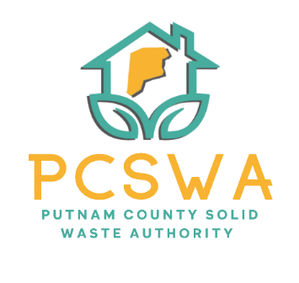
Putnam County Solid Waste Authority

Minutes

Monday, November 17th, 2025

(INCLIMATE WEATHER SHIFT FROM 11/10/25)

45:00 p.m. (Area 34/ 971-WV34 Hurricane, WV)

Before the meeting was called to order a motion to amend the agenda, add a motion to submit the PPOD Tire Grant, and Get quotes to repair the truck’s shifter linkage to new business was made by Carrie Grimm and seconded by Kim Parsons

Roll Call, Board Members Present: Kim Parsons, Carrie Grimm, Amy Blevins (On Call)
Board Member Absent: Jason Asbury, Ed Conner
Staff Present: Rob Vanater

Minutes for the September 8th and October 19th meetings were presented for review; no changes were noted. Carrie Grimm motioned to approve the minutes as presented, with a second form Amy Blevins and the motion carried unanimously.

Financial Reports (Rob went over the expenses, asked if there were any questions regarding the reports, none were raised

A motion to accept the financial statements as presented was made by Amy Blevins with the second by Carrie Grimm with a unanimous vote to follow.

Directors’ Report

Rob gave a general update on the recycling lot, he updated the board of the installation of solar lights, reflective tape, and new feather flags for better visibility. He updated the board about the CED grant received and how we will reform our grant to use some of those funds form marketing of our events since Goodwill services will be doing the events for free. Lastly, he informed the board that he is slowly working to develop a volunteer group page on Facebook as a central landing page for events, clean-ups, and other events where people can get involved with what we are doing whether on lot or out in town.

Unfinished Business

The signature cards were addressed.
  - Amy Blevins made a motion to approve the ordering of the brochures for the recycling lot from HD Media for a total of $850 for 10,000 printed and folded brochures with 4,500 of those being placed In the Putnam Herald. Carrie Grimm seconded the motion, and it carried unanimously.

New Business
  - Rob will revisit attendance for the SWMB training in April.
  - Carrie Grimm made a motion to move forward with pursuing our 2025 audit form the state auditor’s office, Amy Blevins seconded the motion, and it carried out unanimously.
  - Carrie Grimm made the motion to pursue quotes for the repair of the shifter linkage on the truck with a second from Amy Blevins followed by a unanimous vote to carry the motion.
  - A motion was made by Carrie Grimm to submit our 2026 PPOD Tire collection grant for $5,200. Amy Blevins made a second on the motion and it carried unanimously.
- Miscellaneous Business
  - After receiving the approval letter from the WVSWMB on our Commercial SW Facility Siting Plan, Carrie Grimm made a motion to approve the final plan for publishing and distribution.
  - CED Events will now coincide with tire collection in Winfield on the first Saturday each month starting December 6th.

Public Comment – No public comment given.

Next Meeting (December 8th 4pm 971 wv-34, Hurricane, WV 25526)

The adjournment was motioned at 4:40 pm

Respectfully submitted by: Rob Vanater (ED)

