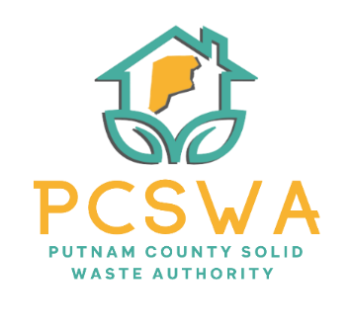

Putnam County Solid Waste Authority

Minutes

Monday, June 8th, 2026

4:00 p.m. (Area 34/ 971-WV34 Hurricane, WV)

Meeting was called to order by Kim Parsons at 4:06pm

Roll Call, Board Members Present: Kim Parsons, Ed Conner, Carrie Grimm, Amy Blevins, Dawn Lemle
Board Member Absent:
Staff Present: Rob Vanater
Guests: Brian Holley (Lot Attendant)

Minutes for the May 11th^{th} meeting were presented for review; Ed Conner Made a motion to accept the minutes with changes to date, and 2/A, with a second from Carrie Grimm and the motion carried unanimously.

Financial Reports- After reviewing the statements prepared by Rittenhouse Accounting, a motion to accept the financial statements as presented was made by Ed Conner with a second by Amy Blevins followed with a unanimous vote.

Directors’ Report

Rob Vanater gave a general update on the office and lot successes and improvements and introduced Brian Holley to the board. He talked about the amazing performance from Brian and how it has increased our overall performance with contamination.

Unfinished Business
- Carrie Grimm motioned to table Risk Assessment for further discussion in July, Amy Blevins seconded the motion, and it carried unanimously.
- Ed Conner made a motion to approve FY27 Budget as presented, Carrie Grimm made a second on the motion and the board voted unanimously in favor.

New Business
a. Rob discussed the changes to the FY27 REAP grant application that was approved at the last meeting.
8. Miscellaneous Business-
a. Rob discussed the pricing received from Rumpke for glass recycling, Ed Conner made a motion to move forward with the quote, Amy Blevins seconded the motion, and it carried unanimously.

Next meeting will be July13th at 4pm at Area 34

The adjournment was motioned at 5:06 pm by Ed Conner with a second from Amy Blevins and carried out unanimously.

Respectfully submitted by: Rob Vanater (ED) X________

X__________________________________ Chairperson

