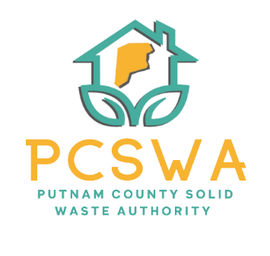

Putnam County Solid Waste Authority

Minutes

Monday August 114th, 2025

4:00 p.m.

Roll Call, Board Members Present: Jason Asbury, Kim Parsons, Amy Blevins, Carrie Grimm, Staff Present, Rob Vanater

Absent- Ed Conner

Approval of Minutes of July 14th, 2025, meeting

Amy Blevins made a motion to accept the minutes with spelling corrections with a second from Kim Parsons and the motion carried unanimously.

Financial Reports

A motion to accept the financial statements was made by Kim Parsons with the second made by Amy Blevins with a unanimous vote to follow.

Directors’ Report

Rob gave a general update on the recycling lot with the total tons of 2.32 of cardboard to date. The public response to the center has been great, with great support and cooperation by the community in sorting and breaking down boxes. The Fair board sent a very thankful letter to the Authority for their support with the waste contract at the fair. Rob informed the board that our Siting Plan has been submitted for final approval by the SWMB. Finally, Rob updated the board on how well the first woodchipper/ recycling day went as well as the ongoing status of Tire collection.

Unfinished Business

After discussing the total amount of seven of us going to the conference, Kim Parsons made a motion to pay registration and room reservation fees (Should not exceed $3,500). Amy Blevins made a second to the motion and it carried unanimously.

After a brief discussion on the updates to the MOU with the City of Hurricane regarding the lawncare of the site and surrounding area; Amy Blevins made a motion to sign the MOU with the City. Carrie Grimm seconded the motion, and it carried unanimously.

New Business

Miscellaneous Business
  - Rob was granted permission to start evaluating a budget line for a short-hour contract employee to assist with the center/ tire collection. Will report back next month.
  - Rob was granted permission to looking into cover/ carport options as a means of shelter for the woodchipper.

Public Comment – No public comment given.

Next Meeting (September 8th, 2025, PCSWA office)

The adjournment was motioned by Kim Parsons at 5:03 pm with a second by Amy Blevins.

Respectfully submitted by: Rob Vanater (ED)

