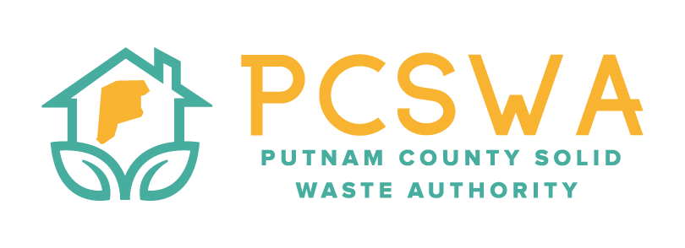

AGENDA

Monday June 8th, 2026, 4:00 p.m.

971 WV-34 Hurricane, WV 25526

Roll Call / Introduction of guests

Approval of Minutes of the May 11th,2026 meeting.

Financial Reports for last month

Revenues & Expenses

Budget vs Actual

Reconciliation

Directors Report

General update on office, and lot operations.

Unfinished Business

Risk Assessment and Internal Control Process

FY27 Budget

New Business

FY27 REAP grant application

Miscellaneous Business

Rumpkie Glass program

Public Comment – Limited to three minuets

Next Meeting (July 13th, 2026 @4:00pm PCSWA office)

Adjournment

