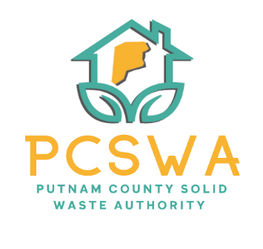

Putnam County Solid Waste Authority

Minutes

Monday, March 9th, 2026

4:00 p.m. (Area 34/ 971-WV34 Hurricane, WV)

Meeting was called to order by Kim Parsons at 4:01pm

Roll Call, Board Members Present: Ed Conner, Carrie Grimm, Amy Blevins, Kim Parsons
Board Member Absent:
Staff Present: Rob Vanater
Guests:

Minutes for the February 9th meeting were presented for review; one error noted and fixed on #1. Carrie Grimm motioned to approve the minutes with noted correction, with a second form Amy Blevins and the motion carried unanimously.

Financial Reports- after reviewing the statements prepared by Rittenhouse Accounting, A motion to accept the financial statements from February as presented was made by Amy Blevins, a second by Ed Conner and was followed with a unanimous vote.

Directors’ Report

Rob gave a general update on the condition of the lot, office, and all other events.

Unfinished Business
- We are in line for an Audit.
- After reviewing the Part time employee packet, Ed conner made amotion to more forward with the hiring process. Carrie Grimm made a second on the motion and it carried unanimously.

New Business
a. Ed Conner made a motion to authorize Rob to present the Winfield Lot proposal to County Commission. Amy seconded the motion, and it carried unanimously.
b. Bin Pricing was tabled until the next meeting.
c. After discussion Amy Blevins made a motion to approve the paper shredding partnership with PCB. PVB. And PFCU for %50 of the cost of 6 shredding events around the county. Ed Conner made a second on the motion and the board carried it unanimously.
d. Carrie made a motion to pay the AWVSWA membership fee of $200, Ed Conner seconded the motion, and it carried out unanimously.
- Miscellaneous Business
  - CED with Tires April, June, Oct, Dec
  - Bags are selling!

Next meeting will be April 13th at 4pm at Area 34

The adjournment was motioned at 5:22 pm by Carrie Grimm and a second by Ed Conner.

Respectfully submitted by: Rob Vanater (ED)

