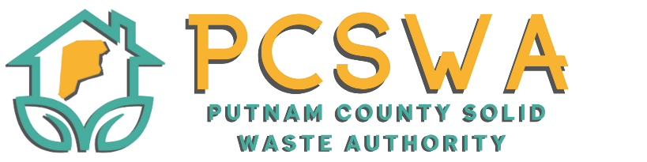
AGENDA

Sunday Oct, 19th 2025

5:00 p.m.

Roll Call.

Approval of Minutes of the September 8th,2025 meeting

Financial Reports

Financial Statment for April

YTD P&L

Financial Statment YTD

Reconciliation Report

Directors Report

Clean up, Ethics opionion, Touch a truck, Chipper day, litter control,

Unfinished Business

Motion to approve quote from City Insurance/ Geico (Only quote recieved).

New Business

Motion to approve fundraising / sponsorship program (Attached)

Motion to approve Recycing Bags Program. (Attached)

Permission to host “Fill you cup” for $250 (Educational serices hosted by the chamber, to present to businesses and individuals on recycling options and proper waste sorting methods for home and work.)

Miscellaneous Business

Public Comment – Limited to three minuets

Next Meeting (Nov, 10th 2025 PCSWA office)

Adjournment

Recycling Bag Project Proposal
Project Overview
The Putnam County Solid Waste Authority (PCSWA) is proposing the creation of heavy-duty, multiuse recycling bags to encourage cleaner, more efficient recycling throughout the county. Modeled after the durable bags used by stores such as Aldi, these reusable bags will display the PCSWA logo on the front to promote our mission and services. The reverse side of each bag will feature 3–4 local business sponsors, highlighting their support for community recycling initiatives.
Purpose and Community Impact
The goal of this project is to provide residents with a convenient and reusable option for storing and transporting recyclables. Rather than using disposable bags or loose containers, residents will have the option to purchase these PCSWA recycling bags for just $2 each. This affordable price point ensures wide accessibility, while also instilling a sense of ownership and pride in the recycling process. By normalizing the use of a uniform “recycling bag,” PCSWA hopes to increase participation, reduce contamination, and streamline recycling drop-offs.
Project Budget and Funding Model
The total project cost will not exceed $2,500, which will cover design, production, and printing of the bags. Funding will be offset through two main avenues:
- Business Sponsorships – Sponsors’ logos will be printed on the back of the bags in exchange for a financial contribution, helping to underwrite production costs.
- Bag Sales – Residents will purchase bags at $2 each, which will recoup the project expense and create a sustainable cycle for future re-orders.
Implementation Plan
- Design & Sponsorship (1 month): Finalize bag design with PCSWA branding and secure commitments from 3–4 local sponsors.
- Production (1 month): Place the order with the selected manufacturer for up to $2,500 in bags.
- Distribution (Ongoing): Bags will be made available for sale at PCSWA recycling centers, community events, and gifted through outreach programs at schools and civic organizations.
Measuring Success
- Number of bags sold and in active use.
- Increase in recycling participation and reduction in contamination at drop-off sites.
- Positive community feedback and repeat orders from residents.
Conclusion
The PCSWA Recycling Bag Project is a low-cost, high-impact initiative that directly benefits both residents and the environment. By combining community engagement, sponsorship opportunities, and practical tools for recycling, this project offers a sustainable and visible way to strengthen local recycling efforts.

Putnam County Solid Waste Authority (PCSWA)
Recycling Drop-Off Sponsorship Program
Location: Hurricane, WV
The Putnam County Solid Waste Authority is excited to offer a new opportunity for local businesses and community partners to support recycling in our county while gaining valuable visibility! Our Recycling Drop-Off Site in Hurricane, WV serves between 250–350 cars each week, making it an excellent location to advertise your business or service while showing your commitment to environmental stewardship.
Each sponsorship sign will measure 3 feet tall by 5 feet wide, printed on durable grommeted Coroplast, and securely attached to the interior fence panels of the lot. Each fence panel (7’x7’) will accommodate two sponsorship signs.
Your sponsorship directly supports the continued operation of our recycling center. All proceeds are used as emergency hauling funds and, at year’s end, any remaining balance helps sponsor local youth to attend the WVDEP Youth Environmental Camp.

Sponsorship Options
Business Fence Sign Sponsorship – $500 (First Year)
- Includes one 3’x5’ full-color sign displayed for 12 months
- Renewal Rate: $400 per year thereafter
- Non-renewed signs will be replaced with new sponsors
Wall of Donors Recognition – Any Amount Under $400
- Individuals or businesses donating under $400 will be listed on our “Wall of Donors” sign, recognizing your dedication to our mission

Sponsorship Information
Business / Organization Name: _________________________________________
Contact Name: _______________________________________________________
Phone Number: ____________________ Email: ___________________________
Mailing Address: _______________________________________________________
Sponsorship Option (check one):
☐ Business Fence Sign Sponsorship – $500
☐ Renewal – $400
☐ Wall of Donors Donation – $____________
Please make checks payable to: Putnam County Solid Waste Authority
Memo: Recycling Sponsorship Fund
Mail to:
Putnam County Solid Waste Authority
971 WV-34 Ste.5
Hurricane, WV 25526

Sign Design: Sponsors may provide a print-ready design (3’x5’, full color, horizontal layout).
If you’d like assistance with design, PCSWA staff can coordinate layout for an additional fee.
Thank you for supporting local recycling efforts and helping us build a cleaner, greener Putnam County!
For questions or to submit artwork, please contact:
📧 info@pcswa.org ☎️ 681-235-3276

