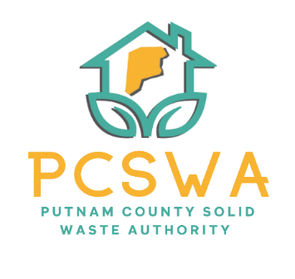

Putnam County Solid Waste Authority

Minutes

Sunday, October 19th, 2025

5:00 p.m. (Canaan Valley Resort Pine Room)

Roll Call, Board Members Present: Kim Parsons, Amy Blevins, Carrie Grimm, Ed Conner Staff Present, Rob Vanater
Board Member Absent: Jason Asbury

Minutes for the September 8th meeting will be presented in Nov for approval (Rob did not have them emailed with the packet as previously thought.)

Financial Reports (Rob went over the expenses asked if there were any questions regarding the reports.

A motion to accept the financial statements was made by Amy Blevins with the second made by Carrie Grimm with a unanimous vote to follow.

Directors’ Report

Rob gave a general update on the recycling lot, the success of this year’s clean ups, told the board about the Touch a truck event at Gritts Farm, chipper day and how well the Litter Control program is going this year. Rob also expressed his excitement at the positive response from the WV Ethics Commission for sponsorship programs for the lot.

Unfinished Business

After discussion Carrie Grimm made a motion to accept the insurance quote received with a second by Amy Blevins, and the motion passed with a unanimous vote.

New Business
  - Amy Blevins made a motion to approve the sponsorship program which Ed Conner made a second on and the vote was unanimous.
  - Ed Conner motioned to approve the recycling bag program with a second by Carrie Grimm as well as a unanimous vote to follow.
  - Carrie Grimm made a motion to approve the “Fill your Cup” speaking event for $250 with the Putnam Chamber to educate on our offerings and proper method of sorting for work and home. Amy made a second on the motion and it carried unanimously.
- Miscellaneous Business

Public Comment – No public comment given.

Next Meeting (November 10th 4pm 971 wv-34, Hurricane, WV 25526)

The adjournment was motioned at 5:29 pm

Respectfully submitted by: Rob Vanater (ED)

