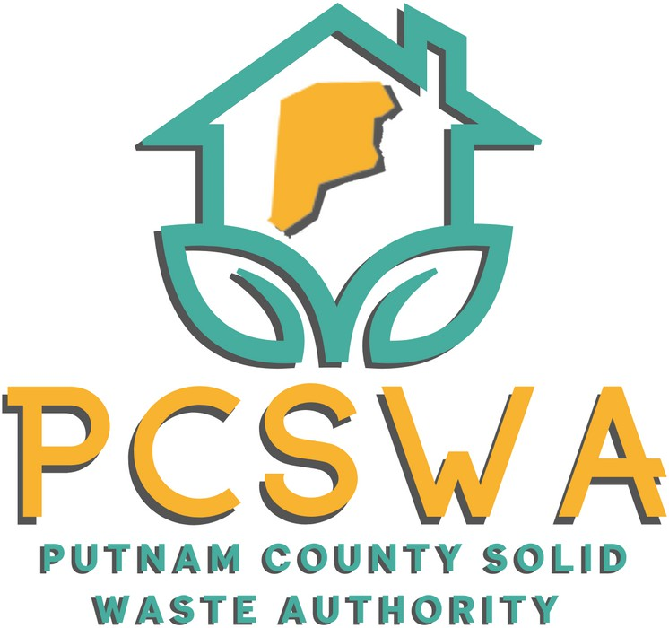

**Minutes**

Monday July 14th, 2025

4:00 p.m.

1. Roll Call, Board Present, Kim Parsons, Amy Blevins, Carrie Grimm, Staff Present, Rob Vanater

Absent- Jason Asbury, Ed Conner

1. Approval of Minutes of the June 9th, 2025, meeting

Amy Blevins made a motion to accept the minutes with corrections with a second from Carrie Grimm and the motion carried unanimously.

1. Financial Reports

A motion to accept the financial statements was made by Amy Belvins with the second made by Carrie Grimm, a unanimous vote to follow.

1. Directors’ Report

Rob informed the board about the change in our phone carrier from Comcast to Verizon to accommodate the cameras for the recycling center. The board saw the camera view from the lot. Rob also informed the board about the FY26 litter control grant which we were granted $4,000 for the year. He also informed the board of the completion of our Ground Water Protection Plan and non-exposure permitting with the DEP. Finally, he updated the board on the lower cost for the engineering from Triad for the encroachment permit.

1. Unfinished Business
   1. After reviewing, a motion to approve the minutes from the June 2nd Siting Plan public hearing was made by Carrie Grimm and seconded by Amy Blevins with a unanimous vote following.
   2. Carrie Grimm made a motion to submit Solid Waste Facility Siting Plan to the WVSWMB for review and final approval with a second from Amy Blevins followed by a unanimous vote.
2. New Business
   1. Officer Elections, Amy Blevins nominated Jason Asbury to be Board Chair, that nomination was seconded by Carrie Grimm and a unanimous vote. Carrie Grimm nominated Amy Blevins as Treasurer, Kim Parsons seconded that nomination it was approved unanimously.

Amy Blevins nominated Kim Parsons as Vice Chair with a second from Carrie Grimm and a unanimous vote followed.

* 1. The board viewed five items from Amazon that include a small storage building and maintenance tools for the recycling center totaling around $452. Amy Blevins made a motion to approve the purchase with a second from Carrie Grimm followed by a unanimous vote.

1. Miscellaneous Business
2. Public Comment – Limited to three minutes
3. Next Meeting (August 11th, 2025, PCSWA office)
4. Adjournment was motioned by Amy Blevins at 5:06 pm with a second by Carrie Grimm.

Respectfully submitted by: Rob Vanater (ED)