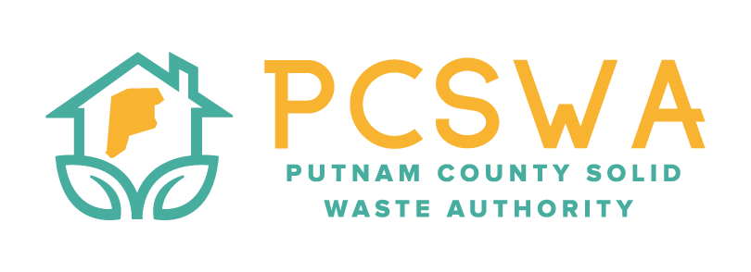

AGENDA

Monday July 13th, 2026, 4:00 p.m.

971 WV-34 Hurricane, WV 25526

Roll Call / Introduction of guests

Approval of Minutes of the June 8th,2026 meeting.

Financial Reports for last month prepared by Kathy Rittenhouse (CPA)

Revenues & Expenses

Budget vs Actual

Reconciliation

Directors Report

General update on office, and lot operations.

Unfinished Business

Risk Assessment and Internal Control Process

FY27 REAP grant application

Glass Program

New Business

26’ Fair July 10th - 18th

Budget amendments

Board Member Elections

Miscellaneous Business

Rumpke Glass program

Public Comment – Limited to three minuets

Next Meeting (August 10th, 2026 @4:00pm PCSWA office)

Adjournment

