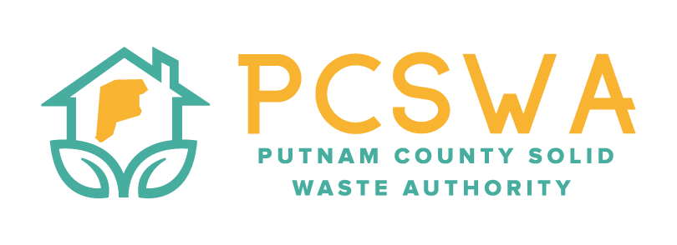

AGENDA

Monday May 11th 2026, 4:00 p.m.

971 WV-34 Hurricane, WV 25526

Roll Call / Introduction of guests

Approval of Minutes of the April 13th,2026 meeting.

Financial Reports for last month

Revenues & Expenses

Budget vs Actual

Reconciliation

Directors Report

General update on SWMB Training, office, and lot operations.

Unfinished Business

FY24-25 Audit

Sign P-Card Packet for submittal

New Business

Review Risk assessment and internal control process, first reading.

FY27 budget committee

Miscellaneous Business

Procedure for paying office expenses as they are received throughout the month.

Procedure for handling office mail.

Public Comment – Limited to three minuets

Next Meeting (June 8th, 2026 @4:00pm PCSWA office)

Adjournment

