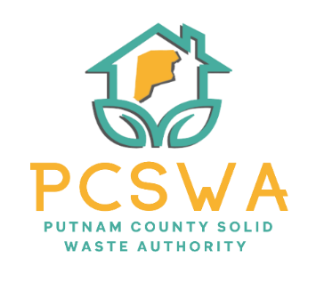

Putnam County Solid Waste Authority

Minutes

Monday, May 11th, 2026

4:00 p.m. (Area 34/ 971-WV34 Hurricane, WV)

Meeting was called to order by Amy Blevins at 4:05pm

Roll Call, Board Members Present: Ed Conner, Carrie Grimm, Amy Blevins
Board Member Absent: Kim Parsons
Staff Present: Rob Vanater
Guests: Kristen Kelley (Leadership Putnam)

Minutes for the April 13th^{th} meeting were presented for review; Carrie Grimm made a motion to accept the minutes as presented, with a second from Ed Conner and the motion carried unanimously.

Financial Reports- After reviewing the statements prepared by Rittenhouse Accounting, a motion to accept the financial statements as presented was made by Ed Conner with a second by Carrie Grimm followed with a unanimous vote.

Directors’ Report

Rob Vanater gave a general update on the sessions from SWMB Training and went over a few upcoming changes that he would like to look at that would make things operationally smoother and more aligned with the standards of the SWMB and WV State Audit practices. The amazing performance from our lot attendant has increased our overall performance with the processors and the response from them to the lowest contamination has been amazing.

Unfinished Business
- Rob Vanater reported that our ‘25 audit report has been posted to the WV State Auditors website.
- P-Card Package ready to submit.

New Business
a. Rob Vanater and the Board reviewed the Risk Assessment and Internal Control Process to be adopted at the June meeting.
b. Carrie Grimm, Amy Blevins, and Rob Vanater will meet on May 26th at 8:30am to discuss and create the FY27 budget.
8. Miscellaneous Business-
a. Carrie Grimm made a motion to give the Executive Director/ Office Manager authority to pay routine monthly office and operational expenses as they are received to maintain normal business operations. All expenses must be supported by invoices, receipts, or other appropriate documentation, and copies of all invoices and payments made since the previous meeting shall be included in the financial review packet provided to the Board at each regular board meeting. Ed Conner made a second on the motion and it was carried unanimously.
b. Carrie Grimm made a motion to create a procedure to have all mail received on behalf of PCSWA opened and date-stamped by designated Putnam County Chamber of Commerce staff upon receipt. Mail containing invoices, payments, bank statements, or other financial documents shall be forwarded promptly to the appropriate PCSWA officer or staff member for processing and recordkeeping. This procedure is intended to provide appropriate segregation of duties and support accurate financial oversight and internal controls. Ed Conner seconded the motion and a unanimous vote followed.

Next meeting will be June 8th at 4pm at Area 34

The adjournment was motioned at 5:19 pm by Ed Conner with a second from Carrie Grimm and carried out unanimously.

Respectfully submitted by: Rob Vanater (ED) X________

X__________________________________ Chairperson

