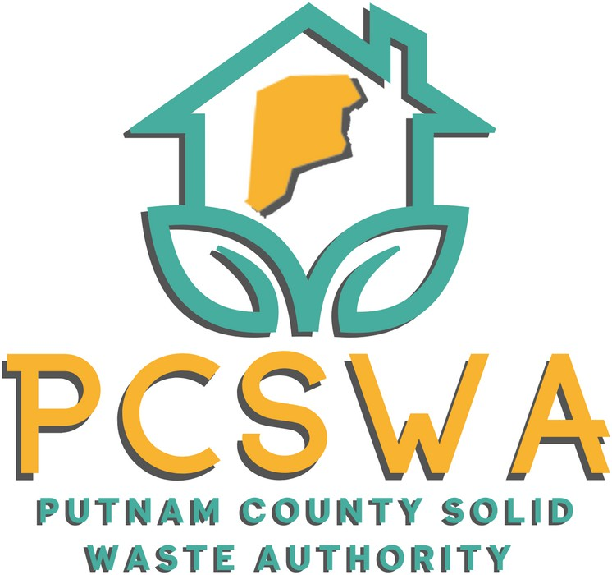

**AGENDA**

Monday July 14th, 2025

4:00 p.m.

1. Roll Call.
2. Approval of Minutes of the June, 9th, 2025 meeting
3. Financial Reports
   1. Financial Statment for June
   2. YTD P&L
   3. Financial Statment YTD
   4. Reconciliation Report
4. Directors Report

Phone Swapped to Verizon, Cameras Active (View?), Litter Control FY26’ $4,000, non exposure permit filed, triad (half price)

1. Unfinished Business
   1. Review and make motion to approve minutes from the June 2nd Siting Plan public hearing.
   2. Motion to sumbit Commercial Solid Waste Facility Siting Plan to the SWMB for final approval.
2. New Business
   1. Board Officer Elections
   2. Site Enhancments for Recycing Center $452 for whole package. (Packet inculded) Motion to purchase/ Motion to shop around more?
3. Miscellaneous Business
   1. Discussion of items/ actions to write for on the DEP/REAP recycling grant.
4. Public Comment – Limited to three minuets
5. Next Meeting (August 11th 2025 at the PCSWA office)
6. Adjournment



971 WV-34 / Suite 5

Hurricane, WV 25526

[www.pcswa.net](http://www.pcswa.net/)

[info@pcswa.org](mailto:info@pcswa.org)

681-235-3276