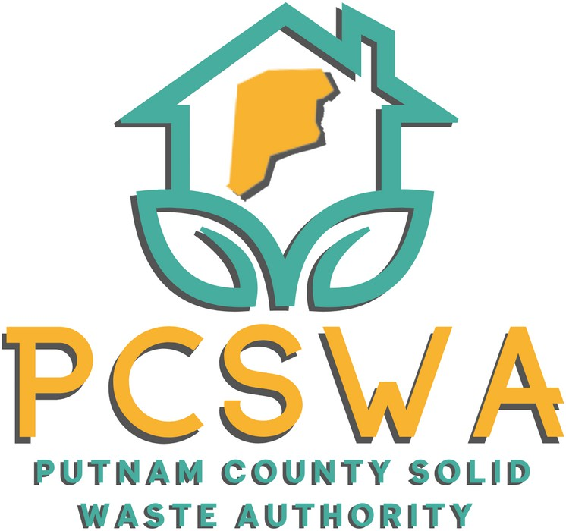

**AGENDA**

Monday May 12, 2025

4:00 p.m.

1. Roll Call.
2. Approval of Minutes of the April, 14th, 2025 meeting
3. Financial Reports
   1. Financial Statment for April
   2. YTD P&L
   3. Financial Statment YTD
   4. Reconciliation Report
4. Directors Report
   1. Tire Collection, Podcast May 30th, Hometown Clean-up June 14th, Hurricane Site, SWMB Grant, Earth Day, Commercials
5. Unfinished Business
   1. Vote on Bin Purchase for Hurricane Center from the three bids provided.
6. New Business
   1. Form Budget Committee
   2. Vote on time for Aduit Exit Interview (After June Meeting?)
7. Miscellaneous Business
   1. According to the Auditors we are complete and i am hopeful to schedual the interview
   2. Final Hauling quote from MSW is attached this is the quote used to apply for the SWMB grant from hauling asssistance vs bin purchase.
   3. Hurricane Site Projections
   4. Election Discussion for June (as a full board may not be present)
8. Public Comment – Limited to three minuets
9. Next Meeting (June, 9th 2025 PCSWA office)
10. Adjournment



971 WV-34 / Suite 5

Hurricane, WV 25526

[www.pcswa.net](http://www.pcswa.net/)

[info@pcswa.org](mailto:info@pcswa.org)

681-235-3276