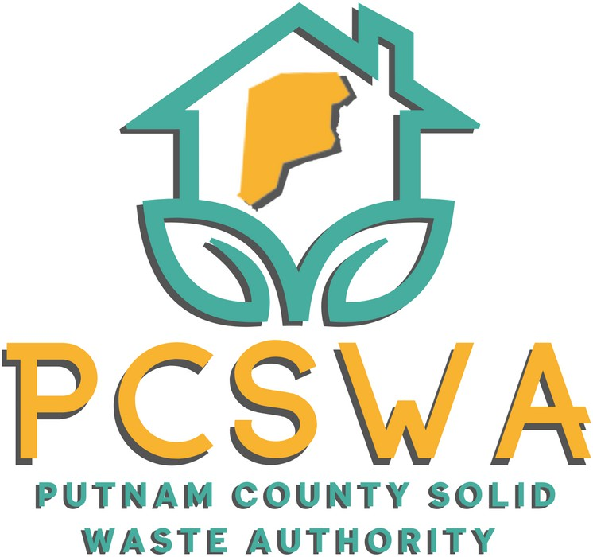

**AGENDA**

Monday August, 11th 2025

4:00 p.m.

1. Roll Call.
2. Approval of Minutes of the July, 14th, 2025 meeting
3. Financial Reports
   1. Financial Statment for April
   2. YTD P&L
   3. Financial Statment YTD
   4. Reconciliation Report
4. Directors Report

Center Update 2.32 ton cardboard week 1&2, public responce, County Fair Follow up, Siting Plan sent, Tire and recycle day udates

1. Unfinished Business
   1. Confrence Update and final count
   2. Motion to pay registration and book rooms for confrence Aprox ($3,500) depending on final count.
   3. MOU with City of Hurricane, review and approve
2. New Business
   1. AARP Grant (“Can Canpaign”) $1,000
3. Miscellaneous Business
   1. Permission to start the budget evaluation and search process for a short hour contract employee for site operations and Tire collection assistance when needed.
   2. Permission to Look into carport options for the Wood Chipper, (In Pack)
4. Public Comment – Limited to three minutes
5. Next Meeting (September, 8th 2025 @ the PCSWA office)
6. Adjournment



971 WV-34 / Suite 5

Hurricane, WV 25526

[www.pcswa.net](http://www.pcswa.net/)

[info@pcswa.org](mailto:info@pcswa.org)

681-235-3276