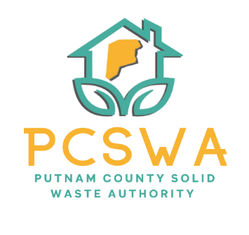

Putnam County Solid Waste Authority

Minutes

Monday, April 13th, 2026

4:00 p.m. (Area 34/ 971-WV34 Hurricane, WV)

Meeting was called to order by Amy Blevins at 4:00pm

Roll Call, Board Members Present: Ed Conner, Carrie Grimm, Amy Blevins
Board Member Absent: Kim Parsons
Staff Present: Rob Vanater
Guests: None

Minutes for the March 9th meeting were presented for review; A change was noted on section 7/c to correct spelling. Carrie Grimm made a motion to accept with changes, with a second from Ed Conner and the motion carried unanimously.

Financial Reports- after reviewing the statements prepared by Rittenhouse Accounting, A motion to accept the financial statements from March by Ed Conner and a second by Carrie Grimm followed with a unanimous vote.

Directors’ Report

Rob Vanater gave a general update on the condition of the lot, office, and all other events.

Unfinished Business
- Rob Vanater reported that our 25’ audit is complete.
- The bin purchase was tabled until the REAP grant cycle.
- Rob Vanater announced the hiring of Brian Holley as the part-time lot attendant.

New Business
a. After a discussion on the P-Card program, Ed Conner made a motion to start the onboarding process with a second on the motion from Carrie Grimm. The motion carried unanimously.
b. Rob Vanater announced that the PPOD Tire grant was approved and received.
c. After reviewing the purchase order, Carrie Grimm made a motion to purchase the amazon cart of items for a total of $280.95 including bags, grabbers, and gloves, Ed Conner made a second on the motion and it carried unanimously.
d. Carrie Grimm made a motion to use $600 of the CED grant to run and ad for the year in the Putnam Herald with a second from Ed Conner and a unanimous vote to follow.
- Miscellaneous Business- None

Next meeting will be May 11th at 4pm at Area 34

The adjournment was motioned at 4:43 pm by Carrie Grimm and it carried out unanimously.

Respectfully submitted by: Rob Vanater (ED) X________

X__________________________________ Chairperson

