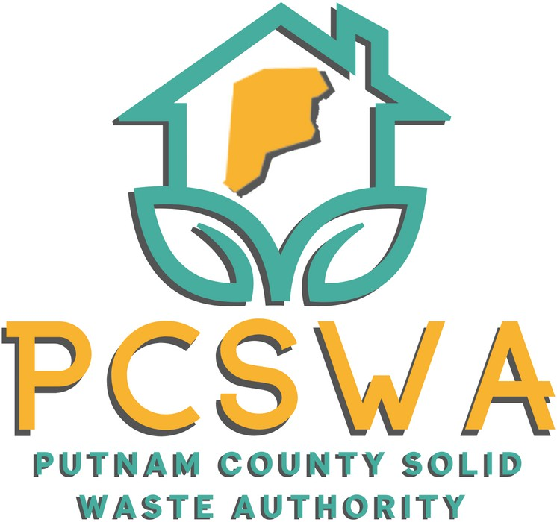

**AGENDA**

Monday June, 9th 2025

4:00 p.m.

1. Roll Call/ Introduction of Guests
2. Approval of Minutes of the May, 12th, 2025 meeting
3. Financial Reports
   1. Financial Statment for April
   2. YTD P&L
   3. Financial Statment YTD
   4. Reconciliation Report
4. Directors Report
   1. Hurricane Site update, Litter Control Update,
   2. Recycling Coalition Growing, YEP Covered
5. Budget Committee Report
   1. Review nd Approval of FY26’ Budget
6. Unfinished Business
7. New Business
   1. Board members expirations/ appointments
8. Miscellaneous Business
   1. Report from public hearing for Commercial Siting Plan
   2. Fianl Look at payments for Bins and Site to close out FY25’
9. Public Comment – Limited to three minuets
10. Next Meeting (July, 14th 2025 PCSWA office)
11. Adjournment



971 WV-34 / Suite 5

Hurricane, WV 25526

[www.pcswa.net](http://www.pcswa.net/)

[info@pcswa.org](mailto:info@pcswa.org)

681-235-3276