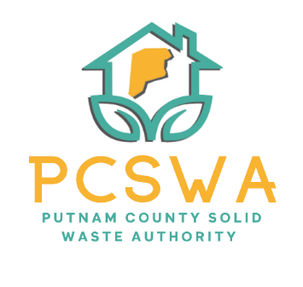
Putnam County Solid Waste Authority

Minutes

Monday, February 9th, 2026

4:00 p.m. (Area 34/ 971-WV34 Hurricane, WV)

Meeting was called to order by Amy Blevins at 4:05pm

Roll Call, Board Members Present: Ed Conner, Carrie Grimm, Amy Blevins, Kim Parsons (On Call)
Board Member Absent:
Staff Present: Rob Vanater
Guests:

Minutes for the January 12th meeting were presented for review; two no errors were noted. Carrie Grimm motioned to approve the minutes as presented, with a second form Ed Conner and the motion carried unanimously.

Financial Reports- after reviewing the statements prepared by Rittenhouse Accounting, A motion to accept the financial statements from November as presented was made by Kim Parsons with the second by Ed Conner with a unanimous vote to follow.

Directors’ Report

Rob gave a general update on the condition of the lot, office, and all other events.

Unfinished Business
Rob informed the board that our 25’ fiscal audit would take place in April.

New Business
a. Ed Conner made a motion to pay dues for the recycling coalition in the amount of $150 annually, with a second from Carrie Grimm and it carried unanimously.
b. After discussing a part-time employee, Carrie Grimm made a motion to table the subject for further research, Ed Conner seconded the motion, and it carried unanimously.
c. Rob discussed the CED refund with the board and said that we will keep $1,000 for marketing our event throughout the year.
d. Rob went over the calendar of events for the year with he board.
- Miscellaneous Business
  - Bags are in and sells have started!
  - We have three signs getting printed for the lot from our sponsorship program.
  - CED Collections will happen in conjunction with Tire Collection in Feb, April, June, Oct, and Dec.

The adjournment was motioned at 5:08 pm by Carrie Grimm and a second by Ed Conner.

Respectfully submitted by: Rob Vanater (ED)

