PUTNAM COUNTY SOLID WASTE AUTHORITY
COMPREHENSIVE LITTER AND SOLID WASTE
CONTROL PLAN

2014 Update

2020 Update
APPROVED BY THE PUTNAM COUNTY SOLID WASTE AUTHORITY ON October 20, 2014

TABLE OF CONTENTS (check page numbers after edits)
Introduction 1
Executive Summary 2
Goals and Objectives 3
Status of Existing Solid Waste Activities 4
Funding Strategy 6
Hierarchy of Solid Waste Disposal 7
Assessment of Litter and Solid Waste Problems in Putnam County 8
Evaluation and Assessment of Solid Waste Collection and Disposal Services
Waste Hauler Information 9
Demographic and Population Projection Information 11
Geological Information 13
Transportation 15
Recommendation for Siting of a Landfill 16
Timetable for Implementation of Plan 17
Cleanup and Open Dump Programs 17
Voluntary Assistance Programs 17
Coordination with Other Entities 18
Use of Inmates for Litter Pick Up 18
Identification of Out of County Waste 19
Mandatory Disposal 20
Provisions to Assist Law Enforcement 20
Facilities Generating More Than Five Tons of Solid Waste 21
Amendment Process 22
Conclusions 22
Comprehensive Recycling Plan 23
Appendix A — Maps
Wasteshed Map
Waste Hauler Map
Land Use Map
Soils Map
Appendix B — Mandatory Disposal Program
WV Rule 33CSR7
Putnam County Model Ordinance
Sample Mandatory Disposal Letter
Info Card
Appendix C — Public Participation Process
Class I Legal Ads
Minutes to Public Hearings

INTRODUCTION
The Putnam County Comprehensive Litter and Solid Waste Control Plan is an outline of the current and future activities, and goals of the Putnam County Solid Waste Authority. This plan is mandated by law and is governed by the regulations developed by the West Virginia Solid Waste Management Board.
Solid waste management in West Virginia involves a host of state and local agencies: Department of Environmental Protection, Division of Natural Resources, Public Service Commission, Division of Highways, Conservation District, Solid Waste Management Board, as well as local health departments, planning commissions, county commissioners, mayors, and city councils.
Solid waste disposal impacts every household and business in Putnam County. The availability of dependable and reliable solid waste services is a benefit for the entire community. Putnam County residents are fortunate in that two landfills exist in the area and that curbside collection service is universally available. However, we are still evolving from a culture that has widely accepted open burning and open dumping as proper means of solid waste disposal. There is still much to do and this plan is but an outline of things that need to be done. Hopefully this document will service our citizens well and encourage the proper management of solid waste.

EXECUTIVE SUMMARY
The Putnam County Solid Waste Authority has had a successful tenure in providing service to the residents of Putnam County. The past five years have seen major changes in the ability of the Putnam County Solid Waste Authority to address solid waste issues. During the planning process the Authority had two public hearings and members had work meetings to discuss what we were doing and where we were going. The entire year of 2010 was a transition year for the Authority as our previous Chief Administrator retired in August and a new Executive Director was hired in October. The Authority made a concerted effort that by being a more active volunteer body we could provide more service to the general public. New members and new ideas have led us into new directions that will benefit the community. These shared ideas and hopes for a cleaner Putnam County will be achieved in the coming years as the Authority works to implement this plan of action.
The plan concludes that existing and future disposal needs of Putnam County can be met with existing facilities; that recycling and reuse opportunities in the county will expand over the next five year period; and that Putnam County must address new issues such as electronics recovery, and mobile home recycling in the not too distant future. The plan outlines the Authority's ever growing involvement in litter control and open dump cleanup, and through projects like "Pick It Up Putnam", the county will become a cleaner place.

COMPREHENSIVE LITTER AND SOLID WASTE CONTROL PLAN GOALS AND OBJECTIVES
Every five years the Putnam County Solid Waste Authority is required to update the Comprehensive Litter and Solid Waste Control Plan for Putnam County. The Plan acts as a mechanism for guiding the Authority over the next twenty years and moving it toward the successful completing of its statutory responsibilities.
The general goals of the Authority have not drastically changed since our initial plan was implemented in 1992. Along the way we have had successes and failures, but have continued to move forward. The following is a list of the long-term goals of the Putnam County Solid Waste Authority in accordance with rules and regulations established by the WV Solid Waste Management Board:
- To encourage and participate in road side cleanup projects;
- To ensure the availability of adequate solid waste pick-up and disposal services to residents of Putnam County;
- To promote recycling, composting, and source reduction by residents, businesses, and government offices throughout the county;
- To assist local governments and community organizations in the cleanup and removal of illegal dumps throughout Putnam County;
- To coordinate solid waste activities between various state, local, and private organizations for the betterment of Putnam County;
- To work with local solid waste hauling, landfill, and recycling companies in improving solid waste services that are available to the residents of Putnam County;
- To educate Putnam County residents on the proper means of disposing of solid waste;
- To encourage the purchase of materials made from recycle content products;
- To encourage the removal of dilapidated buildings;
- To assist in statewide river sweeps and cleanups;
- To encourage recycling to youth by promoting school contests and having recognition awards; educating school aged youth by providing in school and public library programs, as well as contests.
- To sponsor annual recycling days in which electronics scrap metal, tires and white goods are collected;
- To encourage participation in recycling by all county youth groups and schools;
- Establish paper recycling drop-offs at local post offices and county courthouse; and
- Continue to sponsor a sludge land application program with local farmers.

STATUS OF EXISTING SOLID WASTE ACTIVITIES
Currently Putnam County has two private landfills that are permitted by the Department of Environmental Protection. Sycamore Landfill, Inc., owned by Allied Waste Systems, is located on Sycamore Creek. Disposal Services, Inc. owned by Waste Management, Inc., is located on Hurricane Creek. Both landfills are permitted to accept up to 20,000 tons per month and have a current base rate per ton of waste of $30.00 $33.75 at Sycamore and $45.50 $40.00 at DSI. In addition, a state and local assessment fee of $8.75 per ton is also charged. The City of St. Albans also operates a transfer station (SWF-5026) just inside the Putnam County line. The transfer station handles approximately 709 tons per month. A survey of landfill operators conducted by the WV Solid Waste Management Board in 2013 estimates the remaining life of Sycamore Landfill as less than 40 years and that of Disposal Services of 25 54 years.
Other solid waste facilities that merit attention are the three transfer stations that utilize landfills in Putnam County. These are public transfer stations in Boone County located at Madison and Fosterville, and Refuse Disposal operated by Waste Management, Inc. in Peck's Mill, Logan County. Municipal solid waste landfills located in close proximity to Putnam County include:
- The City of Charleston Landfill, Kanawha County, West Virginia
- Green Valley, Greenup County, Kentucky
- Gallia County, Bidwell, Ohio
- Athens-Hocking, Nelsonville, Ohio
Putnam County is located in Wasteshed H which includes Boone, Cabell, Calhoun, Kanawha, Lincoln, Logan, Mason, Roane, and Wayne counties. Mason County was added to the Wasteshed in order to exempt it from an assessment fee that has since been repealed (Appendix A - Wasteshed Map Attached.) It is projected by the WV Solid Waste Management Board that the landfill tonnage in 2015 was 35,520 per month. Of this amount, Putnam County is estimated at contributing 3,904 tons per month. Projections thru 2025 for the Wasteshed and Putnam County respectfully are 34,649 and 3,917 tons. The Wasteshed is serviced by the two landfills in Putnam County and the City of Charleston, Kanawha County.
Waste tires were banned from disposal in municipal solid waste facilities in the mid 1990's. Three permitted waste tire monofills are located in West Virginia. These are in Nicholas, Lewis and Preston counties. These facilities were specifically designed to accept waste tires and to hold the tires until some future date. Currently, a Putnam County Resident is in the process of opening a monofill outside of Hurricane city limits. The application process has begun, and the Authority is hopeful that the monofill will be operating within the next five years. The tires can then be reclaimed. West Virginia's waste tire law authorizes tire dealers to charge a fee for tire disposal when a customer purchases a new tire, even if the customer wants to take the waste tire back. The fee is generally between $1.00 - $2.00 per passenger or light duty tire. Approximately 99% of all waste tires are now handled by tire dealers and the waste tire monofills.

The Solid Waste Authority has authorized There is one recycling center in Putnam County; West Virginia Cashin Recyclables in the Nitro Industrial Park. Today that program is completely self-sufficient and is completely operated by WV Cashin recyclables
The Authority does not have any regulatory responsibility toward salvage yards. These facilities are governed by the Putnam County Commission and the Putnam County Planning Commission.
Recycling services offered by solid waste collection services include commercial and cardboard programs, appliance recycling in conjunction with the bulky goods program, and residential household services in selected areas of Putnam County. Waste Management offers residential recycling services in all of Putnam County south of the Kanawha River and in the Poca area. Recycled materials such as steel, aluminum cans, cardboard, and appliances can be taken to West Virginia Cashin Recyclables.
The Authority continues to work with E&L Sanitation and has a drop-off location located at Red House. In addition, the Authority has assisted the City of Hurricane with their one drop-off recycling center including the purchase of a chipper. WV Cashin Recyclables assists the Authority in meeting its' recycling goals by having drop-off locations at the Courthouse, Nitro and a paper recycling box in Poca.
The Authority is now working with local solid waste collection service to expand their recycling services on selected materials. We have placed a newspaper collection box at the office of E&L, Inc. and have developed a public drop-off center at WV Cashin Recyclables. The Authority has run several ads in local Putnam County newspapers about the availability of recycling services. The Putnam County Commission has authorized the placement of an office paper, newspaper, and aluminum can recycling containers at the Putnam County Courthouse complex.
Composting and land application of sludge has been a major solid waste concern of the Authority. The Authority works with local waste water treatment facilities like Nitro and St. Albans in providing beneficial uses of sludge. The Authority has developed a program that includes 16 approved farms in Putnam County. Participating operators have access to two Authority owned sludge spreaders. The goal of this program is to simultaneously reduce the cost of sludge management to local waste water treatment facilities, increase grass, and hay yields on pastoral acreage. This program recycles about 1,800 tons of sludge per year and initial crop research shows higher grass yields in treated fields.
In 2010, the Authority purchased a new Vermeer wood chipper for the City of Hurricane. The chipper is to be used for the chipping of tree limbs and tree waste from city streets and parks. The chipper will also be used for Christmas tree recycling. The program is available to all county residents on select days of each week. In 2014 the chipper was transferred to the City of Hurricane.

FUNDING STRATEGY
For each fiscal year, the Solid Waste Authority shall review the previously listed goals. The objectives of the Solid Waste Authority are to work towards achieving and maintaining the previously listed goals. Incorporated in this plan is an outline of our projected yearly activities as they relate to our long-term goals.
In carrying out the goals of this plan, the Authority has access to the following financial resources:
- A monthly stipend assessment fee from the West Virginia Solid Waste Management Board.
- Recycling or solid waste management grants from the Department of Environmental Protection, and the West Virginia Solid Waste Management Board.
- State funds made available for open dump cleanup and waste tire removal.
- A monthly assessment fee of $0.50 per ton levied on solid waste disposed of at landfills in Putnam County.
Currently, the Putnam County Solid Waste Authority receives about $124,000 $95,000.00 per year from the county assessment. The Authority receives approximately $25,000 per year from the WV Solid Waste Management Board. The Authority currently spends about $97,000 per year on solid waste programs. The Authority has made major purchases of equipment utilizing available grant funds. The Authority has no outstanding debts.
The Putnam County Solid Waste Authority has utilized existing income and grants for the following activities:
- Personnel
- Countywide Cleanup
- "Pick It Up Putnam" Litter Control Program
- Mandatory Disposal
- Recycling
- Public and In-school Education and Advertising
- Dilapidated Buildings
- Open Dump Cleanup
- Disaster Assistance
- Composting/Sludge
- Mobile Home Recycling
- E-Waste Events
- Public Advertisements
- Litter Control Program
The Authority, Putnam County 4-H and WV Cashin have a scholarship program that not only promotes recycling but provides a means by which recycling containers can be transported for free. This reduction in transportation costs has helped reduce our recycling costs.

HIERARCHY OF SOLID WASTE DISPOSAL

Each Solid Waste Authority must adopt a hierarchy of solid waste management activities that will guide the Authority over the next five years. For the purposes of this plan, the Authority has adopted the following solid waste activities in descending order of preference.

Incineration: Currently, there are no solid waste incinerations operating in Putnam County. Incineration is banned by state law as a means of disposal and the Authority concurs. Inc. W Va. Code §22C-4-1 establishes an integrated waste management hierarchy on which to base these comprehensive plans. In order of preference, the hierarchy is as follows:
- Source reduction.

2) Recycling, reuse, and materials recovery.
3) Landfilling. ineration is not a favored means of solid waste disposal.i
I would suggest reversing the order of these – placing
- Landfills: The Solid Waste Authority supports the private ownership of landfills in the county and will encourage the continuance of such as long as all state regulations are complied with and the operations continue to be a valuable asset to the community.
- Recycling/Composting: The Solid Waste Authority will continue to support and promote recycling and composting activities.
- Source Reduction
The Authority has supported the established hierarchy through program efforts over the past five years. These actions include:
- Establishment of appliance recycling program.
- Establishment of recycling drop-off sites at Nitro, Poca, Red House, Winfield, and Hurricane.
- Establishment of a sludge land application program.
- Establishment of a wood mulching program in the City of Hurricane.
- Establishment of a school education program involving contests.
- Continue to run monthly stories and advertisements on solid waste management activities.
- Mobile home and structure recycling program.
- Actively engage in public education on these issues.
- Paper, newspaper and aluminum can collection at the county Courthouse.
- Newspaper collection at many post offices throughout the county.
- Assisted the Putnam County Day Report with a pick-up truck and Durango, which has assisted them in their roadside cleanup efforts.

ASSESSMENT OF LITTER AND SOLID WASTE PROBLEMS
The Authority works very closely with both the DNR and DEP in identifying and enforcing open dumping and littering laws, and collects about $500-$1,000 annually in fines. The Authority has plastic litter control signs that are distributed to the public but are also placed in certain areas of the county. The Authority also additionally has in place its own dilapidated building program in which burned out buildings or condemned property or property that is viewed as a safety hazard belonging to low income individuals within a certain income limit can be demolished.
The Authority tries to reduce open dumping and littering through our "Pick It Up Putnam" program. The program which began in 2002 features nearly six weeks of solid waste activities. This includes a countywide cleanup. Advertising is done by newspaper ads, banners, and public service announcements. Adopt-A-Highway groups are notified and the Authority provides litter reachers to participating persons.
Major litter and open dumping problems still exist in the following areas:
Ventroux Hollow
Scary Creek
Midway Hollow
Poca River Road
Fletcher Road
Heizer-Manila Creek
Red House Hill
Manilla Ridge
Route 60
Route 35
Route 34
Route 62
Route 817
Teays Valley Road

In addition to these major roadways, litter is heavy on Teays Valley Road, Poca River Road, Eighteen Mile Creek Road, and Poplar Fork Road.
In the past ten years, most of the major dumps in Putnam County have been cleaned up. Current dumping problems tend to be automotive equipment, shingles or home construction debris, dead dear, and an occasional bulky good. The majority of dumps that the Authority finds can be cleaned up for less than a thousand dollars.
In conjunction with the DEP-REAP's-Pollution Prevention Open Dump Program (PPOD), the Putnam County Solid Waste Authority has cleaned up 452 dumps, removing 3,354 tons of material removed, reclaiming 453 acres and 67,287 tires since the programs inception in 1989. 316 open dumps, removing 3,100 tons of material, reclaiming 301 acres of land and removing 53,758 tires since 1989.

EVALUATION AND ASSESSMENT OF SOLID WASTE COLLECTION AND DISPOSAL SERVICES WASTE HAULER INFORMANTION
Current solid waste collection services are more than adequate to serve the future needs of Putnam County. Curbside collection service is available to 98% of residents. Residents also have access to two landfills and one free day per month that can be utilized for the proper disposal of waste. Regular bulky goods collection is available; recycling services are available in most parts of the county; and the Authority conducts spring and fall cleanups which are open to all county residents. In addition, the Authority also provides funding for cleanup activities in all municipal areas of Putnam County.
Putnam County is serviced entirely by two solid waste collection services: Waste Management and E&L, Inc. Since 1992 several changes have occurred in the collection services offered to Putnam County residents. E&L, Inc. acquired the former Vaughan Collection Service that operates in Red House, Bancroft, and Buffalo areas. Waste Management acquired both Don's Disposal, which provides commercial services in a portion of the county and Ron's Disposal, which provided services along the Putnam/Jackson County line. The Waste Hauler Map (Appendix A) provides a general outline of the service territories of the two waste collection companies operating in Putnam County.
Both companies hold operating certificates from the West Virginia Public Service Commission. Rates for service are established by the Commission and the public is afforded input into the rate making process through public notice and comment. The Commission has both inspectors and legal staff that are obligated to resolve conflicts between the different solid waste companies, or between the companies and their customers. In reviewing the descriptions of the territories served, it can be concluded that all residents in Putnam County have access to solid waste collection service. Residential rates vary in Putnam County. Residents are charged just over $15.00 per household by E&L, Inc. and $17 by Waste Management. This fee by Waste Management includes any recycling of newspaper, plastic bottles #1 & #2, and steel and aluminum cans. Commercial service is provided by both carriers in selected areas of Putnam County.
Residential subscription rates in Putnam County are quite high by West Virginia standards. E&L, Inc. and Waste Management service about 15,000 households in the county. The City of Nitro provides residential service to several hundred households in the Putnam County portion of the city. Mobile home parks and apartment complexes are treated as commercial accounts in most cases.
Waste Management as the largest provider of residential services has, over the past few years, been an innovator in residential services. The company has a six bag limit on regular subscriptions at $17.74 with each additional bag costing $1.14. The company has introduced robotic container pick-up in two thirds of the service area. Specialized trucks with only one employee pick up thirty and ninety-five gallon containers. The driver does not leave the truck and approximately 850 households can be serviced in a single day. This is nearly double the collection efficiency of a rear loader compactor with two men crews.

In the fall of 2013, the Putnam County Solid Waste Authority was informed that Allied Waste would be accepting new customers in the Hurricane area for trash service and recycling. The trash and recyclables are currently transported to Kentucky.
In 1998-99, the West Virginia Public Service Commission required regulated solid waste carriers to implement a monthly residential bulky goods program. Bulky goods are those oversized items that are normally generated by household, examples include appliances and furniture. The program called for one regularly scheduled pick up a month when residential customers would be allowed to place up to two bulky good items on the curb for collection. The cost of this service is $0.50 per month. Non customers would be afforded the same service for a fee of $15.00. Some exceptions were made for Freon containing items like freezers and refrigerators. Both Waste Management and E&L, Inc. will take two televisions per month on their bulky goods day.

DEMOGRAPHIC AND POPULATION PROJECTION INFORMATION
Putnam County is a 352 square mile (225,280) county located in the southwest portion of the state, surrounded by Cabell, Mason, Lincoln, Jackson, and Kanawha counties (Appendix A - Land Use Map.) The Kanawha River, moving slowly northwestward to the Ohio River, nearly bisects the county. Putnam County, for the most part, is a rural county but is one of the fastest growing counties in the state. With the construction and completion of Interstate 64 linking such population/industrial centers as Huntington and Charleston, the area along 1-64 became prime development property for residential and small service-oriented businesses.
As depicted in the Land Use Map, most of the development/population increase has occurred along two areas, Teays Valley and along the Kanawha River. Industrial/commercial development occurs mostly along the major transportation arteries of Route 35 and 62, which parallel the Kanawha River, Routes 60 and 34, and Interstate 64. While some residential development is occurring in the outlying areas, these areas are still characterized as rural privately owned agricultural/forested areas. The Land Use Map depicts the major transportation facilities as well as county roads.
Over the past ten years, Putnam County has seen continued population growth both in corporate and incorporated areas. Between 2000 and 2010 incorporated areas of Putnam County changed by the following amounts:
 |  | 2000 | 2010
 | Bancroft | 367 | 587
 | Buffalo | 1,171 | 1,236
 | Eleanor | 1,345 | 1,518
 | Hurricane | 5,222 | 6,284
 | Nitro | 6,824 | 7,178
 | Poca | 1,013 | 974
 | Winfield | 1,858 | 2,301

Hurricane and Winfield were all in the top twenty growing communities in the state. The overall population of Putnam County increased from 51,589 in 2000 to 55,486 in 2010. Only those counties in the Eastern Panhandle of West Virginia had larger population rates of growth. Putnam County grew by 3,897 persons or at a rate of 7.5% for the decade.
Over the next five years Putnam County's growth rate will continue to increase but at a slower rate. We anticipate by 2020 having about 56,450 58,400 residents according to U.S. Census Quick Facts. Most of the growth will occur in rural areas. We don't anticipate this having any adverse impact on solid waste services.
The construction of major There are two major manufacturing facilities has also occurred located in Putnam County. The two most notable are Toyota Motor Company and Diamond Electric. Both plants are located on the North side of the Kanawha River along Route 62 between Eleanor and Buffalo. In addition, a major new bridge has been was constructed linking Buffalo to Route 35. A major new expansion of the Winfield Locks has also been undertaken as well as interstate improvements. Teays Valley, Hurricane, Winfield, and the Putnam County section of Nitro have seen a number of new commercial establishments. Riverfront developments seem to be increasing in population along both the Kanawha and Poca Rivers. New, but more scattered developments, seems to be taking place along the Jackson, Mason, and Cabell County lines.

New public or industrial developments that could impact economic and population growth over the next ten years include the upgrade of Route 35, construction of a major airport in Lincoln County, and expansion of the Toyota engine and transmission plants. The county could adversely be affected by a decline in chemical and manufacturing activity in adjacent Cabell and Kanawha counties. Constraints on water and sewer might limit population growth in upcoming years.
GEOLOGICAL INFORMATION
SOILS
Five soil units occur in Putnam County with Fill-in-Upshur Vendalia being the predominate series (Source: Putnam County Soils, USDA, 1958.) The soils distribution is illustrated on the Soil Map (Appendix A).
Kanawha-Linside-Urban Land
The land unit consists of soils and urban land along the Kanawha River. Covering about six percent of the county, this unit is about 11 percent Kanawha soils, 11 percent landside soils, 8 percent urban land, and 70 percent soils of minor extent. Most of this land unit is cleared and used for cultivated crops and hay, or for urban development. The hazard of erosion is slight or moderate. The Kanawha soils have few, if any, limitations for community development. The seasonal high water table and hazard of flooding in the low areas are the main limitations of the Landside soils for community development. The seasonal high water table, moderately slow to slow permeability, hazard of flooding, slippage, and depth to bedrock is the main limitations of the minor soils for community development.
Moshannon-Vandalia-Senecaville
This land unit consists of soils along Eighteen-Mile Creek, Five and Twenty Mile Creek, Hurricane Creek, Little Hurricane Creek, Trace Creek, and the Pocatalico River. Covering about six percent of the county, this unit is about 27 percent Moshannon soils, 24 percent Vandalia soils, 9 percent Senecaville soils, and 40 percent soils of minor extent. The hazard of flooding is the main limitation of the Moshannon soils for community development. The slope, moderately slow to slow permeability, high shrink—well potential, low strength, clayey texture, and the hazard of slippage are the main limitations of the Vandalia soils for community development. The hazard of flooding and seasonal high water table is the main limitations for the Senecaville soils for community development. The hazard of flooding, season high water table, and depth to bedrock, high shrink swell potential, slope, and hazard of slippage are the main limitations of the minor soils for community development.
Monongahela-Vincent
This land unit consists of soils on terraces in Teays Valley, covering about four percent of the county and consists of 28 percent Monongahela soils, 18 percent Vincent soils, and 54 percent soils of minor extent. The slope, seasonal high water table, and moderately slow to slow permeability are the main limitations of the Monongahela and Vincent soils for community development. The slope, seasonal high water table moderately slow to very slow permeability; hazard of flooding, depth to bedrock, and hazard of slippage are the main limitations of the minor soils for community development.

Upshur-Gilpin-Vandalia
This land unit consists of the soils on uplands and foot slopes in the north eastern part of the county. It covers about 26 percent of the county and is 39 percent Upshur soils, 30 percent Gilpin soils, 7 percent Vandalia soils and 24 percent soils of minor extent. The slope, moderately slow to slow permeability, hazard of flooding, seasonal high eater table, and depth to bedrock is the main limitations of the minor soils for community development.

Gilpin-Upshur-Vandalia

This land unit consists of soils on uplands and foot slopes in the central and southern parts of the county. It covers about 58 percent of the county. This unit is about 48 percent Gilpin soils, 19 percent Upshur soils, 5 percent Vandalia soils, and 28 percent soils of minor extent. The slope and depth to bedrock are the main limitations of the Gilpin soils for community development. The slope, moderately slow to slow permeability, high shrink-swell potential, clayey texture, and hazard of slippage are the main limitations of the Upshur and Vandalia soils for community development, the erosions are moderate to severe. The slope, moderately slow to slow permeability, hazard of flooding, seasonal high water table, and depth to bedrock is the main limitations of the minor soils for community development.
Flora and Fauna
Typical vegetation cover types for the county include open agricultural, pasture, and croplands, wetlands, and flood plains, and forested regions comprised mostly of oak (Quercus sp.), American beech (Fagys Qrandifolia), Virginia pine (virinana), hickory (Caaa so.), tuplic poplar (Liriodendron tulip fera), and maples (Acer sp.). Wildlife typically associates with the cover types described above includes white tail deer (odocoileus virqinianus), squirrel (Sciurus spo.), Chipmunk (T"amias striatus), grounding (Marmot a monax), rabbit (Svlviliagus floridanus), and striped skunk (Mephitis mephitis). The county is well populated with various species of songbirds, warbles, game birds, raptors, and owls due to the variety of and suitability of habitat, which exists for these birds.

TRANSPORTATION INFORMATION
Major roadways used for the movement of solid waste include Routes 60, 35, and 34. Most traffic entering Putnam County's two landfills is moving West along Route 60 then South along Route 34. Roadways are more than adequate for existing traffic. The St. Albans Transfer Station is located along Route 35 but is screened and has very good truck access. No solid waste is transported by existing rail or barge lines. Increased litter along Route 60 is really the only major problem connected with waste transportation.
Out-of-state waste haulers tend to concentrate their routes along 1-64 and major side roads. These companies usually focus on commercial accounts that are located near major interstate exits
New Route 35 and its future completion could change the way waste is transported in the county.

RECOMMENDATION FOR SITING OF A LANDFILL

The Authority continues to support the location and operation of the two existing landfills in Putnam County. The expected landfill capacity is adequate for increased growth over the next twenty years. The Authority does not anticipate utilizing an out-of-county facility. The Authority has not encountered any problems with the operation of St. Albans Transfer Station. The Authority does not see need to open a public recycling facility given the current availability of services in the county.

TIMETABLE FOR IMPLEMENTATION OF PLAN
Current and Ongoing Projects
Program | 20142020 | 20192025 | 20242030 | 20292035 | 20342040
Open Dump Clean Up* | X | X | X | X | X
Litter Control* | X | X | X | X | X
Mandatory Collection* | X | X | X | X | X
Recycling Education* | X | X | X | X | X
Agency Coordination* | X | X | X | X | X
Prison Program* | X | X | X | X | X
E-waste* | X | X | X | X | X
Mobile Home Recycling* | X | X | X | X | X
Dilapidated Building* | X | X | X | X | X
Pharmaceuticals** | X
*All programs are intended to be ongoing based the availability of funds and labor. **Conducted by the Putnam County Sheriff's Department.
CLEAN UP AND OPEN DUMP PROGRAMS
- Continue to cooperate with community groups in their annual cleanup projects.
- Cooperate with the towns and cities of Winfield, Poca, Eleanor, Bancroft, Buffalo, Nitro, and Hurricane in their annual cleanups.
- Organize clean ups for both the Kanawha and Poca Rivers.
- Assist in maintaining and keeping clean public wildlife management areas and public fishing areas. These include the Amherst Wildlife Area and public fishing areas at Black Betsy and Buffalo.
Within these four areas, the Authority will be responsible for assisting with the financing the cleanup and organizing volunteer activities. All projects will be done in cooperation with the appropriate state agencies.
VOLUNTARY ASSISTANCE PROGRAMS
- Continue to promote work with Adopt-A-Spot and Adopt-A-Highway. Use of litter reachers, safety signs, hats, and other promotional items.
- Continue to work with local probation office in utilizing juveniles to do roadside litter and dump cleanups.
- Continue to track litter violators and work with local magistrates for community service hours for litter control.
- Continue to provide litter reachers, hats, and other items as part of the "Pick It Up Putnam" program.

COORDINATION WITH OTHER ENTITIES

- Continue to hold waste summit meetings.
- Evaluate the use of litter vacuums for use along Route 60 with the Department of Highways.
- Coordinate activities of DOH with the "Pick it Up Putnam" Committee.
- Work with DOH and Day Report on getting volunteers to maintain Park and Ride areas.
These are ongoing projects that the Authority is involved in. Over the next twenty years the Authority will probably have to invest in mechanical vacuums for litter control. These could be very useful in suburban areas and along major routes like US 60. We have placed two mechanical vacuums with Parks and Recreation, and two with the County Commission.
USE OF INMATES FOR LITTER PICK UP
- Continue to utilize community service hours and volunteers for litter and open dump cleanup.
- Develop waste warriors t-shirts and other items such as hats, stickers, and logos that will make these young people feel they are doing something really appreciated by the public.
- Limit the use of regional jail inmates litter cleanup on federal highways.
- Continue to use alternate sentencing and community service for litter violations.
The Authority has used incarcerated individuals in the past for litter cleanup and has found their use of limited value. With our regional jail inmates you are paying for transportation and supervision. Our prior experience with the use of regional jail inmates is a large number of public does not want such persons along their roads or in their neighborhoods. Long-term litter collection over the next twenty years will become more mechanized.

IDENTIFICATION OF OUT OF COUNTY WASTE
Putnam County has two landfills that serve as regional disposal facilities. Kanawha, Cabell, Lincoln, Mason, Wayne, and Boone County all contribute some waste to the local landfills.

MANDATORY DISPOSAL
The PCSWA recognizes and supports WV Code §22C-4-10 and WV Rule 33CSR7, Proof of Proper Solid Waste Disposal laws.
The Putnam County Solid Waste Authority has previously adopted rules for the disposal of all solid waste generated by residents and businesses. The model ordinance is included as an attachment. Such rules attest that all residents and businesses shall subscribe to solid waste collection service or regularly utilize a proper solid waste facility for disposal. The Authority regularly sends letters to individuals who have dropped off garbage service about their legal obligations. In some cases complaints about persons misusing garbage dumpsters or not properly disposing of their waste is forwarded to the Division of Natural Resources and the Department of Environmental Protection. In addition to letters, the Putnam County Solid Waste Authority also runs news releases and newspaper ads that outline the requirements of proof of proper disposal. The Solid Waste Authority works very closely with the West Virginia Division of Natural Resources and the Department of Environmental Protection. In recent years, the Authority has received assistance in using the endorsement powers of these two offices in cleaning up unsightly areas and reducing solid waste problems associated with mobile home parks.
The PCSWA also assists with:
- Informing the public about free day.
- Works with the county commission, planning commission, magistrates and law enforcement officials.
- Cooperates with the landfills.
- Providing info cards regarding mandatory disposal.
- Assists the county commission with dilapidated building issues.
Copies of WV Rule 33CSR7, the Putnam County model ordinance, sample mandatory disposal letter and info card is included in Appendix B.
PROVISIONS TO ASSIST LAW ENFORCEMENT
In an effort to better assist local law enforcement officers in enforcing mandatory disposal, the Authority has used surveillance cameras, mailed out letters, and worked with solid waste carriers to identify problem households, The Authority has also used our waste summit meetings to educate magistrates and other legal authorities about the issue.

FACILITIES GENERATING MORE THAN FIVE TONS OF SOLID WASTE
Major waste generators in Putnam County producing more than five tons monthly include the following:
American Electric Power
Power Plant Services
Putnam County School Board
Kroger
Diamond Electric
Toyota Motor Company
CAMC Teays Valley
McJunkin
Wal-mart
Foodland Piggly Wiggly
WV Cashin
Putnam County Schools
Goodwill Industries
Tasty Blend
Parkline
Home Depot
Lowes
Ashley Furniture
Big Sandy

AMENDMENT PROCESS
A mandatory update must take place every five years however, the plan can be amended at any time. A public notice and hearings on updates or amendments shall be given and held in the same manner as described in Title 54 Legislative Rules, Series 3, Section 7. A revised plan is to cover a period of twenty (20) years and the Solid Waste Management Board must approve amendments in the same manner as the previous plan.
Minutes from the Putnam County Solid Waste Authority meetings in which the new, updated or amended plan is approved should include:
- New, updated or amended plan.
- Previous plan submitted for approval by the Solid Waste Management Board.
- Minutes signed by the Chairman.
- Authority's responsibility that it is legally constituted to conduct business.
CONCLUSIONS
The Putnam County Solid Waste Authority feels that at this time, the current solid waste collection services are more than adequate to serve the future needs of the residents of Putnam County.
Over the next twenty years, the Authority also plans to work towards achieving the following:
- Continued growth in recycling, especially paper, occ, aluminum, electronics, tires and organics
- Increased involvement in pharmaceutical recycling.
- More involvement in school recycling curriculum.
- More involvement in school organic waste. Management and training. This is associated with high tunnels crop production.
- Increase awareness of free day and proper solid waste disposal practices.
- Broaden roadside cleanup activities and continue to explore little vacuums with day report program.
- Develop recycle, composters, and waste management program.
- Work with magistrates and law enforcement to enforce litter and solid waste laws.

COMPREHENSIVE REYCLING PLAN
The Authority, in developing this plan, is looking at effective recycling activities that can be encouraged and are feasible given location, costs and processing capability.
First, the Authority does not see itself as the primary provider of recycling services for Putnam County. We are to encourage, coordinate, and help develop an infrastructure that will provide our residents recycling services at reasonable costs.
Second, at this time, the Authority does not want to make recycling mandatory at curbside. The northern part of Putnam County is very rural and a drop-off recycling program may be more efficient than a curbside program in that area. Currently recycling drop-off locations exist at Red House, Poca, Nitro, Hurricane, and Winfield. Curbside service is available in select areas of Hurricane and Teays Valley. The Authority is working to develop a practical and quality recycle program for plastic #1 and #2 bottles. Recycling plastics has been problematic for many years because of contamination.
The Authority will also concentrate on recycling electronics and organics over the next five years.
COLLECTION AND PROCESSING
Characterization of Waste Stream
According to a study released by the US Environmental Protection Agency entitled, Municipal Solid Waste Generation, Recycling, and Disposal in the United States: Facts & Figures for 2012 2010, it was determined that the average waste generated per person per day is now 4.38 4.43 lbs. the 2010 US Census noted that Putnam County had a population of 55,486 persons.
Based on the calculations of 4.38 4.43 lbs. of waste per person, and a population of 55,486 people, the monthly solid waste projections for Putnam County would be 3,645.43 3,738 tons per month.
The following table shows the monthly recycling potential based on the waste stream characterization study for Wasteshed F and H, as conducted for the West Virginia Solid Waste Management Board by GAI Consultants.
Monthly Recycling Potential
Material | Percentage in  Wastestream | Wastestream in  Tons | Percentage  Recyclable | Recyclable Tons
Paper | 45.4% | 1,697 | 22.4% | 837
Plastics | 15.4% | 576 | 13.0% | 486
Glass | 7.8% | 291 | 7.8% | 291
Metals | 5.3% | 198 | 5.0% | 187
Misc. | 26.1% | 976 | 0.0% | 0
Totals | 100% | 3,738 | 48.2% | 1,801

By taking the above data into consideration, the Putnam County Solid Waste Authority has chosen to designate paper, metals, and misc. as the three recyclable materials that can be most effectively source- separated by the consumer.
EXISTING AND ANTICIPATED MARKETS
Markets for materials collected in Putnam County include the following:
Appliances Mansback Metals, Ashland, Kentucky
Cardboard Jefferson Smurfitt, Ohio; Inland Container, Maysville, Kentucky
Aluminum Cans ALCOA Recycling, Pennsylvania
Steel Cans Tube City, PA
Newspaper Jefferson Smurfitt, Ohio; Bowater Paper, Tennessee
Office Paper Lind Paper, Montana
Plastic Recycling Rumpke Recycling, Kentucky
The Authority does not anticipate any new markets opening up for Putnam County materials. Presently most materials are baled at West Virginia Cashin Recyclable and sold in tractor trailer loads. Both intermediate and final end markets are utilized. West Virginia Cashin Recyclables has the capacity to handle over 150 tons of recycled material daily. Given the capacity of the operation, the Authority does not see a need to engage in direct processing of recycled materials.
Sludge from St. Albans treatment plants is land applied on Putnam County farms using the Authority's equipment. The market conditions for a composting operation are somewhat limited at this time.
The Authority estimates that the recovery rate of the following recycled items is being carried out in Putnam County:
- Aluminum Cans | 75%
- Steel Cans | 75%
- Appliances | 90%
- Cardboard | 60%
- Newspaper | 35%
- Office Paper | 30%
- Plastic Containers | 1%
- Sludge | 75%
- E-Waste | 30%
- Textiles | 30%

Residential curbside collection accounts for about 20% of the volume collected. Commercial collection accounts for about 30% of the volume and drop-off and buy back represents about 50% of the volume.

POTENTIAL STRATEGIES FOR COLLECTION OF MATERIALS
The Authority does not anticipate any additional program requirements for yard waste and tires. The Authority keeps a record of existing tire dealers that accept tires for disposal. Both landfills accept tires for a fee and the Authority promotes tire recycling.
PUBLIC EDUCATION PROGRAM
In recent years, the Authority has worked with local health department in providing public service announcements and newspaper ads on the relationship between solid waste and encephalitis. The Authority also participates in WV Recycles' activities by holding an open house and giving away recycled content prizes. Newspaper articles printed in local papers highlight the program and the importance of recycling and source reduction. The Authority will continue to promote this its education program as part of its recycling logo and coloring contests. At times, there are, in conjunction with WV Recycles activities and at other times, they are the Authority's own effort. Each year, the Authority puts together a recycling display at the Putnam County Fair. The Authority, on a regular basis, has made contributions to the Putnam County Library for books and other media about recycling and source reduction to be purchased and placed in circulation. School visits have been made by Authority personnel.
The Authority tries to work with existing organizations in the area to promote recycling. The Authority holds a waste summit every year with public and private organizations to enlist their ideas on solid waste in Putnam County. Lions Clubs, Adopt-A-Highway groups, and the Chamber of Commerce are regular participants.
The Authority has good relationships with local newspapers and stories are regularly carried by Putnam County papers. Television coverage has mostly focused on the illegal tire dumps in Putnam County.
- Regular newspaper ads and articles.
- Direct contact with community groups.
- Contact with schools, 4-H, boys and girls scouts, and civic originations.
- Promotes WV recycle activity coloring contest and essay contest.
- Participates in Earth Day activates.
- Holds awards assembly for school kids.
- Annual awards meeting in December, with all of our cooperating individuals and agencies.
- Educates the County Commission of recycling awareness.
- Addresses the Chamber of Commerce Recycling Committee on a regular basis.
- Annual Association meeting and monthly association meetings.
- Network of Putnam County women.
- Promotes the Putnam County recycling contests.

APPENDIX A - MAPS
Wasteshed Map
Waste Hauler Map
Land Use Map
Soils Map

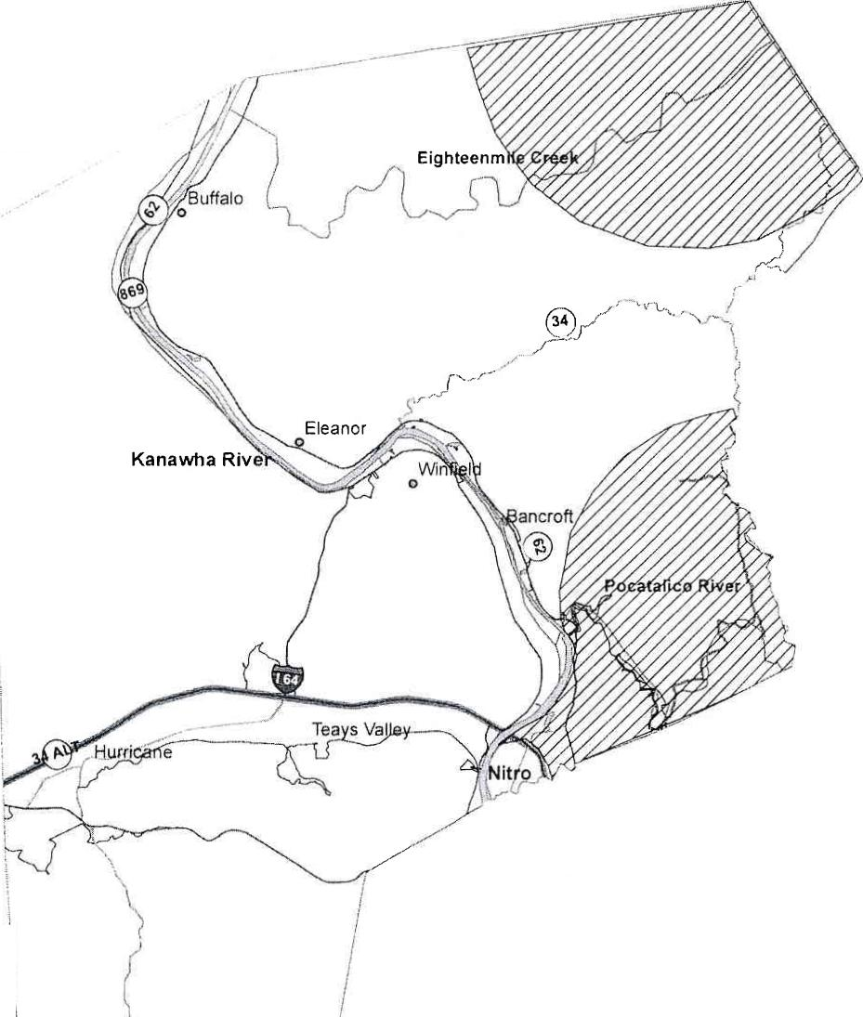
Putnam Waste Hauler Map

Hauler Territories
Waste Management, Inc. E&L Refuse

L
// r

Hauler Territories
E&L Refuse provides services to Putnam County by authority of P.S.0 M.G. Certificate F-4691.
_{I}
Waste Management, Inc. provides services to Putnam County by authority of the following Permits and Certificates:
P.S.C. M.C. Certificate F-6768, P.S.C. M.C. Certificate F-6769, P.S.C. M.C. Certificate F-7014, P.S.C. M.C. Certificate F-7020, P.S.C. M.C. Certificate F-7460, P.S.C. M.C. Permit H-10296,
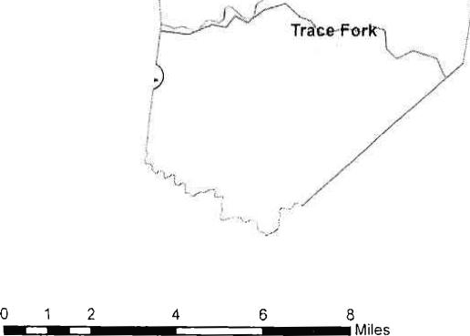
2
8
4
6
'N. (
Tr'ice-Fork
0 1
Miles
P.S.C. M.C. Permit H-10789.
Waste hauler territories are complex and don't lend themselves well to mapping. This map is intended for planning purposes only. Anyone in need of information on hauler territories should contact the West Virginia Public Service Commission.

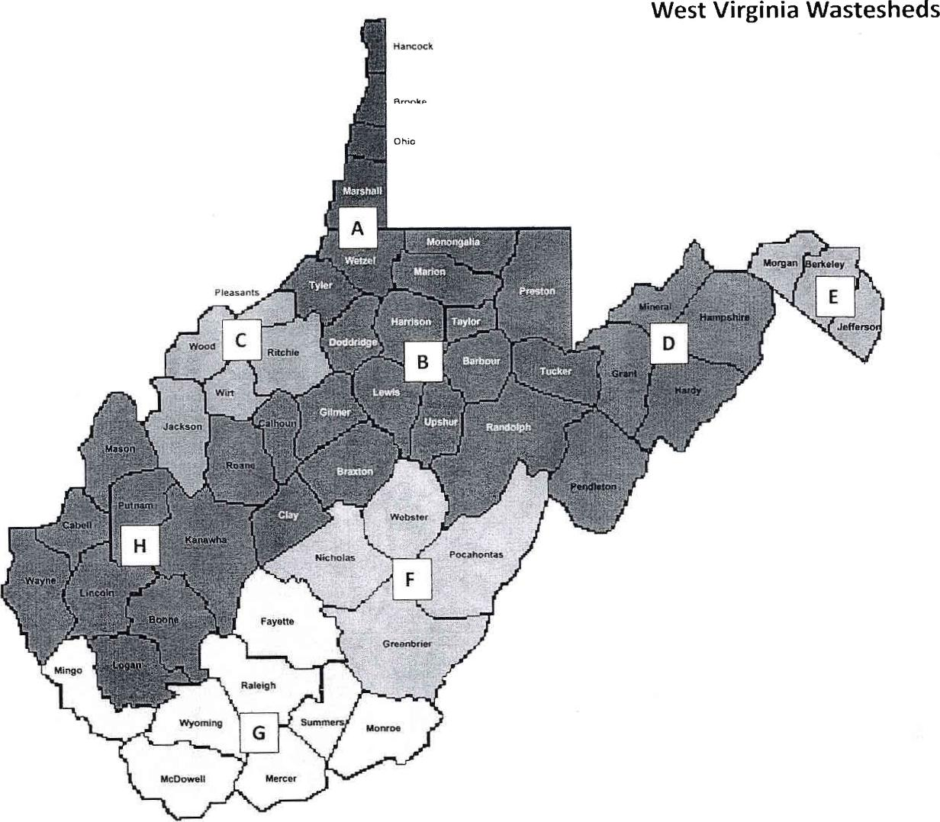
West Virginia Wastesheds
Ohio
j
olAAAA.A,4,₄
Pleasants
^{IL}*

kliocrat
A HamprAhirt
Gran
Jackson
e,

St
Webster
Pocahontas
Fayette
Greenbrier
Raleigh
Wyoming _{G}
McDowell
Mercer

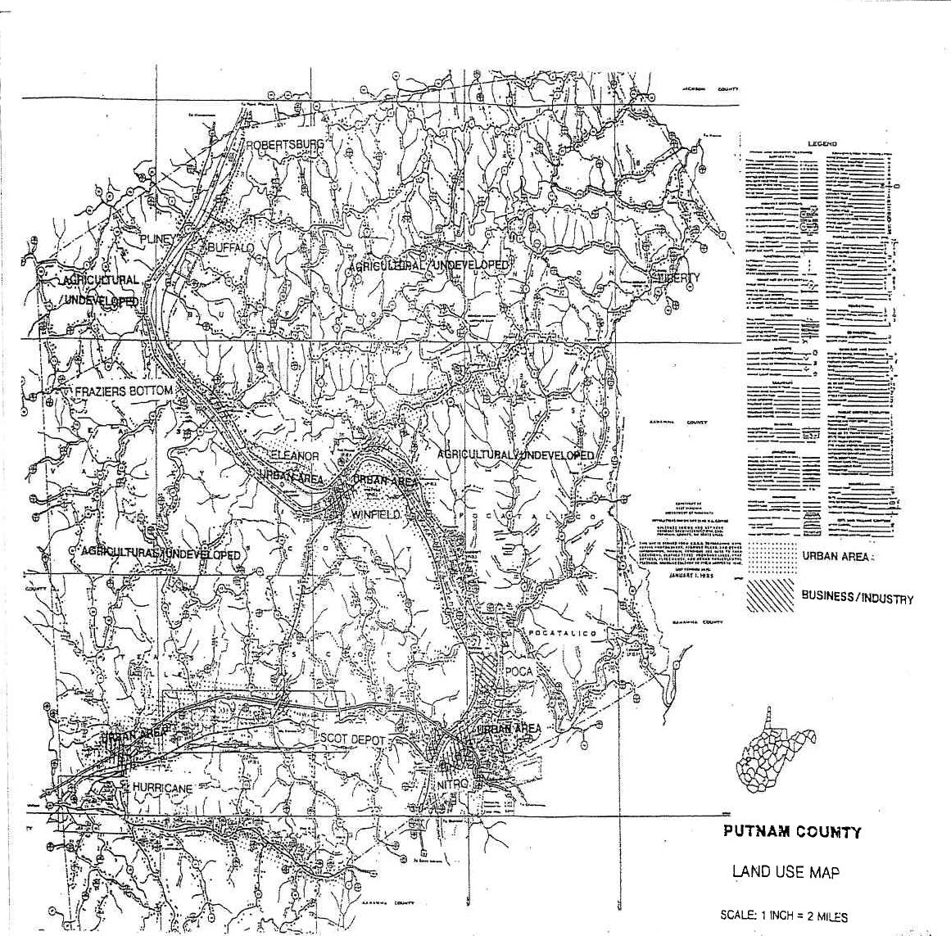
...•••••
RY
s r.
FRAZIERS BOTTOM
RIfL~RALI
N., ylday.
ary =7
URBAN AREA:
BUSINESS /INDUSTRY
/
POCA
PUTNAM COUNTY LAND USE MAP
SCALE: 1 INCH = 2 MILES

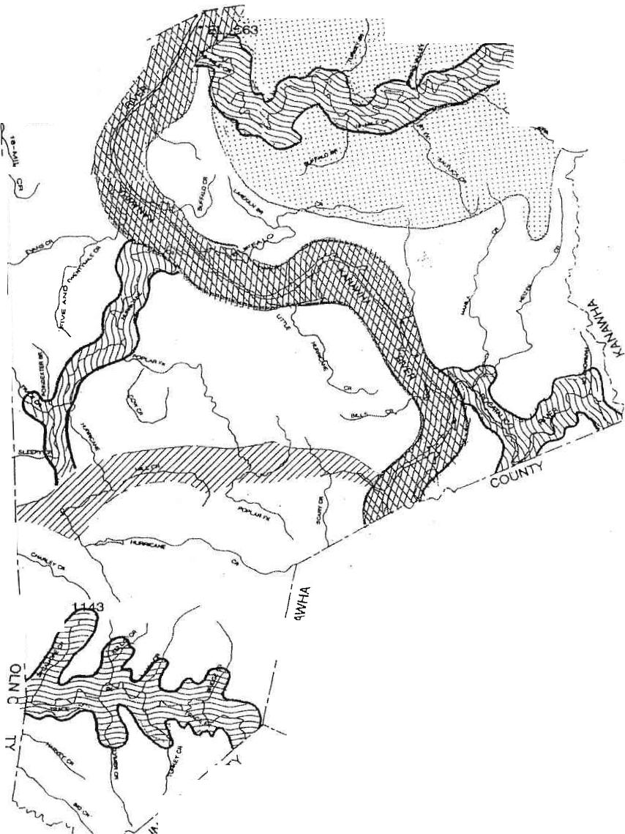
__
COO 1'4¹'¹, -•-•"......---•......
--•••••••-•-• '''''' -...:::••
------... ..... ....... .....
--r.:- . •-• .. ... ..... ............................... .
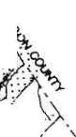
----: .. .77-.-:-:-.'..... ..1:1::: ........... 1.. . .
..:..11::1::11::::::. ¹ ...*:.•..-•11.:::t: .. -.1:1111:::.......„.... ........ .tx,„,
-,..:.: .......... ...:::'•-•1.1::::•CV . .*:11N
sot

a;./
*•'••711 :::::111..„,... . . . . .....
........ ......
.....;:. ... ¹.... ....
. :11111::: .............. :
... / ..:.- ,,,
,..-4
- ...,,
f 0
rm.
> o_{fz}
--<
C)
O C

0 co
m
-
0
0
Z
GENERAL SOILS AND STREAM MAP
EL
r I> T1VAM 4C CD ium⁻ry

KANAVVHA-LINDSIDE-URBAN LAND MOSHANNON-VANDALIA-SENECAVILLE
0
itt
1
MONONGAHELA-VINCENT
0
z
UPSHUR-GILPIN-VANDALIA GILPIN-UPSHUR-VANDALIA

7 i r
,  G^{O} | 111-C ALAI

Appendix B — Mandatory Disposal Program
WV Rule 33CSR7
Putnam County Model Ordinance
Sample Mandatory Disposal Letter
Info Card

TITLE 33
INTERPRETIVE RULE
DIVISION OF ENVIRONMENTAL PROTECTION
OFFICE OF WASTE MANAGEMENT
SERIES 7
PROOF OF PROPER SOLID WASTE DISPOSAL
§33-7-1. General
1.1 Scope and Purpose. -- This rule provides guidance to persons occupying a residence or
operating a business establishment in this state regarding the approved methods of providing proof of proper solid waste disposal to the Division of Environmental Protection.
1.2. Authority. -- W. Va. Code §22C-4-10.
1.3. Filing Date. -- February 24, 1999.
1.4. Effective Date. -- April 1, 1999.
§33-7-2. Proof of Proper Solid Waste Disposal.
2.1 Applicability. - Each person occupying a residence or operating a business establishment
in this state must be able to provide proof to the Division of Environmental Protection that his solid waste was disposed of at an approved solid waste facility.
2.2 Forms of Proof. - Proof of proper solid waste disposal includes:
2.2. a. Records demonstrating that a person has subscribed to and used a solid waste collection service and has paid the fees established therefore; or
2.2. b. Records, including bills of receipt, demonstrating that a person has delivered his or her waste to an approved solid waste facility for disposal.
Note: The term "solid waste collection service" means a collection service offered either by a common carrier certificated by the West Virginia Public Service Commission (or similar body of a contiguous state) or by a municipality or other governmental body.
2.3 Recordkeeping Requirements. - The owner or operator of each approved solid waste
facility in this state must maintain records of each delivery of solid waste made by an individual who is not in the business of hauling or disposing of solid waste. Such records must include:
2.3. a. The name and address of the individual who delivered the waste for disposal;
2.3.b. A description of the origin, type, and estimated amounts of the waste delivered for disposal;

2.3.c. A copy of the bill of receipt for the waste delivered for disposal.
2.4. Maintenance and Retention of Records. All records required under this rule must be maintained for a minimum of three (3) years and be made available for inspection by an authorized representative of the director upon request.

PUTNAM COUNTY SOLID WASTE AUTHORITY
MODEL PROOF OF PROPER SOLID WASTE DISPOSAL ORDINANCE
- Scope and Authority.
1.1 Scope and purpose. - The rule details requirements for persons occupying a residence or operating a business establishment in MODEL County to provide proof of proper solid waste
management to representatives of the MODEL County Solid Waste Authority or any law enforcement agency upon request.
1.2 Authority. - W. Va. Code §§22c-4-10 and 22c-4-23
1.3 Filing Date.-
1.4 Effective Date.-
- Proof of Solid Waste Disposal.
2.1 The primary resident of each residence or Chief Executive Officer of each business establishment in Putnam County shall, within thirty days of request, provide proof to the Putnam County Solid Waste Authority or any state or local law enforcement agency that his or her solid waste was properly managed and disposed of at an approved solid waste facility. Records establishing such proof should be maintained for a minimum of three years.
2.1.1 At least one instance of transfer to an approved solid waste facility during each quarter the person has resided in Putnam County, or the business has been in operation, must be shown to constitute proper disposal.
2.2 Proof of proper solid waste management includes, but is not limited to:
2.2.1 Records demonstrating that a person has subscribed to and paid for a solid waste collection service certificated by the West Virginia Public Service Commission or by a municipality , or other governmental body, and has paid the fees established therefore;
2.2.2 Records, including but not limited to, bills of receipt, cancelled, checks, contracts, or bills of lading, demonstrating that a person has delivered his or her waste to an approved solid waste facility; or
2.2.3 Records, including but limited to, written contracts, leases, or rental agreements, which provide solid waste collection service as part of any tenant agreement or neighborhood association agreement.

3. Penalty.
3.1 Any primary resident or Chief Executive Officer who fails to provide proof of proper solid
waste management within thirty calendar days of a request by a duly authorized representative of Putnam County Solid Waste Authority or state or local law enforcement official, shall be subject to a civil assessment of one hundred and fifty dollars (150.00) plus the unpaid solid waste collection fees for every year that a fee has not been paid.
3.2 The civil assessment provided in this rule is in addition to all other statutory and
regulatory enforcement provisions. The payment of such civil assessment fees not affect the availability of any other civil or criminal enforcement provisions in connection with the violation for which the civil assessment is levied.
3.3 Persons subject to this rule are not excused by compliance with it from the duty to
comply with all other laws, regulations, and rules. Compliance with this section shall not constitute a defense to a charge of violations with any other law, regulation, or rule.
3.4 Should any provision of this rule be declared illegal, void, or unconstitutional, by any
competent legal authority, such action shall not affect the validity of any other provision of this rule.

Example of Info Card
Attention county residents!
State law (WV 22C-4-10) requires you to do one of the following with your solid waste:
- Subscribe to and use a solid waste collection service.
- Have proof that your waste is disposed of at a landfill.
What's illegal?
It's illegal to burn solid waste (WV 22-5-6), bury solid waste (WV 22-15-10), dump solid waste (WV 2215-10), dump solid waste in or near a stream or body of water (WV 20-7-28), dump solid waste into a roadside dump (WV 20-7-26) or create an open dump on your property (WV 22-15-10).
Solid waste definition
Solid waste includes but is not limited to newspapers, cans, bottles, garbage, trash, discarded household furniture, appliances, tires, carcasses of dead animals, cigarette butts, shingles, construction and demolition waste and other waste materials.
A warning
Criminal penalties range from fines of $2,500 to $25,000 per day of violation and/or incarceration for up to one year.
Prepared by the West Virginia Division of Environmental Protection, Public Information Office, 10 Mclunkin Road, Nitro, WV 25143-2506
The DEP is an equal opportunity/affirmative action employer.
Printed on recycled paper.

Appendix C — Public Participation Process

