CITY OF THOMPSON FALLS

SEWER REGULATIONS

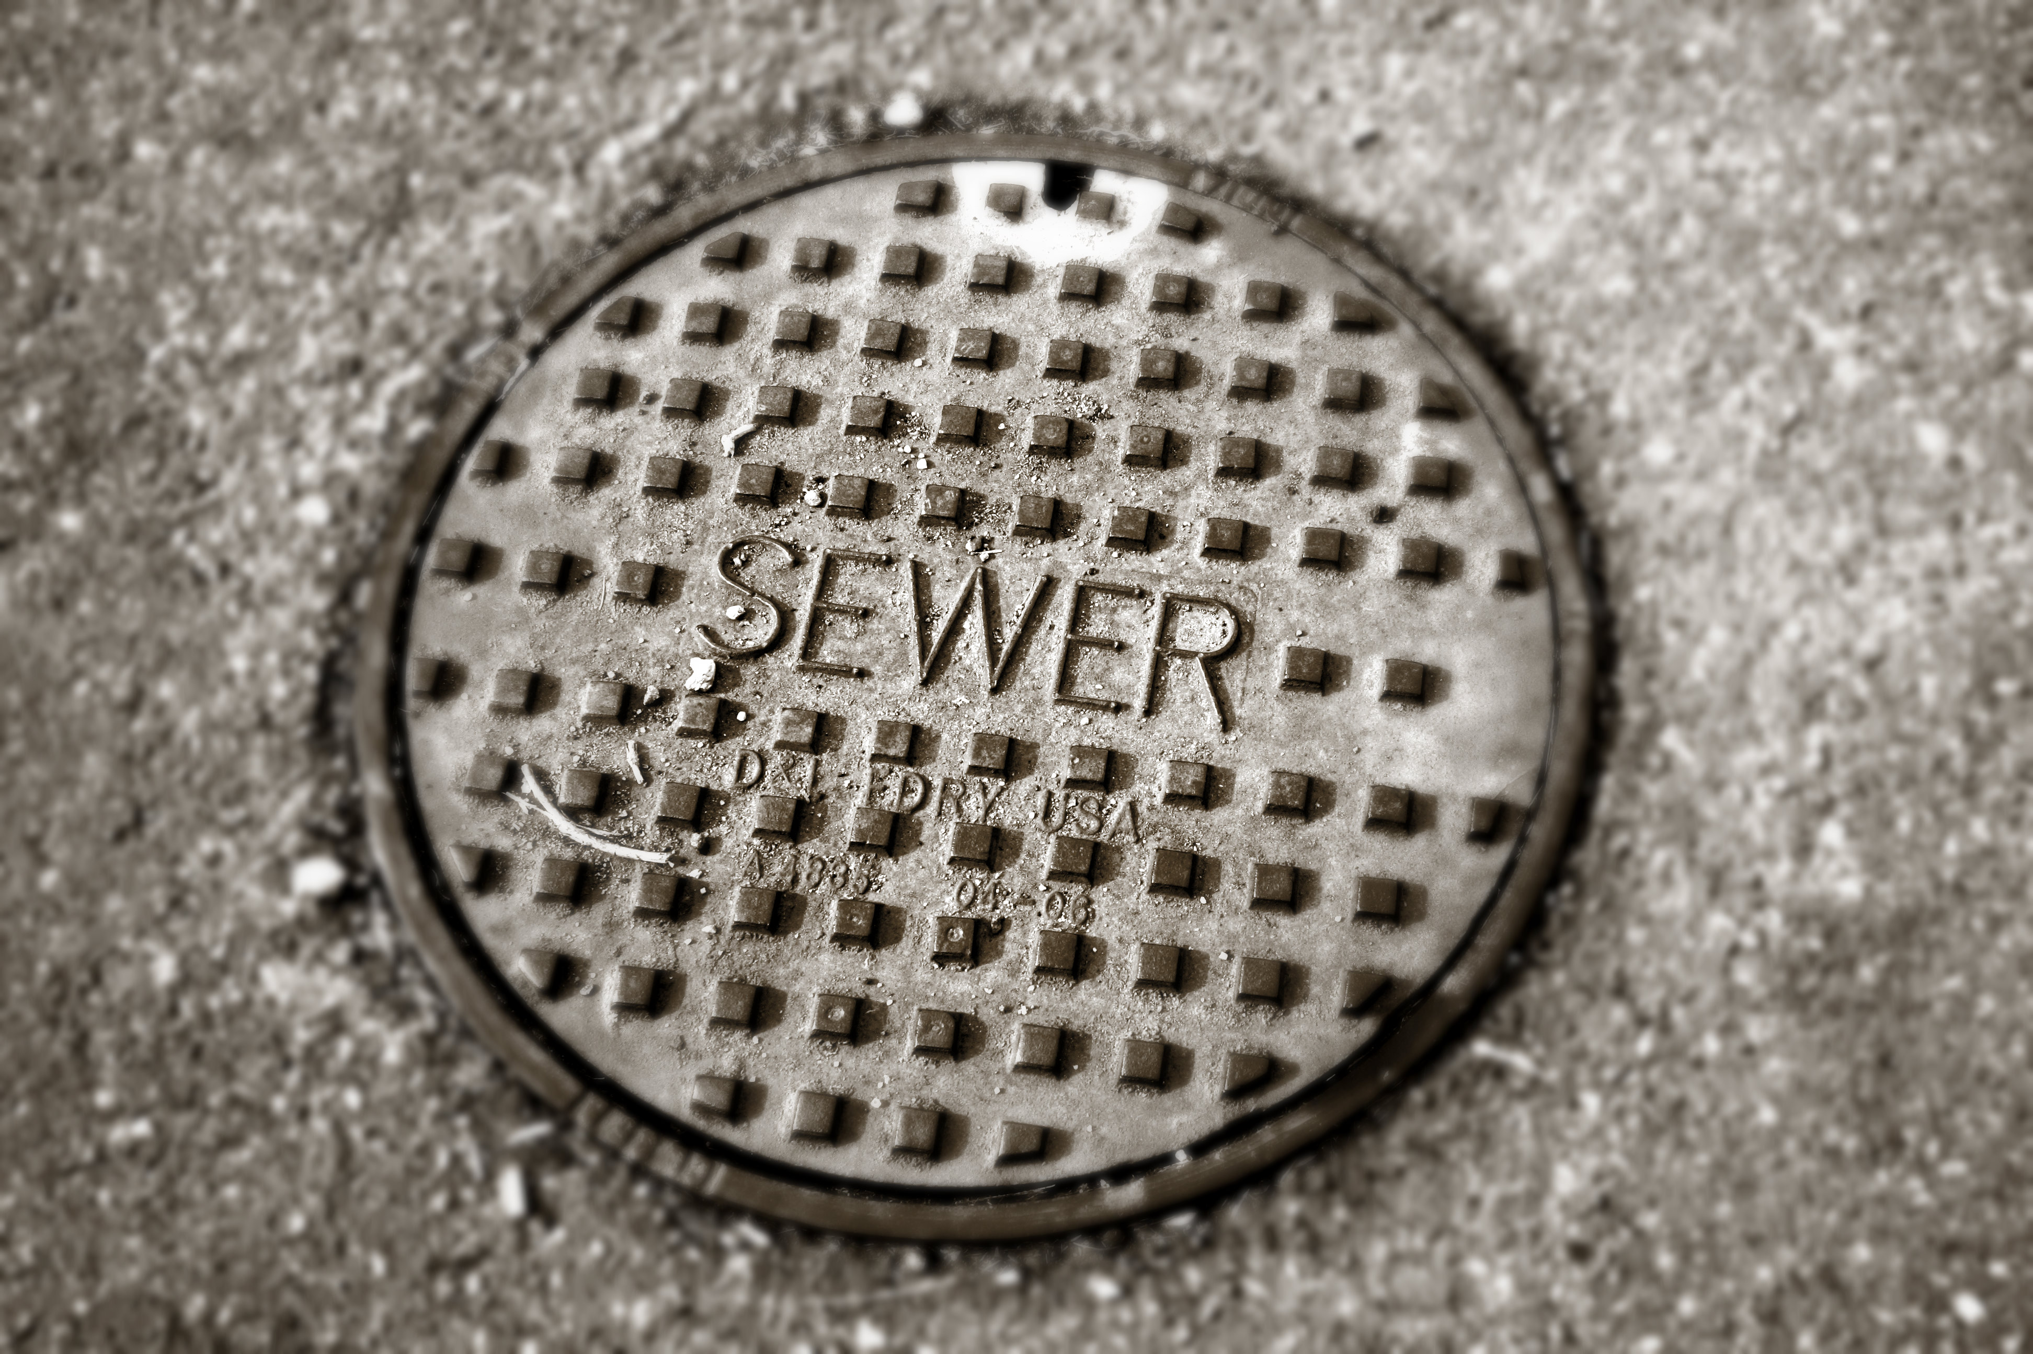

MARCH 13, 2017

SEWER SYSTEM AND
PRIVATE WASTEWATER DISPOSAL REGULATIONS
THOMPSON FALLS, MONTANA

I. GENERAL PROVISIONS

Section 1: Authority - The following regulations governing the sewer system and private wastewater disposal in the City of Thompson Falls have been adopted by resolution by the City Council of Thompson Falls pursuant to the authority granted by Section 69-7-210, M.C.A. These regulations are set apart from the existing City Code pertaining to sewer and septic systems. This separation is:
- for ease of access by the public to the rules applying to sewer and septic systems in Thompson Falls, and
- for ease of the City Council to revise sewer rates from time to time.
These regulations do not supersede the City Code, but must be read together with the Code.

Section 2: Service Area - The service area of the Thompson Falls Sewer System shall be all of that area of the City within its corporate limits.

Section 3: Service Connection – Any person desiring the extension of a new sewer service for premises within the service area shall make application in writing to the Clerk of the City of Thompson Falls for a service connection. The applicant shall pay a connection fee of $2,500 at the time the application is made. The City shall extend sewer service from an existing sewer main to the property line of the premises for which service is sought, and it shall be the responsibility of the applicant to provide plumbing running from the property line to the place of use on the premises. Such plumbing shall not be installed unless there is advance notice of the time and manner of proposed installation. All connections shall be made under the supervision of the superintendent and no connection shall be covered until the superintendent has inspected and approved the work. Any person, firm, or corporation on property located outside of incorporated City limits may be required by the City, as a condition to initiate sewer service, to consent to annexation of the tract of property to be served by the City. See Mont. Code Ann. § 7-13-4314; § 69-7-201 (2015).

Section 4: Plumbing – No new service connection to the sewer system shall be made for premises in which the plumbing does not comply with the requirements of the building and plumbing code in effect at the time of the performance of such activity and as adopted by the State of Montana.

Section 5: Tampering – No person shall tamper with, alter or damage any part of the city sewer system.
Section 6: Repairs – Owners of the premises served shall keep the drain pipes and plumbing in good repair and shall prevent the leakage of sewage from drain pipes. They shall be liable to the City of Thompson Falls for failure to do so. All repairs for drain pipes and plumbing systems within the boundaries of premises serviced by the sewer system shall be made at the expense of the owners of the premises served. The City may, in the case of an emergency, repair any drainpipes and the owner of the premises served shall reimburse the City such repair work.

Section 7: Septic Waste – No person shall introduce into the sewer system or discharge directly into the sewage treatment lagoon any septic sewage which comes from or is generated by individual septic tanks, cesspools, or other private sewage disposal systems.

Section 8: The use of Public Sewers –
- Unpolluted Drainage: No person shall discharge or cause to be discharged any unpolluted waters such as stormwater,
surface water, groundwater, roof runoff, subsurface drainage, or cooling water to the City sewer. After the effective date hereof, no new clear water connection from roof drains, storm drains or otherwise shall be made to the City wastewater sewer.

- Use of Storm Sewer Required: Stormwater and all other unpolluted drainage shall be discharged to such sewers as are
specifically designated as storm sewers, or to a natural outlet approved by the superintendent and the state department of health. Unpolluted industrial cooling water or process waters may be discharged, on approval of the superintendent, to a storm sewer or natural outlet.

- Prohibited Discharges: No person shall discharge or cause to be discharged any of the following described water or
wastes to any public sewers:
- Any gasoline, benzene, naphtha, fuel oil, or other flammable or explosive liquid, solid or gas.
- Any liquids containing toxic or poisonous solids, liquids or gases in sufficient quantity, either singly or by
interaction with other wastes, to contaminate the sludge of any municipal system, to damage or interfere with any sewage treatment process, constitute a hazard to humans or animals, create a public nuisance, or create any hazard in or have an adverse effect on the waters receiving any discharge from the treatment works.
- Solid or viscous substances in quantities or of such size capable of causing obstruction to the flow in sewers, or other
interference with the proper operation of the wastewater facilities such as, but not limited to, ashes, cinders, sand, mud, straw, shavings, metal, glass, rags, feathers, tar, plastics, wood, unground garbage, whole blood, paunch manure, hair and fleshings, entrails, paper dishes, cups, milk containers, etc., either whole or ground by garbage grinders.
- Any prohibited discharge of toxic pollutants which cause an increase in the city's cost of managing the effluent or the
sludge of the City treatment works shall result in the increased costs being assessed to the responsible party.

- Harmful Materials/Substances: The following described substances, materials, waters or wastes shall be limited in
discharges to the City sewer to concentrations or quantities which will not harm either the sewers, the sludge of the system, the wastewater treatment process or equipment, will not have an adverse effect on the receiving stream, or will not otherwise endanger lives, limb, public property, or constitute a nuisance. The superintendent may set limitations lower than the limitations established in the regulations in this subsection if, in his opinion, such more severe limitations are necessary to meet the above objectives. In forming his opinion as to the acceptability, the superintendent will give consideration to such factors as: 1) the quantity of subject waste in relation to flows and velocities in the sewers, 2) materials of construction of the sewers, 3) the wastewater treatment process employed, 4) capacity of the wastewater treatment plant, and other pertinent factors. The limitations or restrictions on materials or characteristics of waste or wastewaters discharged to the sanitary sewer which shall not be violated without approval of the superintendent are as follows:

- Wastewater having a temperature higher than one hundred fifty degrees Fahrenheit (150°F) (65°C).
- Wastewater containing more than twenty five milligrams per liter (25 mg/I) of petroleum oil, non-biodegradable cutting oils, or product of mineral oil origin.
- Wastewater from industrial plants containing floatable oils, fat or grease.
- Any garbage that has not been properly shredded. Garbage grinders may be connected to sanitary sewers from homes, hotels, institutions, restaurants, hospitals, catering establishments, or similar places where garbage originates from the preparation of food in kitchens for the purpose of consumption on the premises or when served by caterers.
- Any waters or wastes containing iron, chromium, copper, zinc and similar objectionable or toxic substances to such degree that any such material received in the composite wastewater at the wastewater treatment works exceeds the limits established by the superintendent for such materials.
- Any waters or wastes containing odor producing substances exceeding limits which may be established by the superintendent.
- Any radioactive wastes or isotopes of such half-life or concentration as may exceed limits established by the superintendent in compliance with applicable state or federal regulations.
- Quantities of flow, concentrations, or both, which constitute a "slug" as defined in the City Code (9-2-1). A "slug" is defined as any discharge of water or wastewater which in concentration of any given constituent, or in quantity of flow, exceeds for any period of duration longer than fifteen (15) minutes more than five (5) times the average twenty-four (25) hour concentration or flows during normal operation and shall adversely affect the collection system or performance of the wastewater treatment works.
- Waters or wastes containing substances which are not amendable by treatment or reduction by the wastewater
treatment processes employed, or are amendable to treatment only to such degree that the wastewater treatment plant effluent cannot meet the requirements of other agencies having jurisdiction over discharge to the receiving waters.
- Any water or wastes which may interact with other water or wastes in the public sewer system, release noxious
gases, form suspended solids which interfere with the collection system, or create a condition deleterious to structures and treatment processes.

- Authority To Reject, Require Pretreatment, Or Control Quantity: If any waters or wastes are discharged, or are proposed to be discharged to the public sewers, which waters contain the substances or possess the characteristics enumerated in subsection C or D above, and which in the judgment of the superintendent may have a deleterious effect upon the wastewater facilities, processes, equipment or receiving waters, or which otherwise create a hazard to life or constitute a public nuisance, the superintendent may:
- Reject the wastes;
- Require pretreatment to an acceptable condition for discharge to the public sewers;
- Require control over the quantities and rates of discharge; and/or
- Require payment to cover the added cost of handling and treating the wastes not covered by existing taxes or sewer charges.

If the superintendent permits the pretreatment or equalization of waste flows, the design and installation of the plants and equipment shall be subject to the review and approval of the superintendent and the state department of health.

- Interceptors Required:
- Required: Grease, oil and sand interceptors shall be provided when, in the opinion of the superintendent, they are
necessary for the proper handling of liquid wastes containing floatable grease in excessive amounts as specified in subsection 03 of this section, or any flammable wastes, sand or other harmful ingredients; except that such interceptors shall not be required for private living quarters or dwelling units.
- Type; Capacity; Location: All interceptors shall be of a type and capacity approved by the superintendent and the
state plumbing code and shall be located as to be readily and easily accessible for cleaning and inspection.
- Collected Materials; Records: In the maintaining of these interceptors, the owner shall be responsible for the proper
removal and disposal by appropriate means of the captivated material and shall maintain records of the dates and means of disposal which are subject to review by the superintendent. Any removal and hauling of the collected materials not performed by owner's personnel must be performed by currently licensed waste disposal firms.
- Maintenance: Where pretreatment or flow equalization facilities are provided or required for any waters or wastes,
they shall be maintained continuously in satisfactory and effective operation by the owner at his expense.

Section 9: Inspectors –
- Right of Entry: The superintendent and other duly authorized employees of the city bearing proper credentials and
identification shall be permitted to enter all properties for the purposes of inspection, observation, measurement, sampling and testing pertinent to discharge to the City sewer.
- Safety Rules; Indemnification: While performing the necessary work on private properties referred to in subsection A of
this section, the superintendent or duly authorized employees of the city shall observe all safety rules applicable to the premises established by the company, and the company shall be held harmless for injury or death to the city employees, and the city shall indemnify the company against loss or damage to its property by city employees and against liability claims and demands for personal injury or property damage asserted against the company growing out of the gauging and sampling operation, except as such may be caused by negligence or failure of the company to maintain safe conditions as required in subsection 9-2-5G of this chapter.
- Access To Easements: The superintendent and other duly authorized employees of the city bearing proper credentials
and identification shall be permitted to enter all private properties through which the city holds a duly negotiated easement for the purposes of, but not limited to, inspection, observation, measurement, sampling, repair and maintenance of any portion of the wastewater facilities lying within said easement. All entry and subsequent work, if any, on said easement, shall be done in full accordance with the terms of the duly negotiated easement pertaining to the private property involved.

Section 10: Outdoor Privies, Prohibited – No person shall erect or maintain an outdoor privy or privies within the City.

Section 11: Private Wastewater Disposal –
- Public Sewer Unavailable: Where a public sanitary sewer is not available, the building sewer shall be connected to a
private wastewater disposal system complying with the provisions of this section.
- County Permit Required: Before commencement of construction of a private wastewater disposal system, the owner shall
first make application to the Sander County Sanitarian and obtain a written permit signed by the Sanitarian or designated agent. The application, fees, procedures and all administration shall be conducted through the Sanders County septic regulations.
- Inspection: A permit for a private waste disposal system shall not become effective until the installation is completed in
accordance with the Sanders County septic regulations.
- The type, capacities, location and layout of a private wastewater disposal system shall comply with current septic
regulations of Sanders County.
- Public Sewer Becomes Available: At such time as a public sewer becomes available to a property served by private
wastewater disposal system, a direct connection shall be made to the public sewer within one hundred twenty (120) days, and any septic tanks, cesspools and similar private wastewater disposal facilities shall be cleaned of sludge and filled with suitable material at no expense to the city.

II. SEWER RATES

Section 1: Rate Schedule – Charges for the Thompson Falls sewer service area are based on the size of service line and on an equivalent domestic user of a ¾ inch water line (an “EDU"). This formula is used to allocate the costs to the users of the system based on flow and volume. Each meter size has an EDU multiplier associated with it (the “EDU Multiplier”).

The minimum monthly charge is determined by multiplying the base rate by the EDU Multiplier associated with the water line size.

The Residential Base Rate is $38.00 per month for a ¾" service line. The Commercial Base Rate is $45.00 per month for a ¾" service line.

A commercial service with multiple separate occupants shall be assessed the base rate for the first occupant and $15 per month per additional occupant.

A residential connection with additional separate rental(s) shall be charged the base rate of $38.00 per month for the first user and $25
per month for each additional rental units. New Wastewater User Charges. The Residential rental units using the System originally
were charged a base rate of $5 per month. Per Resolution #655 adopted on August 11, 2014 the Council voted to gradually raise the
rates to $38 per month; immediately to $25 and then each of the next 3 years by $4.33 per month on October 1, 2014, October 1, 2015
and October 1, 2016. The rate changed was missed on October 1, 2014. The City Council is changing the rate increases to October 12, 2015, October 1, 2016 and the final rate change on October 1, 2017.

Size | EDU Multiplier | Base Rate
Up to ¾ inch | 1.00 | Residential- $38
 |  | Commercial - $45
1 inch | 1.79 | $80.55
1 ½ inch | 4.00 | $180.00
2 inch | 7.14 | $321.30

The minimum monthly base rate charge covers the first 4,000 gallons of discharged wastewater per residence/apartment. The discharge volume is an annual calculation, based upon the average monthly water consumption, from water meter records, for January through May and November through December of the previous calendar year. This volume is used to determine additional chargers for wastewater discharge in excess of 4,000 gallons/month. The following schedule of rates shall then be charged to those in the City sewer service area:

Class Usage Monthly Rate

Residential Account 4,000 Gallons and below $45.00 monthly charge
Commercial Account 4,000 Gallons and below $38.00 monthly charge
Additional Usage Over 4,000 Gallons add $4.00/thousand gallons

Section 2: Modification of Rate Schedule – The foregoing rate schedule may be amended from time to time by resolution of the City Council in accordance with the City code of Thompson Falls and laws of the State of Montana. Any such resolution modifying the rate schedule shall also provide for amendment of these regulations to reflect the new rate schedule.

III. COLLECTION OF SEWER CHARGES AND
ENFORCEMENT OF REGULATIONS

Section 1: Billing Cycle – Sewer charges shall be assessed and billed monthly. The billing cycle shall end on or about the 10th day of each month and bills shall be issued by the City on or about the 20th of each month for payment on the first day of the following month.

Section 2: Party Responsible for Payment – The owner of the premises in the sewer service area shall be responsible to pay bills for the sewer services. For the purpose of this regulation the term “owner” shall mean a purchaser on contract for deed in cases where property is being purchased on contract. If two NSF checks are received from an individual thereafter as payment for a sewer bill, only cash will be accepted as payment from that individual.

Section 3: Notice of Delinquent Sewer Bills – When a sewer bill for any premises shall have been delinquent for sixty days, the City Clerk shall prepare and mail by certified mail to the party who has been billed for such delinquent account a notice of delinquency. The notice shall state with particularity the amount and period of such delinquency and the notice shall advise the recipient that he or she may provide a written explanation or appear before the City Council at the next regular meeting to show cause why sewer service to the premises should not be turned off. The notice shall further state the consequences of a failure to bring the sewer bill current as set forth hereinafter.

Section 4: Council Authority to Defer Payment – The City Council shall have the authority to continue providing water/sewer service and to defer the payment of delinquent sewer bill after notice of delinquency is sent as hereinabove provided if in the Council’s judgment good cause exists for such deferment, but the Council shall have no authority to defer the imposition of sanctions hereinafter provided for a period of longer than six months after the notice of delinquency is sent.

Section 5: Failure to Cure Delinquency – If a delinquent sewer bill has not been paid before the next regular council meeting after notice of delinquency is sent and if no person appears or, having appeared, fails in the judgment of the council to show cause why service to the premises shall not be turned off, the council shall direct the water superintendent to turn off the water supply without further notice to the owner or occupant of the premises. Notice of impending water shut-off shall be posted on the property, in a readily observable location, no less than 24-hours before the water service is to be shut off. Failure of a property owner or water customer to see the notice shall not constitute a defense in failing to meet the intent of the notice or the rules of water service.

IN WITNESS WHEREOF the City Council of Thompson Falls, Montana passed and approved the foregoing regulations effective the 8th day of May, 2017.

_____________________________________
Mark Sheets, Mayor

Attest: ________________________________
Chelsea Peterson, City Clerk/Treasurer



