**City of Thompson Falls City Council Meetings**

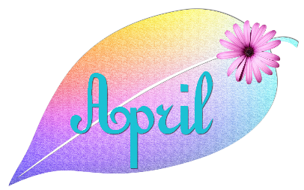

***Community & Public Relations Committee meeting April 10, 2023 immediately following the City Council meeting*. Agenda: To continue discussion with Kim Annis, FWP Grizzly Bear Management Specialist, to address the increasing black bear nuisances within the city.**

**Regular City Council Meeting at the City Hall, 108 Fulton Street, Thompson Falls, MT**

**Monday, April 10, 2023 @ 6:00 P.M. following the Public Hearing**

**AGENDA**

**OPEN MEETING**

**ROLL CALL OF THE COUNCIL**

**PLEDGE OF ALLEGIANCE**

**UNSCHEDULED PUBLIC COMMENT**

**SET THE AGENDA**

**CONSENT AGENDA: Claims, Minutes, Financial Reports, Court Report, Water Shut-off List/Arrangements**

**STANDING COMMITTEE REPORTS**

**INFORMATIONAL: Presentation of the bear conflicts over the last several years in Thompson Falls, as well as their causes and provide the layout of the steps that a community could take to become a Bear Smart Community.**

**ACTION ITEMS**

**OLD BUSINESS:**

1. **Softball and Baseball Fields Lease Agreement with the Thompson Falls School District Mark Sheets**
2. **Parking Ordinance Mark Sheets**
3. **Water/Sewer Regulation changes Mark Sheets**

**NEW BUSINESS:**

1. **Adjust water bill due to water leak Jeanette Lord**
2. **Presentation on Downtown Park Assessment Kayla Mosher**
3. **Block part of Mill Street Cody Mosher**
4. **Wastewater Project Request for Reimbursements Phases 1 & 2 Mark Sheets**
5. **Wastewater Project Request for Reimbursements Phases 3 & 4 Mark Sheets**
6. **Water Project Request for Reimbursements Mark Sheets**

**MAYOR’S REPORT**

**ADJOURN**