City of Thompson Falls City Council Meeting

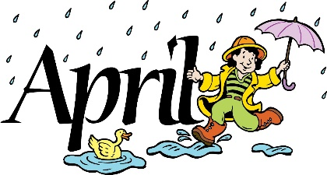
This Photo by Unknown Author is licensed under CC BY-NC-ND

City Council Committee of the Whole
Monday, April 12, 2021 @ 5:30 p.m. Agenda: Community Survey

City Council Meeting at the Community Center
410 Golf Street, Thompson Falls, MT
Monday, April 12, 2021 – 6:00 P.M.

AGENDA
OPEN MEETING
ROLL CALL OF THE COUNCIL
PLEDGE OF ALLEGIANCE
UNSCHEDULED PUBLIC COMMENT
SET THE AGENDA
CONSENT AGENDA
- Claims
- Minutes
- Financial Reports
- Court Report
- Water Shut-off List/Arrangements
STANDING COMMITTEE REPORTS
COMMITTEE DECAY UPDATE
INFORMATION: Montana Southern Rail line – Informational Presentation/Endorsement
ACTION ITEMS:
- Variance Request 228 Ferry Street Alysha Franck
- Montana Southern Rail line – Informational Presentation/Endorsement Mark Sheets
- Second Reading of Chicken, Rabbit, Duck & Coturnix Ordinance changing to allow
5 Rabbits (3 does and 2 bucks), 20 Coturnix Quail in City Limits Mark Sheets
- Veterans Memorial Bronze Plaques in Honor of Rodney Knutson & Victor Pirker Mark Sheets
- Wastewater Request for Reimbursements – SRF BAN #3 – Pay Construction Company Razz, Great West Engineering & Dept of Revenue. Mark Sheets
- Appoint City Council Vice Chair Mark Sheets
MAYOR’S REPORT
ADJOURN

