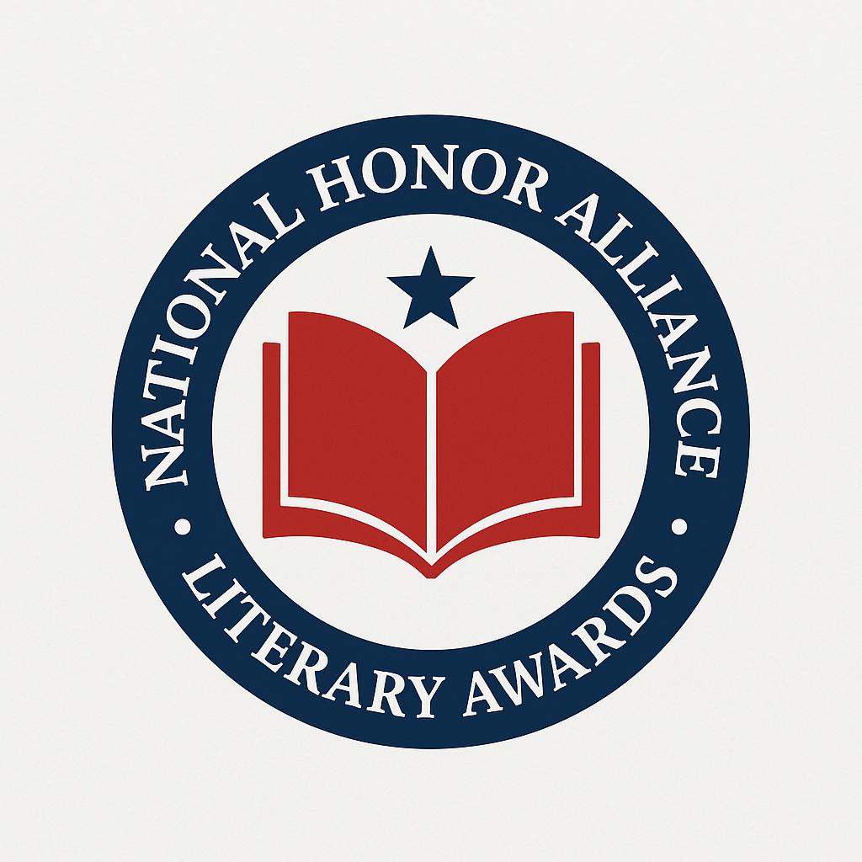

2026 National Honor Alliance Literary Awards
ENTRY FORM
Deadline for Submissions: January 25, 2026
Winners Announced: February 2026

Entrant Information
Name (Person Submitting Entry): ____________________________________
Phone Number: ____________________________________
Email Address: ____________________________________ (All contest communication will be sent to this email – please print clearly)

Book Information
Full Book Title: ____________________________________
Author Name: ____________________________________
Publisher Name (if applicable): ____________________________________
Website (if applicable): ____________________________________
ISBN-13 (if applicable): ____________________________________

Categories (Select One or More)
See full category descriptions at NationalHonorAlliance.org

📚 Fiction Categories
- Fiction – General
- Fiction – Historical
- Fiction – Mystery / Suspense / Thriller
- Fiction – Fantasy
- Fiction – Science Fiction
- Fiction – Horror
- Fiction – Romance
- Fiction – Women’s Fiction
- Fiction – Multicultural
- Fiction – LGBTQ+
- Fiction – Inspirational / Religious
- Fiction – Young Adult
- Fiction – New Adult
- Fiction – Short Story / Anthology
- Fiction – Novella / Novelette

📖 Non-Fiction Categories
- Non-Fiction – General
- Non-Fiction – Narrative / Creative Non-Fiction
- Biography – General
- Autobiography / Memoir
- Non-Fiction – Inspirational / Motivational
- Non-Fiction – Multicultural
- Non-Fiction – LGBTQ+
- Non-Fiction – Parenting & Family
- Non-Fiction – Business / Leadership
- Non-Fiction – Education / Academic
- Non-Fiction – History (General, Military, or U.S.)
- Non-Fiction – True Crime
- Non-Fiction – Sports
- Non-Fiction – Social Change / Current Affairs

✒️ Poetry Categories
- Poetry – General
- Poetry – Narrative
- Poetry – Contemporary
- Poetry – Religious / Spiritual

👶 Children’s & Young Readers
- Children’s – Picture Book
- Children’s – Fiction
- Children’s – Non-Fiction
- Children’s – Educational
- Children’s – Interactive

🌟 Legacy & Special Categories
- Legacy – Fiction (any genre, pre-2021 titles)
- Legacy – Non-Fiction (any genre, pre-2021 titles)
- Best Cover Design – Fiction
- Best Cover Design – Non-Fiction
- Debut Author – Fiction
- Debut Author – Non-Fiction

Entry Fees
$35 per title/per category
Example: One book in two categories = $70
Individual Payment Transactions are required for multiple categories
☑ I paid online (at NationalHonorAlliance.com)
Email address used for payment: ____________________________________

Submission Checklist
- Completed Entry Form (this page)
- Entry fee processed online
- PDF copy of your book (include cover)
- Press Release or Marketing Material (optional, if available)
📧 Email all materials to: team@nationalhonoralliance.com

Rules & Guidelines
- Entries must be submitted on or before January 25, 2026.
- Winners and finalists announced February 2026.
- Eligible books: publication years 2021–2026 (Legacy titles may be earlier).
- English-language submissions only. ISBN required for published titles (not required for manuscripts).
- All rights remain with the author.
- All sales are final. Submissions are deleted from the entry database after the competition concludes.

Agreement
I certify that the information provided is accurate, and I agree to abide by the contest rules.
Signature: ____________________________________ Date: ____ / ____ / ______

