AGENDA
REGULAR MEETING
DOWNEY CITY COUNCIL
TUESDAY, February 8, 2022
Public Hearing is 6:30pm, Regular Meeting will follow immediately after

Call to Order

Prayer – Gary Barnes
Pledge of Allegiance

ACTION ITEM - CONSENT AGENDA
The following business items may be approved by one motion and a vote. If any one member of the Council so desires, any matter listed can be moved to a separate agenda item.
- Council Minutes – January 11, 2022
- Accounts Payable – February 2022

Law Enforcement

ACTION ITEM- Executive Session for Idaho Code Section 74-206(f)
ACTION ITEM- Consider Approval to Procure Myers Anderson as the Architect for the Community Center
ACTION ITEM- Consider Approval to Procure SICOG as the Grant Administrator for the Community Center CDBG Grant
ACTION ITEM- Consider Approval to Pass Fair Housing Resolution
ACTION ITEM- Consider Approval to Pass Citizen Participation Plan
ACTION ITEM- Consider Approval for Bruce Burt’s Non-Commercial Kennel License
ACTION ITEM- Consider Approval for Fiber Internet
ACTION ITEM- Consider Approval for Spending with Covid Funds
ACTION ITEM- Consider Approval to Cancel Contract with Xerox

Comments from the audience on items only
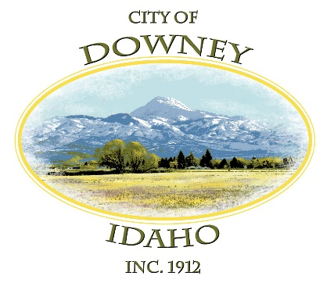
REPORTS

Tony Hancock Kiesha Keller
Gary Barnes Bonnie Hill
John Hyde Grant Johnson
Mayor Nielsen

ACTION ITEM – Adjournment

