AGENDA
REGULAR MEETING
DOWNEY CITY COUNCIL
TUESDAY, JUNE 8, 2021
7:00 PM

Call to Order

Prayer – Grant Johnson
Pledge of Allegiance

ACTION ITEM - Consider Approval of the Agenda

ACTION ITEM - CONSENT AGENDA
The following business items may be approved by one motion and a vote. If any one member of the Council so desires, any matter listed can be moved to a separate agenda item.
- Council Minutes – May 2021
- Accounts Payable – June 2021
- Noncommercial Kennel License- Amanda Frew

Law Enforcement
ACTION ITEM- Consider approval of City Council Member Daniel Wilson’s Resignation
ACTION ITEM- Consider approval of Mayor Rex Nielsen’s Appointed, New City Council Member, John Hyde
Oath of Office Administered to newly appointed Council Member.
ACTION ITEM- Consider approval of New and Final Clean-up Date for Owners Wadsworth L. JR Lothrop and Sallie Lothrop, Location- 413 North Main Street.

ACTION ITEM - Consider approval of Alcohol Beverage Catering Permit for American Legion Post 21 at the Bannock County Fair

ACTION ITEM- Consider approval of Reimbursing Jessica Murray for Non-use of Rental Agreement, Community Center Office
ACTION ITEM- Consider approval of a New Meter Install and Rate Review for Craig Criddle Located at Parcel: RPR4433011400
ACTION ITEM- Financial Growth Opportunities for the City of Downey
ACTION ITEM- Consider approval of Bannock County Fair Board Lease Agreement Rate and Terms of Lease for the Downey RV Park
DISCUSSION ITEM- City of Downey’s Law Contract with Bannock County Sheriff Department

Comments from the audience on Agenda items only

REPORTS
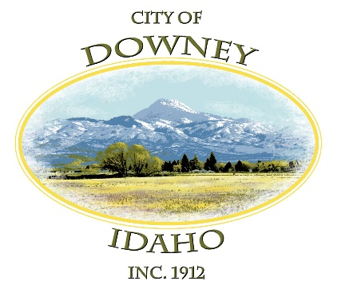
Tony Hancock
Selena Guthrie
Gary Barnes
Bonnie Hill
New City Council Member
Grant Johnson
Mayor Nielsen

ACTION ITEM – Adjournment

