AGENDA
REGULAR MEETING
DOWNEY CITY COUNCIL
TUESDAY, January 11, 2022
7:00 PM

Call to Order

Prayer – Rex Nielson
Pledge of Allegiance

ACTION ITEM - CONSENT AGENDA
The following business items may be approved by one motion and a vote. If any one member of the Council so desires, any matter listed can be moved to a separate agenda item.
- Council Minutes – December 14, 2021
- Accounts Payable – January 2022
- Business Licenses- Ultimate Handyman and Clayton Hulet Bird Taxidermy

Law Enforcement

ACTION ITEM- Oath of Office Administered to newly elected Council Members, Grant Johnson and John Hyde
ACTION ITEM- Consider selection of a Council President
ACTION ITEM- Approval for Community Development Block Grant
ACTION ITEM- Consider Approval for New Business for Balanced Yoga
ACTION ITEM- Consider Approval for two more office phones for Verizon for the Council Table and Mayor’s Office
ACTION ITEM- Consider Approval for Fiber Internet
ACTION ITEM- Consider Approval for Tony’s Computer in the Maintenance Shop
ACTION ITEM- Consider Approval for Resolution No. 2022 -101 for Non-Emergency Spending
ACTION ITEM- Consider Approval for New Council Assignments

Comments from the audience on items only
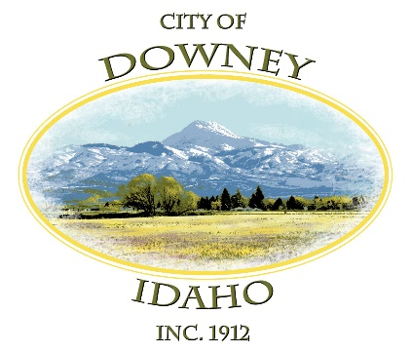
REPORTS

Tony Hancock Kiesha Keller
Gary Barnes Bonnie Hill
John Hyde Grant Johnson
Mayor Nielsen

ACTION ITEM – Adjournment

