MEETING NOTICE

The Regular Meeting of the Downey City Council scheduled for May 11, 2021,
will be held at the Downey Community Center, 21 South Main,
instead of the Downey City Office. Due to Covid-19 restrictions, social
distancing will be required. Masks are optional.

AGENDA
REGULAR MEETING
DOWNEY CITY COUNCIL
TUESDAY, May 11, 2021
7:00 PM
Call to Order

Prayer – Tony Hancock
Pledge of Allegiance

ACTION ITEM - Consider Approval of the Agenda

ACTION ITEM - CONSENT AGENDA
The following business items may be approved by one motion and a vote. If any one member of the Council so desires, any matter listed can be moved to a separate agenda item.
- Council Minutes – March 2021
- Accounts Payable – April 2021
- Livestock Permit- Steven Fergus- One Horse

Law Enforcement

DISCUSSION ITEM- Daughters of Utah Pioneer Cabin Restoration Project
ACTION ITEM- Consider approval of the Downey livestock Permits, Annual Review
ACTION ITEM- Consider approval of a New Meter Install and Rate Review for Craig Criddle Located at Parcel: RPR4433011400
ACTION ITEM- Financial Growth Opportunities for the City of Downey
DISCUSSION ITEM- City of Downey’s Law Contract with Bannock County Sheriff Department

Comments from the audience on Agenda items only

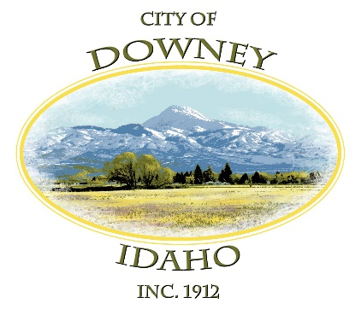
REPORTS
Tony Hancock
Selena Guthrie
Gary Barnes
Bonnie Hill
Daniel Wilson
Grant Johnson
Mayor Nielsen

ACTION ITEM – Adjournment

