MEETING NOTICE

The Regular Meeting of the Downey City Council scheduled for May 20, 2021,
will be held at the Downey Community Center, 21 South Main,
instead of the Downey City Office.

AGENDA
SPECIAL MEETING
DOWNEY CITY COUNCIL
THURSDAY, MAY 20, 2021
1:00 PM

Call to Order

Prayer and Pledge of Allegiance- Dan Wilson

ACTION ITEM - Consider approval of Alcohol Beverage Catering Permit for American Legion Post 21 at the Bannock County Fair
ACTION ITEM- Consider approval of Noncommercial Kennel License for Amanda Frew
ACTION ITEM- Financial Growth Opportunities for the City of Downey
DISCUSSION ITEM- City of Downey’s Law Contract with Bannock County Sheriff Department

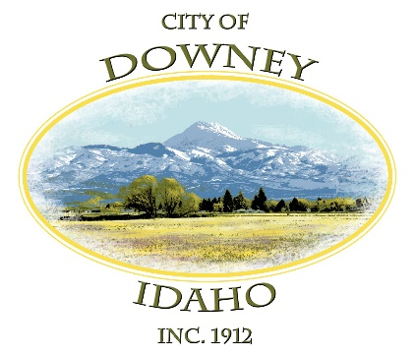
REPORTS-
Rex Nielsen
Selena Guthrie

ACTION ITEM – Adjournment

