AGENDA
SPECIAL MEETING
DOWNEY CITY COUNCIL
WEDNESDAY, MARCH 23, 2022
7:00PM

Call to Order

Prayer – Bonnie Hill
Pledge of Allegiance

AUDIT REPORT- Larry Burden will be Presenting the Audit for Fiscal Years 2018-2019 and 2019-2020

ACTION ITEM- Accept the Audits for Fiscal Years 2018-2019 and 2019-2020

ACTION ITEM- Approve the Engagement Letter from Searle, Hart, and Associates for Audit for Fiscal Year 2020-2021

Comments from the audience on items only

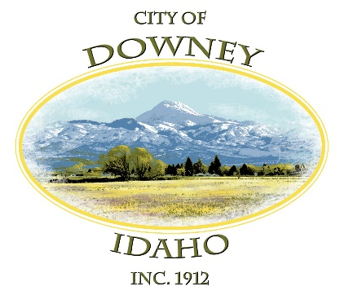
ACTION ITEM – Adjournment

