AGENDA
REGULAR MEETING
DOWNEY CITY COUNCIL
TUESDAY JULY 12, 2022
7:00 PM

Call to Order

Prayer – Bonnie Hill
Pledge of Allegiance

ACTION ITEM - CONSENT AGENDA
The following business items may be approved by one motion and a vote. If any one member of the Council so desires, any matter listed can be moved to a separate agenda item.
- Council Minutes – Regular Meeting June 14, 2022, and Special Meeting June 15,2022
- Accounts Payable – July 2022
- Business License- Name Change from This Old House to Delany’s Old House

Law Enforcement

ACTION ITEM- Consider Approval of an Alcohol Beverage Catering Permit for the American Legion to Sell Beer at the Bannock County Fair August 4, 2022, through August 6, 2022

ACTION ITEM- Appoint Tad Bybee as Animal Control Officer

DISCUSSION ITEM- Ireland Bank Lease Program, Savings and Online Payment Options

DISCUSSION ITEM- Police Contract for year 2022-2023
Comments from the audience on items only
REPORTS

Tony Hancock Kiesha Keller
Gary Barnes Bonnie Hill
John Hyde Grant Johnson
Mayor Nielsen

ACTION ITEM- Executive Session pursuant to Idaho Code 74-206(1)(b):
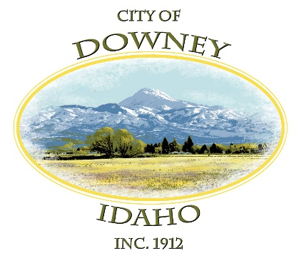
ACTION ITEM- 2022- 2023 Employee Wages

ACTION ITEM – Adjournment

