AGENDA
REGULAR MEETING
DOWNEY CITY COUNCIL
TUESDAY MAY 10, 2022
7:00 PM

Call to Order

Prayer – Grant Johnson
Pledge of Allegiance

ACTION ITEM - CONSENT AGENDA
The following business items may be approved by one motion and a vote. If any one member of the Council so desires, any matter listed can be moved to a separate agenda item.
- Council Minutes – April 12, 2022
- Accounts Payable – May 2022

Law Enforcement

DISCUSSION ITEM- III-A Annual Report via Zoom
DISCUSSION ITEM- ICCU for Investment Report
ACTION ITEM- Consider Approval for Changes in Investments
ACTION ITEM- Consider Approval for Conditional Use Permit for Corey Nielsen at Parcel: RPRDDOW0033900 (Lots 9-10-11 Block 76)
ACTION ITEM- Consider Approval to Change the Zoning at Parcel: RPRDDOW0033900 (Lots 9-10-11 Block 76)
ACTION ITEM- Consider Approval to Reprioritize Workshop list for Council Committees

Comments from the audience on items only
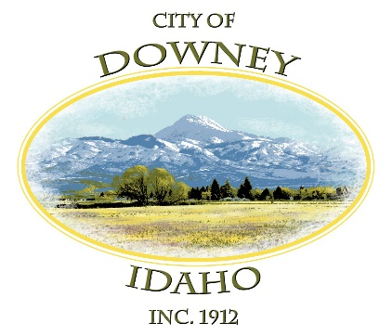
REPORTS

Tony Hancock Kiesha Keller
Gary Barnes Bonnie Hill
John Hyde Grant Johnson
Mayor Nielsen

ACTION ITEM – Adjournment

