AGENDA
REGULAR MEETING
DOWNEY CITY COUNCIL
TUESDAY SEPTEMBER 13, 2022
7:00 PM

Call to Order

Prayer – Bonnie Hill
Pledge of Allegiance

ACTION ITEM - CONSENT AGENDA
The following business items may be approved by one motion and a vote. If any one member of the Council so desires, any matter listed can be moved to a separate agenda item.

- Council Minutes – August 2, 2022, August 9, 2022, and August 23, 2022
- Accounts Payable – September 2022

Law Enforcement

ACTION ITEM- Consider Approval for New Business- Mythstruck
ACTION ITEM- Consider Approval Purchase a New Vacuum for Community Center
ACTION ITEM- Consider Approval Purchase Soft Start for City Well, LMI Chlorinator Pump, and Confined Space Blower with ARPA Funds

Comments from the audience on items only
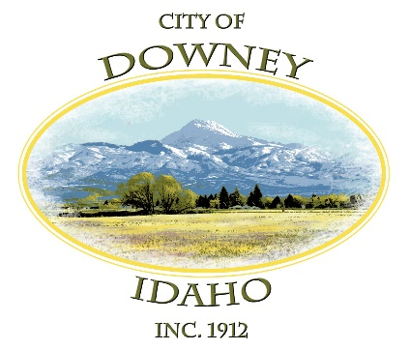
REPORTS

Tony Hancock Kiesha Keller
Gary Barnes Bonnie Hill
John Hyde Grant Johnson
Mayor Nielsen

ACTION ITEM – Adjournment

