AGENDA
REGULAR MEETING
DOWNEY CITY COUNCIL
TUESDAY OCTOBER 11, 2022
7:00 PM

Call to Order

Prayer – Tony Hancock
Pledge of Allegiance

ACTION ITEM - CONSENT AGENDA
The following business items may be approved by one motion and a vote. If any one member of the Council so desires, any matter listed can be moved to a separate agenda item.
- Council Minutes – September 13, 2022
- Accounts Payable – October 2022

Law Enforcement

DISCUSSION ITEM- Direct Communication Fiber Update
ACTION ITEM- Consider Approval for Business License for Benita Hermelink “Play2lrn Child Care”
ACTION ITEM- Consider Approval for Building Permit # DOW2022-006 at 263 N 4th E for Mega Marketing/Frank Maio
ACTION ITEM- Consider Approval for Holiday Office/Maintenance Schedule for Remainder of 2022
ACTION ITEM- Consider Approval to Donate Refreshments at Trunk or Treat Sponsored by Downey Area Business Association
ACTION ITEM- Consider Approval for Bannock County Sheriff Contract for 2022-2023
ACTION ITEM- Consider Approval for Resolution for Surplus Property
DISCUSSION ITEM- Discuss a Raise for Sewer/Water Hookup Fees
ACTION ITEM- Consider Approval for Bannock County Fair “Fall Festival” Request to utilize the City Park October 22nd and October 29th
ACTION ITEM- Consider Approval for Utility Bill Procedure

Comments from the audience on items only
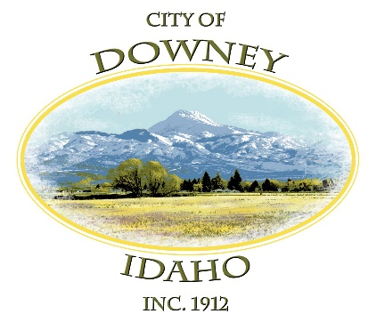
REPORTS

Tony Hancock Kiesha Keller
Gary Barnes Bonnie Hill
John Hyde Grant Johnson
Mayor Nielsen
ACTION ITEM- Executive Session 74-206(1)(a)
ACTION ITEM – Adjournment

