AGENDA
PUBLIC HEARING
DOWNEY CITY COUNCIL
TUESDAY, February 8, 2022
6:30 PM

ACTION ITEM- Public Hearing- Proposal to the Idaho Department of Commerce for an Idaho Community Development Block Grant (CDBG)

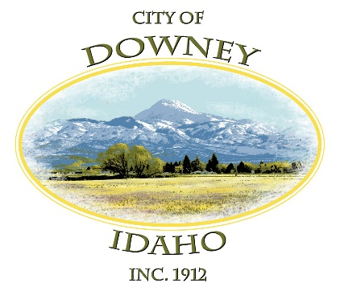
ACTION ITEM – Adjournment

