MINUTES
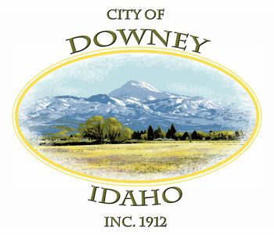
REGULAR MEETING
DOWNEY CITY COUNCIL
TUESDAY, MARCH 8, 2022

ATTENDANCE: Rex Nielsen, Gary Barnes, John Hyde, Bonnie Hill (Absent), Grant Johnson, Tony Hancock and Kiesha Keller.

PATRONS- Officer T. Smith, Officer Durham, Marjohna Madsen, Naomi Geiger, Hagen Jensen, Caleb Jensen, Bam Seauints (Troop 82), Ritchie Helbrook (Troop 82), Lynn Buok (Troop 82), Thor Gunderson Troop 82), Brent Brown, Larry and Diannia Burden, Kelly Fly (Troop 82)

CALL TO ORDER: Mayor Rex Nielsen called the meeting to order and welcomed those attending the meeting.

Rex Nielsen offered the invocation and led the group in the Pledge of Allegiance

Action Item - CONSENT AGENDA
The following business items may be approved by one motion and a vote. If any one member of the Council so desires, any matter listed can be moved to a separate agenda item.
- Council Minutes – February 8, 2022
- Accounts Payable- March 2022
- Business License- Richard Austin Concrete and Construction

John Hyde made the motion to approve Consent Agenda for Council Minutes for February 8, 2022, and Accounts Payable for March 2022 and Business License for Richard Austin Concrete and Construction, seconded by Gary Barnes, roll call vote John Hyde; aye, Gary Barnes; aye, Grant Johnson; aye, motion carried.

Law Enforcement- Officer Smith is going to look into the City Office’s copy of the police report. Officer Smith believes lack of it this month is due to all the changeover in the Sheriff’s office.
John addressed a resident’s concern about the stop signs in town and residents not obeying them. Officer Smith said he would put in a request for more attention to the areas with stop signs.

Action ITEM: Consider Approval for New Business “JK Custom Wood and Design”
Justin Keye’s, been in the cabinet and countertop business for 15 years. Hoping to start small with custom pieces and see where it goes. Grant asked if he had a shop or garage for it? Justin has a garage/shop with just regular table saws and routers. Runs the shop at Cash Valley Cabinets and Tops in Richmond right now but looking to get out on his own.

Grant Johnson made the motion to approve to Approve the New Business License for “JK Custom Wood and Design”, seconded by John Hyde; roll call vote: John Hyde; aye, Gary Barnes; aye, Grant Johnson; aye, motion carried.

Action Item- Consider Approval for Building Permit for Kash Morrison for a Commercial Remodel/Reroof for 15 S Hwy 91 (DOW2022-001)

Kash has turned in the building permit but is waiting on stamped engineered plans. They should be here in the next 10 days. All construction has been stopped until the plans arrive.

Grant Johnson made the motion to approve to Approve Building Permit for Kash Morrison on condition that we receive his stamped engineered plans, seconded by Gary Barnes; roll call vote: John Hyde; aye, Gary Barnes; aye, Grant Johnson; aye, motion carried.

Action Item- Consider Approval for Building Permit for Nathan Moritsen for Residential Addition 341 S 400 E (DOW2022-002)
Tony stated that everything is meeting our ordinances and paperwork is completed.
John Hyde made the motion to approve to Approve the Building Permit for Nathan Moritsen for Residential Addition 341 S 400 E, seconded by Grant Johnson; roll call vote: John Hyde; aye, Gary Barnes; aye, Grant Johnson; aye, motion carried.

Action Item- Consider Approval for Building Permit for Mike Geddes for Residential New Single-Family Dwelling (DOW2022-003)
Geddes wants to put a single-family dwelling behind the Care Center. Tony explained to Geddes the setbacks had to be in ordinance and Tony will make sure the foundation is in our limits. Gary asked what the property line is from Care Center? Tony explained the Care Center has approximately 8 feet before the alley and Geddes property is on the other side of the alley. Tony said Geddes plans on putting two homes on his property which will fit our ordinances. Mike Geddes will live in the first home for a year before building the second and then may move into that one. Brent Brown asked if the house was stick build and Tony confirmed it is.

John Hyde made the motion to Approve the Building Permit for Mike Geddes for Residential New Single-Family Dwelling, seconded by Gary Barnes; roll call vote: John Hyde; aye, Gary Barnes; aye, Grant Johnson; aye, motion carried.

Action Item- Consider Approval for Searle, Hart and Associates to do 2021 City Audit

Since discussing Searle, Hart and Associates Larry Burden has found another auditor that would be interested in doing the audit. Larry said the audit is Maxwell and he does the audit for Inkom. Larry believes we should meet with a few auditors to see who will fit best with our city staff. After a brief explanation on our systems and procedures so far, Larry believes we will need a bit more time to get our audit ready for a new auditor. Ware and Associates hasn’t had the same expectations as a new auditor will want which will cost us more if we don’t take the time to get our audit ready before we send it out to be done.

John Hyde made the motion to Table Approval for Searle, Hart and Associates to do 2021 City Audit pending contact with a minimum of 2 other Firms with written engagement letters from both, seconded by Gary Barnes; roll call vote: John Hyde; aye, Gary Barnes; aye, Grant Johnson; aye, motion carried.

Action Item- Approval on Spending for the Easter Egg Hunt

Kiesha explained the City Office is helping the Chamber do the Easter Egg Hunt so she would like to spend the $200 donation we usually donate to the Chamber on Hot Chocolate and Donuts for the Easter Egg Hunt.

Grant Johnson made the motion to Approve Spending up to $200 for the Easter Egg Hunt, seconded by John Hyde; roll call vote: John Hyde; aye, Gary Barnes; aye, Grant Johnson; aye, motion carried

Action Item- Consider Approval for 2022 Arbor Day Proclamation

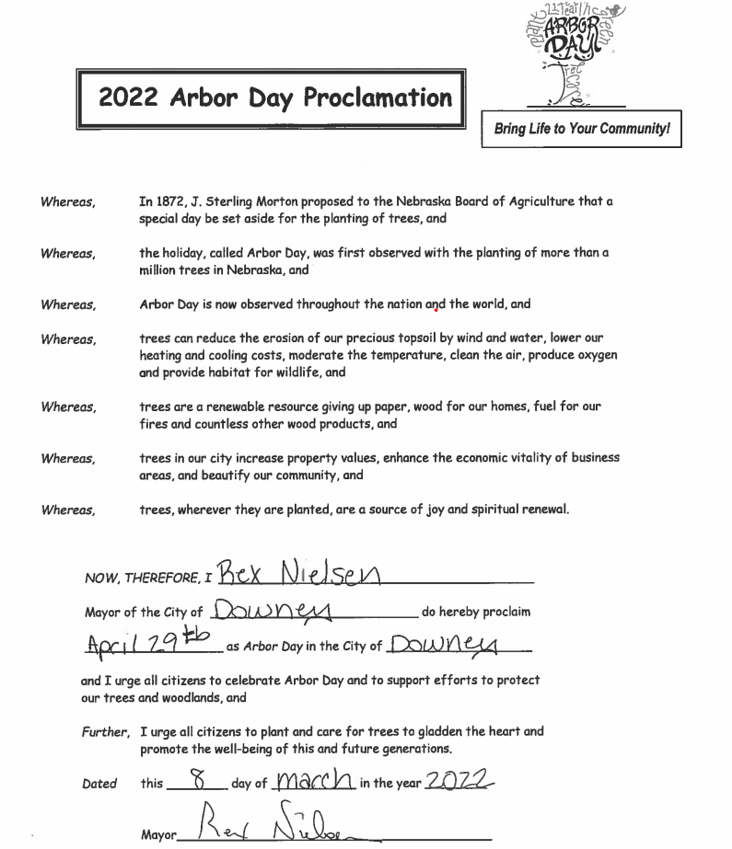

Gary Barnes made the motion to Approve 2022 Arbor Day Proclamation, seconded by Grant Johnson; roll call vote Gary Barnes; aye, John Hyde; aye, Grant Johnson; aye, motion carried.

Comments from the Audience- No Comments

Reports-

Tony Hancock- As of today, there is still 64 gallons per minute coming to town and 160 per minutes turned out to the canyon. Tony received a bid from All American Roofing for the roof over the kitchen in the Community Center for $6800. Discussion was had about paying for the roof as a match funds for the SICOG Grant but the city would still have to find the funds to do it. Tony let Council know the bid on the Lift Pump is $11,000 so if the Covid Money is applicable then it would be wise to use it for the pump. The floors have been cleaned in the Community Center and Offices and the company has been paid. There is a small leak on the check valve in the Well House. The engineer came and went over the soft start and will get a bid on a new one. The engineer will get a bid on software to run the telemetry which runs the well because it needs updated. Covid Money would be a good option for that if it will cover those costs. There has been a few residents that have had frozen water lines, Tony got all the ones on the city side thawed. The Maintenance Dept has their CCR reports to do but are waiting on DEQ to release all the information online, but it will be completed as soon as its up.

Kiesha Keller- There is a Spring AIC training coming up on April 13 9am-3pm. I can get whoever wants to come, registered online. ICCU is donating $1000 for the Community Center along with the $2000 from Rocky Mountain Power and I still have one more grant with Rocky Mountain Power to put in on for the Community Center. The rep for Rocky Mountain came in on Monday and walked through Community Center and suggested $15,000 and to focus on the kitchen. This grant is due by June 15th. The Grant Class last Thursday was helpful.

Gary Barnes- Thanked everybody for being here. Thanked the maintenance staff and office staff. Thanked the community for their support.

John Hyde- Asked if Maintenance was going to be painting the street lines this spring? Tony said not this spring because of chipping and need to check on availability on paint. John also asked that we send out the letters to the truckdrivers for the truck route. Kiesha said she will get them out. John thanked the Maintenance staff for everything they do and thanked the scouts for being at the meeting.

Grant Johnson- Thanked the staff and appreciates they give their best. Commend the scouts and scout leaders for picking up the ball. Grant let the Council know he helped Tony get all the diesel tanks filled before the price goes up.

Mayor Rex Nielson- Rex believes we have everything turned in and are just waiting now for the SICOG Grant for the Community Center. Thanked Larry and Dianna for the help they’ve given the city. All the audits have been turned in now. Thanked Kiesha, the Council and Tony and Matt.

Action Item- Adjournment

Grant Johnson motioned to Adjourn, seconded by John Hyde, motion carried.

APPROVED__________________________________ Rex Nielsen, Mayor

Attest_____________________________
Kiesha Keller, City Clerk

