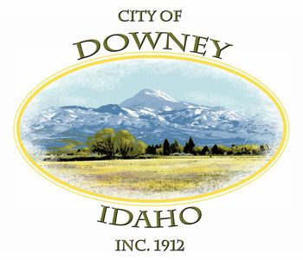
MINUTES
REGULAR MEETING
DOWNEY CITY COUNCIL
TUESDAY, JUNE 8, 2021
7:00 PM

ATTENDANCE: Mayor Rex Nielsen, Grant Johnson, John Hyde, Bonnie Hill, Tony Hancock, Selena Guthrie, Gary Barnes

PATRONS- Barbara Hill, Louise Cummings, John Hyde, Melissa Bowman, Daniel & Robin Wilson, Terry and Bonnie Beck, Officer Smith, Deputy Bonander

CALL TO ORDER: Mayor Nielsen called the meeting to order and welcomed those attending the meeting.

Grant Johnson offered the invocation and led the group in the Pledge of Allegiance.

ACTION ITEM - Consider Approval of the Agenda

Bonnie Hill made the motion to approve the agenda, seconded by Grant Johnson, all voted aye, motion carried.

ACTION ITEM - CONSENT AGENDA
The following business items may be approved by one motion and a vote. If any one member of the Council so desires, any matter listed can be moved to a separate agenda item.
- Council Minutes – May 2021
- Accounts Payable – June 2021
- Noncommercial Kennel License- Amanda Frew, 3 Dogs

Bonnie Hill made the motion to approve the Consent Agenda, seconded by Gary Barnes, all voted aye, motion carried.

Law Enforcement

Bannock County Sheriff’s Department did not have any items to discuss at this time.

The City Council thanked the three officers for attending the meeting and welcomed the new officers.

ACTION ITEM- Consider approval of City Council Member Daniel Wilson’s Resignation

Due to Idaho State law, Daniel’s Newly Elected Office as a new Downey Swan-Lake Highway District Commissioner, Daniel must officially resign as a Member of the Downey City Council.
With understanding and a heavy heart, the City Council and City Staff thanked Daniel for his outstanding service on the City Council. Daniel Wilson has served the city for 3 years and 6 months and a lifetime of secret service in our community.
Bonnie Hill made the motion to approve the resignation of City Council Member Daniel Wilson, seconded by Grant Johnson, all voted aye, motion carried.

ACTION ITEM- Consider approval of Mayor Rex Nielsen’s Appointed, New City Council Member John Hyde

Bonnie Hill made the motion to approve of Mayor Rex Nielsen’s Appointed, new City Council member John Hyde, seconded by Grant Johnson, all voted aye, motion carried.

ACTION ITEM- Swearing in New City Council Member John Hyde

Oath of Office Administered to newly elected, Council Member, John Hyde:
The following Oath of Office was read to John Hyde by Mayor Rex Nielsen:

“Do you solemnly swear (or affirm) that you will support the Constitution of the United States, and the Constitution of the State of Idaho, and that you will faithfully discharge the duties of Councilor of the City of Downey according to the best of your ability?”

John Hyde affirmed, “I will.”

ACTION ITEM- Lothrop’s Home Final Cleanup Date

The clean-up process has been moving forward slowly. Pat Lothrop had rented a dumpster from PSI and a small tractor in his cleanup efforts. Pat filled the dumpster one time and had it returned. The small tractor has been returned as well. The cleanup efforts are at a standstill.
The City Council Members are overwhelmed with the thought of putting thousands of dollars of the City’s money to clean up the debris. In our effort to stay away from high cost, we have sent out for 3 new bids on the property.

The City Clerk has called Bannock County on the process of adding the cost of cleanup onto his taxes. Bannock county explained that it could take more than four years to recoup the money and explained the process of adding a "special" onto his taxes.

The City Council has made a final decision, the property must be cleaned up, 30 days will be issued. The city clerk will work with the City’s Attorney to obtain an official letter. Rex and Tony will hold a special meeting with Mr. Lothrop and Mrs. Lothrop to hand deliver the letters.

Bonnie Hill made the motion to approve Lothrop’s Final Cleanup Date as of thirty days of the written letter to Mr. Lothrop, seconded by Grant Johnson, all voted aye, motion carried.

ACTION ITEM - Consider approval of Alcohol Beverage Catering Permit for American Legion Post 21 at the Bannock County Fair

Bonnie Hill made the motion to approve of the Alcohol Beverage Catering Permit for American Legion Post 21 at the Bannock County Fair, seconded by John Hyde, all voted aye, motion carried.

ACTION ITEM- Consider approval of Reimbursing Jessica Murray for Non-use of Rental Agreement, Community Center Office

John Hyde made the motion to approve of reimbursement of six hundred dollars to Jessica Murray for non-use of Rental Agreement, Community Center Office, seconded by Bonnie Hill.

ACTION ITEM- Consider approval of a New Meter Install and Rate Review for Craig Criddle Located at Parcel: RPR4433011400

History on the water right agreement- When the City of Downey wanted to use the Nine Mile Spring for the town’s water resource, the City of Downey had to go through several properties to bring their new water source to town. Several landowners agreed to have the City water lines go through their farmland to reach the City boundaries. In return the City of Downey made arrangements with the property owners to fit their needs. The arrangements varied from water rights to special rates.

Craig Criddle's family originally had a stock hydrant on one of those parcels of property with the water line running through it. Craig Criddle’s late father Dale Criddle made an agreement with the City of Downey in 1984 to lower his water utility bill at his home located at 377 East Fourth North in Downey, for his water right from his field. The agreement was set for 9000 gallons allowed per month and 15 Cents per 1,000 gallon over the 9000 gallons. Tony Hancock reported to the City Council that Craig Criddle would like to install a new meter back on his property located on his family farm. Craig would like to move the water rights from the house he previously owned at 377 EAST FOURTH NORTH within the City of Downey to his property located at Parcel: RPR4433011400. Tony has spoken with Craig about the new connection fees that will go with a new meter and the possibility of the water flowing too fast in the water line, passing through the location he desires.

The City clerk obtained the City attorney’s recommendations and Mr. Fuller has recommended that if the City is engaging in a new agreement, new rates should be applied.
Bonnie Hill made the motion to approve a New Meter Install at the rate of the current outside city rate for Craig Criddle Located at Parcel: RPR4433011400, seconded by Grant Johnson, all voted aye, motion carried.

ACTION ITEM- Financial Growth Opportunities for the City of Downey

Upon Mayor Rex Nielsen’s request, the City Clerk did not obtain the financial Information discussed in April’s meeting. The City Council made the decision to hold a special meeting for Ireland Bank to present another proposal for the City’s financial accounts. The Mayor contacted Ireland Bank in their efforts to keep the money local and Ireland Bank denied the opportunity to come before the City Council because if they offer a special deal to the City of Downey, they need to give the opportunity to everyone else.
A discussion was held reviewing the three financial opportunities for the city.
Bonnie Hill made the motion to approve the amount of $500,000, investing in ICCU Financial Growth Opportunities for the City of Downey, seconded by Gary Barnes, all voted aye, motion carried.

DISCUSSION ITEM- City of Downey’s Law Contract with Bannock County Sheriff Department

Bannock County Sheriff’s Department proposal for the City of Downey over
the next three years.

DOWNEY
190  180  170  160  140  130 120  110  100 | Actual Vs. Contracted Hours (2015-2020)  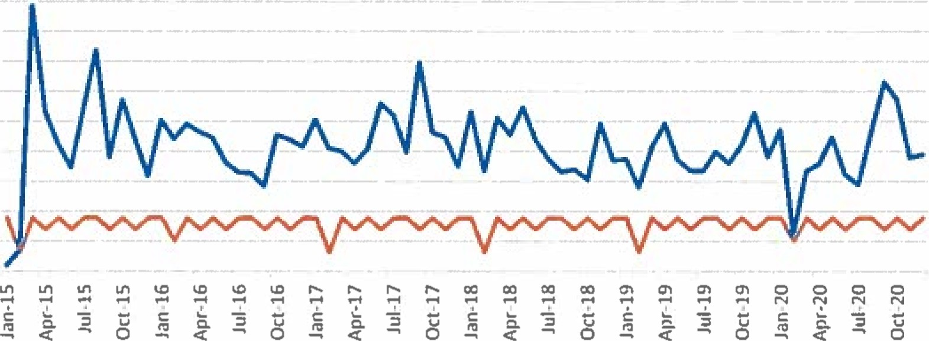  Month & Year  Actual Contracted
Contracted vs. Actual Usage (2020) $22/hr. x 1,390.8 contracted hrs. $30,597.60.
$22/hr. x 1,677.5 actual hrs. $36,905.00

Current Services
- Enforce State of Idaho Laws - 24 Hour Service from BCSO
- Investigate Crimes - Patrol Time
- Issue Citations

Proposed Rate with Projected Hours
$42.89/hr. ^{l} x 1655.48 projected hrs.² = $71 ,002.64

Proposed Services
- Existing Contract Services

¹ Proposed Per Hour Cost is based on hourly cost of officer, vehicle, and total maintenance + labor on vehicle. ² Projected hours are based on annual trend model created from 2015-2020 data.

Burdened by this proposal the Downey City Council is researching several options regarding new law enforcement avenues.
Options discussed.
- Obtaining a quote from Oneida County
- Speaking with the City of Arimo and McCammon for Joint law enforcement.
- Also, requests have been submitted to Bannock County for further investigation on this situation.
- Bonnie Hill would like the City Attorney to check on Downey's obligations under state law to provide law enforcement to the city and the county's obligation as well.

Further discussion will take place next City Council Meeting.

ACTION ITEM- Consider approval of Bannock County Fair Board Lease Agreement Rate and Terms of Lease for the Downey RV Park

The City Council reviewed the lease agreement provided by the City Clerk and discussed several concerns they had, such as, insurance issues, intergovernmental agreement, etc. Bonnie Hill would like to seek further information on this issue before coming to a decision.
No motion was made at this time.

Comments from the audience on Agenda items only

No Comments at this time.
REPORTS

Tony Hancock

235 – 240 Gallons
The well is running
Matt and Tony are mowing and maintaining the City Parks.
Clean-up Downey was a success
Tony has the steal from clean up Downey, that he will turn in
Tony and Matt upgraded the Downey Splash Pad.
Tony and Matt are working with the Downey Swan Lake Hwy District to chip seal our roads.
The seepage test has been complete
The State of Idaho has sent a Road and Street Grant of Seven Thousand Dollars.

Selena Guthrie

Selena has been working on the American Relief Funding. The City of Downey can receive $136,000 total. At the end of the month, the City is hoping to receive the first wave of payments of $68,000 and in 12 months the second set will be received.
Budget Training is scheduled for June 30th

Gary Barnes

Gary thanked the audience for there attendance. Gary expressed his gratitude towards the City Staff and towards the City Council for their efforts as we moved forward.

Bonnie Hill

Bonnie expressed her gratitude towards the City Staff.
Bonnie questioned the City Clerk about the City audit. The City Clerk stressed that she has been trying to make contact with him. She will continue to work on the situation.
Bonnie inquired information about the Fall Clean-up Downey Day. Tony expressed the Fall Clean-up day is sponsored by the City of Downey. We supply 2 to 3 Dumpsters for Downey residence only.
Bonnie inquired information on the stone in front of the City Building, Tony gave an update and will request a new quote for the last three sections of the building.

John Hyde-
John expressed his gratitude towards Daniel for his service.

Grant Johnson

Grant expressed his gratitude towards Daniel for his service

Mayor Nielsen

Rex expressed his gratitude towards the Office Staff and he is looking forward to working with John Hyde.

ACTION ITEM - Adjournment

John Hyde made the motion to adjourn, seconded by Bonnie Hill all voted aye, motion carried.

APPROVED__________________________________ Rex Nielsen, Mayor

Attest_____________________________
Selena Guthrie, City Clerk

