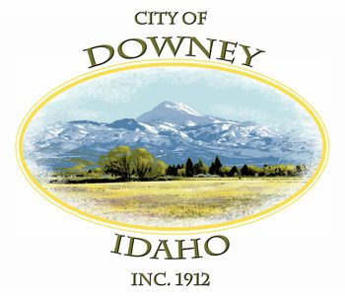
MINUTES
REGULAR MEETING
DOWNEY CITY COUNCIL
TUESDAY, MAY 11, 2021
7:00 PM

ATTENDANCE: Mayor Rex Nielsen, Grant Johnson, Dan Wilson, Bonnie Hill, Tony Hancock, Selena Guthrie, Gary Barnes

PATRONS- Barbara Hill, Louise Cummings, Officer Jeff Fullmer and Officer Housel

CALL TO ORDER: Mayor Nielsen called the meeting to order and welcomed those attending the meeting.

Tony Hancock offered the invocation and led the group in the Pledge of Allegiance.

ACTION ITEM - Consider Approval of the Agenda

Dan Wilson made the motion to approve the agenda, seconded by Grant Johnson, all voted aye, motion carried.

ACTION ITEM - CONSENT AGENDA
The following business items may be approved by one motion and a vote. If any one member of the Council so desires, any matter listed can be moved to a separate agenda item.
- Council Minutes – April 2021
- Accounts Payable – May 2021
- Livestock Permit- Steven Fergus- One Horse

Bonnie Hill made the motion to approve the Consent Agenda, Including Council Minutes, Accounts payable and Steven Fergus’ livestock permit, seconded by Gary Barnes, all voted aye, motion carried.

Law Enforcement

Officer Fullmer inquired a copy of the new livestock permit.

The mayor would like the Officers patrolling the area to keep an eye out for a little brown car racing around town.

DISCUSSION ITEM- Daughters of Utah Pioneer Cabin Restoration Project

Bonnie Hill read a letter received previously from the daughters of Utah Pioneer Organization, Sarah Matkin

We, the daughters of the Utah Pioneers, are planning to restore the Coffin Cabin. As one can see by looking at the Cabin, the foundation is crumbling, and the walls are deteriorating.

We are going to obtain an estimate from Luke Waldron of Malad for possible repairs and restoration. As it will take a sizeable amount of money for the restoration, we are planning to have fundraisers, receive donations, and possibly apply for a grant from the Idaho Heritage Foundation.

In preparation for the restoration, we are apprising our City Council for our intent to do this project. We respectfully seek the help that City may be able to give us to accomplish this restoration. We will be asking for help with building permits and any other assistance with which the city may be willing to give.

Please see the attached history of the Coffin Cabin from the Downey History Book Volume 3.

Sincerely,
DUP Camp Hunt

The City Council requests Sarah Matkin to update the City Council on the progress of the project. Selena will contact the State on possibly waving the building permit. Bonnie suggested volunteers from the city office to donate man hours to help on the project.

ACTION ITEM- Consider approval of the Downey livestock Permits, Annual Review

Bonnie Hill made the motion to approve the Downey livestock Permits as listed in the City Councils Annual Review, with the exception of the expired livestock permits which include the following: James Anderson, Gary Roberts, Jolene Wolford and Chase Graham. The City Office staff will provide a letter to the expired livestock permits, seconded by Dan Wilson, all voted aye, motion carried.

ACTION ITEM- Consider approval of a New Meter Install and Rate Review for Craig Criddle Located at Parcel: RPR4433011400

History on the water right agreement- When the City of Downey wanted to use the Nine Mile Spring for the towns water resource, the City of Downey had to go through several properties to bring their new water source to town. Several landowners agreed to have the city water lines go through their farmland to reach the City Boundaries. In return the City of Downey made arrangements with the property owners to fit their needs. The arrangements varied from water rights to special rates.

Craig Criddle's family originally had a stock hydrant on one of those parcels of property with the water line running through it. Craig Criddle’s late father Dale Criddle made an agreement with the City of Downey in 1984 to lower his water utility bill at his home located at 377 East Fourth North in Downey, for his water right from their field. The agreement was set for 9000 gallons allowed per month and 15 Cents per 1,000 gallons over the 9000 gallons. Tony Hancock reported to the City Council that Craig Criddle would like to install a new meter back on his property located on his family farm. Craig would like to move the water rights from the house he previously owned at 377 EAST FOURTH NORTH within the City of Downey to his property located at Parcel: RPR4433011400. Tony has spoken with Craig about the new connection fees that will go with a new meter and the possibility of the water flowing too fast in the water line, passing through the location he desires.

The City Council was concerned about the rate agreed upon originally. They seek further information such as can the city increase the rate to the current, outside city limit rate. They would like to obtain the Attorney’s recommendation.
The City Clerk will seek this information and return and report.

Bonnie Hill made the motion to table the New Meter Install and to set a rate for Craig Criddle, Located at Parcel: RPR4433011400 until the City attorney provides his input on a situation, seconded by Grant Johnson, all voted aye, motion carried.

ACTION ITEM- Financial Growth Opportunities for the City of Downey

Upon Mayor Rex Nielsen’s request, the City Clerk did not obtain the financial information discussed in April’s meeting. He believes we need to keep the money local. Bonnie Hill and Daniel Wilson are interested in moving the money to Idaho Central Credit union. They believe Idaho Central Credit Union will give the City of Downey more opportunities financially. After much discussion, the City council made the decision to hold a special meeting for Ireland Bank to present another proposal for the city’s financial accounts. The Special meeting is scheduled for May 20, 2021.
Bonnie Hill made the motion to table the financial Growth Opportunities for the city of Downey and schedule a special meeting for May 20, 2021, seconded by Gary Barnes, all voted aye, motion carried.

DISCUSSION ITEM- City of Downey’s Law Contract with Bannock County Sheriff Department
Burdened by this proposal the Downey City Council is researching several options regarding new law enforcement avenues.
Options discussed.
- Obtaining a quote from Oneida County and the City of Preston
- Speaking with the City of Arimo and McCammon for Joint law enforcement.
- Also, requests have been submitted to Bannock County for further investigation on this situation. When the information is submitted to the city, a special meeting will be held.
- Negotiate a new contract with Bannock County.
- Bonnie Hill would like to check with the City’s Attorney to see if the City of Downey must contract with Bannock County Sheriff’s Department.

Bannock County Sheriff’s Department proposal for the City of Downey over
the next three years.

DOWNEY
190  180  170  160  140  130 120  110  100 | Actual Vs. Contracted Hours (2015-2020)  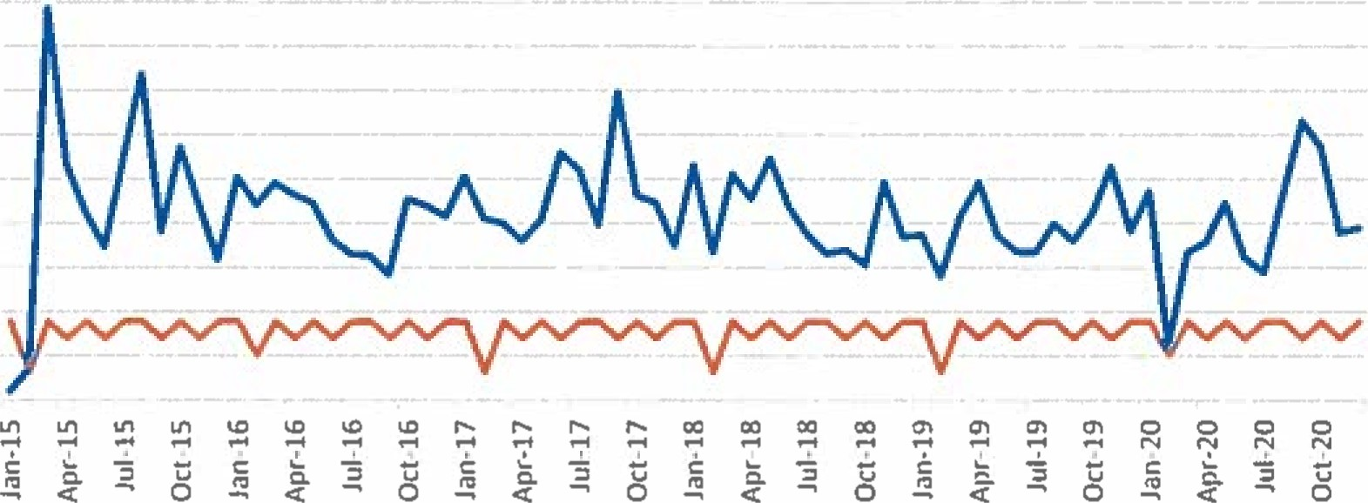  Month & Year  Actual Contracted
Contracted vs. Actual Usage (2020) $22/hr. x 1,390.8 contracted hrs. $30,597.60.
$22/hr. x 1,677.5 actual hrs. $36,905.00

Current Services
- Enforce State of Idaho Laws - 24 Hour Service from BCSO
- Investigate Crimes - Patrol Time
- Issue Citations
Proposed Rate with Projected Hours
$42.89/hr. ^{l} x 1655.48 projected hrs.² = $71 ,002.64

Proposed Services
- Existing Contract Services
¹ Proposed Per Hour Cost is based on hourly cost of officer, vehicle, and total maintenance + labor on vehicle. ² Projected hours are based on annual trend model created from 2015-2020 data.

Comments from the audience on Agenda items only
No Comments at this time.

REPORTS

Tony Hancock

- Spring Flow is at 250gpm
- Bathrooms are open.
- Tony and Matt are working on an addition on the splash pad.
- They are still working on the seepage test on the sewer lagoons. Everything is looking great.
- Cleanup day is May 29, 2021. Tony and Matt will check on the elderly to see if they need help.
- Tony and Matt cleaned up the lot behind the library. They city donated a good amount of gravel for the parking lot.
- Tony and Matt have fencing and weed spraying up nine mile.
- Tony reported the rock should be finished on the building later that week.
- Tony and Matt purchased trees and planted two trees for Arbor Day.
- Tony and Matt have a water class on May 26th.

Selena Guthrie

- Selena investigated a Program called Code Red as discussed in the previous meet. The quote was around $5,000 dollars for an alert energy system. Selena investigated the utility program that the city already is using, and the program has an option to send emails out. The test email was unsuccessful, but the program is no cost to the city.
- Elden Trucking Company has found another property and so they no longer needed assistance from the City of Downey.
- Selena is going to have the Nuisance Ordinance reviewed by the lawyer. That is why the ordinance is not being reviewed at this time.
- Kylie has stepped up and helped Selena. Selena was unable to attend the AIC training and Kylie still went and represented the city.

Gary Barnes

Gary thanked the audience for here attendance. Gary expressed his gratitude towards the city staff and towards the City Council for their efforts as we moved forward.

Bonnie Hill

Bonnie expressed her gratitude towards the City Staff.

Bonnie inquired information about the Care Act Funding. The City Clerk reported that there has not been any information sent out. She has been on the lookout. Selena is hopeful that the information will be released soon. Barbara Hill mentioned the news reported that cities can use the funding on water, sewer and broadband internet projects.

Bonnie inquired information on the railroad ties. She would like to replace the Community Center’s ties; the ties are falling apart, and they need to be replaced.

Bonnie also requested for Tony to remove the City Office sign and put it in the Community center as it is a part of the history of Downey. She would like Tony to have another sign made for the City Office. She does not want a sign with the City Logo on it, only a sign that says “Downey Office”.

Bonnie questioned Tony why 3rd and 4th South streets have not been paved. Tony would be okay paving the streets if we receive grant money, but he would hate to use our budget on paving the roads.

Daniel Wilson

Daniel expressed his gratitude towards the city staff.

Grant Johnson

Grant expressed his gratitude towards the city staff.

Grant also inquired if his email on the Nuisance Ordinance had been received. The City Clerk explained she had forwarded the email to the City Council and the attorney will review the information before the City Council moves forward with the progress of the Nuisance ordinance.

Mayor Nielsen

Mayor Nielsen thanked the City Council and City Staff for their efforts.

ACTION ITEM - Adjournment

Dan Wilson made the motion to adjourn, seconded by Bonnie Hill, all voted aye, motion carried.

APPROVED__________________________________ Rex Nielsen, Mayor

Attest_____________________________
Selena Guthrie, City Clerk

