AGENDA
SPECIAL MEETING
DOWNEY CITY COUNCIL
MONDAY, JUNE 21, 2021
7:00 PM

Call to Order

Prayer – Gary Barnes
Pledge of Allegiance

ACTION ITEM - Consider Approval of the Agenda

ACTION ITEM- Consider approval of Accepting a Bid and Issue a Demolition Permit for the Clean-up of the Debris from Wadsworth Lothrop and Sallie Lothrop’s Burnt Home, Located at 413 North Main Street.

ACTION ITEM- Consider Approval of a Lease Agreement with John Hyde to lease
the Downey Community Center Office Space at 21 South Main

ACTION ITEM- Negotiate Downey’s Law Contract and Code Enforcement Officer

ACTION ITEM- Consider Approval of seeking financial funds from the American Relief Plan 2021

ACTION ITEM- Consider Approval of Donating to the Bannock County Fair and Rodeo Queen Contest

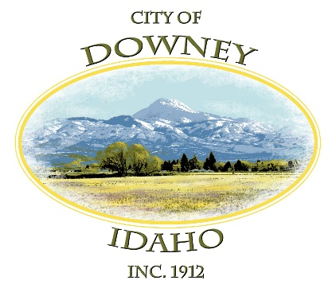
ACTION ITEM – Adjournment

