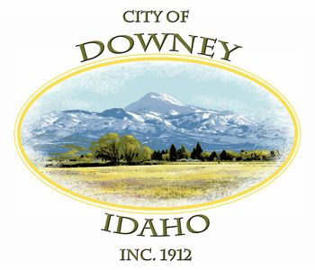
MINUTES
SPECIAL MEETING
DOWNEY CITY COUNCIL
WEDNESDAY APRIL 6, 2022
7:00 PM

ATTENDANCE: Rex Nielsen, Gary Barnes, John Hyde, Bonnie Hill, Grant Johnson, Tony Hancock (Absent) and Kiesha Keller.

PATRONS- Barbara Hill

CALL TO ORDER: Rex Nielsen called the meeting to order and welcomed those attending the meeting.

Rex Nielsen offered the invocation and led the group in the Pledge of Allegiance

Action Item- Approve Auditor for Fiscal Year 2020-2021

Dianna Burden withdrew they’re engagement letter. We only have Searle, Hart, and Associates.

Bonnie Hill made the motion to Approve Searle, Hart, and Associates PLLC for Fiscal Year 2020-2021, seconded by Grant Johnson; roll call vote Bonnie Hill; aye, John Hyde; aye, Gary Barnes; aye, Grant Johnson; aye, motion carried.

Comments from the Audience-

No Comments

Action Item- Adjournment

Grant Johnson motioned to Adjourn, seconded by Bonnie Hill, motion carried.

APPROVED__________________________________ Rex Nielsen, Mayor

Attest_____________________________
Kiesha Keller, City Clerk

