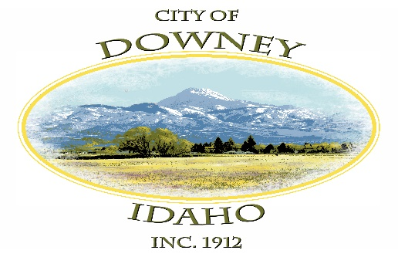

Welcome to Downey

We welcome you to Downey and hope you enjoy the quiet atmosphere and friendship we share here. We would like to provide you with some general information.
Utilities
Water is metered and charged at $41.00 for the first 10,000 gallons used. The cost for each 1,000 gallons thereafter is 60 cents. Water meters are read year round. We encourage water conservation and wise use of outside watering.
Utility bills include water, sewer and garbage fees. This includes: Water - $41.00 (plus extra usage charges if applicable), Sewer- $16 and Garbage - $13. These bills are due monthly. A deposit of $140.00 is required which is the equivalent of two month’s utility bills. Deposits for rental homes are held until the renter moves. For a homeowner, the deposit is held for one year. If the utility bill is paid each month in a timely fashion, the deposit is refunded at the end of one year.
___________ Initials
Garbage is picked up each Monday, usually in the early morning, except on those weeks where a holiday occurs on Monday. On those weeks; garbage is picked up one day later. Holidays included are Christmas Day, New Year’s Day, Independence Day, Labor Day and Memorial Day. Please check to see which side of the street to place your garbage can for pickup. The garbage truck will only go down each street once.
___________ Initials
The City Office is open Monday through Thursday from 8:00am to 2:00pm. We are Closed on Holidays. There is a Utility Payment Drop Box just north of the city office door for after hour’s payments. Please do not put cash in the Drop Box.
Online Payment Available- Go to downeyidaho.us for online payments. You can pay for Utility Payments, Dog Licenses, Shooting Range Donation, Business licenses, RV Park, RV Dump, Building Permit Fees and Plan Review Fees. There is a $1.00 fee per transaction plus 3%.
___________ Initials

Permits and Licenses
Building permit - Any new construction or remodeling, including carports, sheds or adding a new fence, need to be properly permitted and cleared through the city office. Applications for a building permit are available at the city office. Downey has contracted with the Bannock County Building Inspection Office to assure that all building standards and codes are met. Please allow at least two months for the plans to be reviewed and approved before you start a project. This process can take up to six weeks.
___________ Initials

Business License- Anyone doing business within the city limits required to obtain a business license. This includes home businesses such as preschools, daycares, boutiques and breeding and selling of puppies. The application fee is $10.00 per calendar year.
___________ Initials

Livestock Permits- Livestock permits are required for all animals other than dogs or cats. DO NOT BRING ANY LIVESTOCK INTO THE CITY LIMITS WITHOUT A LIVESTOCK PERMIT! Please pick up application forms at The City Office. There is no fee associated with livestock permits. It is required to have seventy five percent of neighbors within a 400-foot radius of the applicant’s property boundaries. The applicant must obtain written confirmation of neighbor’s permission from once the application is completed; it will be present the application to the city council for approval prior to livestock is being brought into city limits. You’ll also need one-half an acre per large animal, such as horse or cow. (Over 200 lbs.) or one-half acre per 2 small animals (under 200 lbs.) There is to be No Roosters, stud horses, bulls or swine and Billy goats in the city limits.
___________ Initials
Dog Licenses- Downey City has a leach law that requires all dogs to be on a leash unless the owner’s yard is adequately fenced to restrict the dog to the owner’s property. Dog Licenses are required by ordinance for dogs over six months old. Proof of rabies vaccination by a licensed veterinarian which was issued by the veterinarian is requiring are due yearly on or before May 31. The limit of dogs in the city limits is 5.
___________ Initials
Burn permits- Burn Permits are required for any outside burning. These permits are available at the City office at no cost. Prior to igniting a burn, the permit holder must notify Bannock County Dispatch. During hot or dry weather when Bannock County issues a ban on burning, burn permits will not be issued. City Residents must follow D.E.Q. guidelines.
See www.deq.idaho.gov for guidelines and www.deq.idaho.gov/air/aqindex.cfm to find out about burn restrictions.
___________ Initials

Downey Community Center
The Downey Community Center is available to rent.
Please contact the City Office to make reservations.
Rental Fee $35
Kitchen Rental Fee $50

Useful Telephone Numbers

The emergency telephone number for fire and ambulance is 911. For police assistance that is not an emergency, please 208-236-7114.
The City Council meets the 2nd Tuesday of each month at 7:00 p.m. at the City Offices.

The mayor and city council include:
Mayor- Rex Nielsen

City Council - Grant Johnson City Council- Gary Barnes
City Council -Daniel Wilson City Council -Bonnie Hill
Once again, welcome to Downey!! We look forward to you becoming part of our community. If you have any questions, please contact the City office at #208-897-5342.

Agreement- The applicant agrees to the provisions set forth and certifies that they understand and will comply with the conditions set forth by the City of Downey.

Applicant’s Signature:____________________________________________________

PLEASE SIGN AND RETURN TO THE CITY OFFICE

