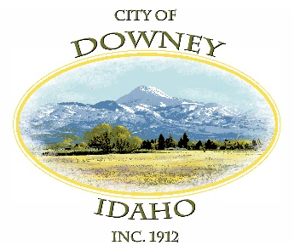

City of Downey
P.O. Box 204 - 15 South Main Street
Downey, Idaho 83234
Phone (208) 897-5342
Monday-Thursday 8a.m. -2p.m.
Jennifer@downeyidaho.us

Downey WOODLAND PARK

Reservations

NAME: ________________________________

Address: _______________________________

Phone Number: __________________________

Email: ________________________________

Date: _________________________

Times: ________________________

