Listicle – Musical Supervisor
Parable of the Sower Soundtrack
Notes for Netflix adaptation of Octavia E. Butler’s Parable of the Sower into a 10-part TV Drama.
Still Asleep – Emily Rubye
The slow and moving ambient instrumental of Still Asleep will play over the news of Lauren’s brother, Keith, being declared dead. Soft piano keys and simple strings over it surges the emotion from the pit of the viewer’s stomach, as Cory, Lauren’s stepmother, sobs over Keith’s tortured body. His eyes were burned out, but the rest of his face was left intact, and his corpse was dumped in a visible location, seemingly taunting the family.
This is one of the first of the many tragedies that struck Lauren, and even though she thinks lowly of Keith, he was still her brother. She loved him. The high notes at the end, like snow falling to the ground, convey a dream-like lullaby that quietly fades away. It’s almost bittersweet.

Genesis – Ruelle
When Lauren is awakened to the realisation that her Father is not returning, the soulful and biblical Genesis by Ruelle holds its hand out painfully, reaching out for the secure past life that Lauren once had, even though she became dissatisfied with it. Her Father, Reverend Olamina, being presumed dead, is another of the many tragedies in Parable of the Sower. Her family, one by one, are killed.
Ruelle soulfully sings lyrics fitting for Lauren’s predicament, “I’m awake for the first time”, “this is where it all begins”, and “the future waits, oh it’s calling”. This scene also displays the moment when “Earthseed”, Lauren’s own religion based on her experience and teachings of her Father, becomes solidified as something she endeavours to complete. She steps into the shoes of her Father to become a religious and spiritual teacher as the song peaks.

What Could Have Been – Sting ft. Ray Chen
Sting painfully laments his feelings for someone who exploited him. In a beautifully slow ballad that reaches a crescendo backed by the talented violinist Ray Chen, Sting wonders, “Why don’t you love who I am? What we could have been.”
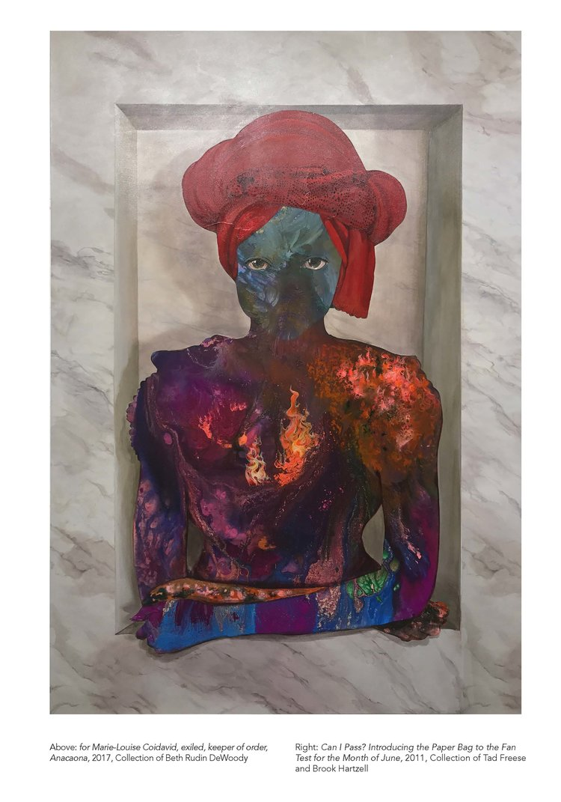
What Could Have Been puts into words every sorrowful thought and desire felt when Lauren is ripped away from her first love, Curtis, and her family, in the aftermath of the tragedy that hit her home. Drug-addicted Pyros destroy and set Lauren’s village on fire. Lauren finds two survivors of her village’s attack. Sting recounts, “I am the monster you created. You ripped out all my parts.” This event changed Lauren forever, as well as the entire trajectory that her life was going to take. The actions she is going to take in the rest of the series are actions she never thought she was capable of.
This has the feeling of Firelei Bάez’s painting, For Marie Louise Coidavid, exiled, keeper of order, Anacoana (2017). Within, sorrowful anger grows into a dark fire.
Playground – Bea Miller
The eerie and sensual voice of Bea Miller introduces and tempts the listener to the Playground, a nightmare society. “Sink into the wasteland underneath”, she sings, describing the dog-eat-dog world. The group witness heinous realities, naked women being beaten, children as young as twelve cannibalising a corpse, and dogs ripping people apart.
The song’s tone presents the mysterious and dangerous things that lie ahead for Lauren, but assures her that she shouldn’t be scared. In order to survive, she simply needs to play the game too.

Bones – Laila
When Lauren and Bankole spend time together, discussing her ideologies and dreams and eventually promise to stay together, Bones by Laila, encompasses the raw and mellow desire for another’s love. She delicately begins with more melancholy, “It’s okay, it’s alright, no one’s ever wanted to fight for me”, putting herself down, “this beat-up, broken-down fool.”
In simple acoustic, the first uncertain, innocent and eventually intense love that Lauren and Bankole have is highlighted with Laila’s breathy and nostalgic tone. As Lauren and Bankole discover each other during the hardships of the journey, it is reflected in the voice, as the song lifts up in the second half and states, “nineteen years of summer in your bones melts away my nineteen years of shivering cold. […] When you’re here I don’t feel so bad.”

I Am The Doctor – Murray Gold & BBC National Orchestra
When the group make a rest stop, Pyros attack. Murray Gold’s fast-paced violin and flute in I Am The Doctor exhibits Lauren's determination when she battles the pyros. Gun at the ready, she is ready to shoot, well-aware that she will also be immobilised due to her hyper-empathy.
The staccato strings, brass layers, choir, as well as the solo piccolo display Lauren’s quick thinking and eccentricity, making for a confident adventure which ends with her collapsing to the ground.

We All Knew – Labrinth
Labrinth’s smooth operatic voice against the gentle strum of the guitar exudes a soulful and sorrowful emotion. Lauren’s hyper-empathy is an instinctual and natural response, like her care for others. Along the way to their safe haven, Lauren helps and accumulates a large group of ragtag companions. They meet Bankole, who falls in love with Lauren and agrees to take them to his final destination – a home where they could set their roots down, where his family lived. After a perilous and exhausting journey, they arrive to find it reduced to rubble. Bankole’s family was dead.
Labrinth’s heartfelt, non-lyrical vocals emphasise the destruction as Lauren and Bankole walk atop the cracked unstable earth. We All Knew conveys the pain that Bankole is unable to utter.

Forever – Labrinth
After the tragedy of finding Bankole’s home destroyed and his family killed, Forever, also by Labrinth, encompasses the hope ripped out of them while also increasing its tempo and coming to a crescendo, portraying that same hope being regained.
Lauren stands around her battered and broken group, counting the seeds that she saved from her village. One by one, everyone agrees to stay, rebuild and begin the first Earthseed community. The atmosphere feels like pieces are picked up and becoming one.
The overall mood of both Labrinth tracks inhabits the sorrowful melancholy that Lauren and her companions experience. We All Knew and Forever hold the same undertones, but as the scene transitions into Forever, the more uplifting spirit portrays Lauren’s resolve.
Like We All Knew, this song is mainly non-lyrical and with the ethereal music and simple use of his own distorted voice, the illusion of the struggle between life and death is represented.

Bάez, F. (2017) For Marie-Louise Coidavid, exiled, keeper of order, Anacoana [painting]. At: Roanoke, VA: Beth Rudin DeWoody Collection

(Word Count – 1076 words)
(Overall – 2499 words)

